Effects of extracts of bioactive glasses on the viability, migration, and ALP activity of osteoblast-like cells.

Yu Li. Department of Hand, Plastic and Reconstructive Surgery, University of Heidelberg, BG Trauma Center Ludwigshafen, D‑67071 Ludwigshafen, Germany

Abstract (300 word limit)
Bone defects caused by infection, tumor, trauma, surgery, and congenital malformation are common, but the repair of large bone defects is still a challenge in orthopedic and craniomaxillofacial surgery. The current gold standard for bone repair, autologous bone grafting, is limited by limited bone supply, pain at the donor site, higher risk of infection, and longer operation time. Thus, various bone graft substitutes were developed in the past decades. Among them, bioactive glasses have drawn much attention because of their good biocompatibility, high osteoconductivity, and excellent osseointegration ability. To elucidate the mechanism of their beneficial effects on bone regeneration, we tested the extracts of bioactive glasses on the viability, migration, and ALP activity in hFOB 1.19 cells. In general, extracts of bioactive glasses at 0.05 g/ml had no effects on the viability, migration, and ALP activity; Extracts of bioactive glasses at 0.1 g/ml slightly inhibited the cell proliferation but increased the ALP activity; Extracts of bioactive glasses at 0.2 g/ml decreased the viability, migration, and ALP activity of cells. Our results indicated that the dissolution products of bioactive glasses contained both beneficial and harmful components for the osteogenic differentiation of hFOB 1.19 cells, and the dose of bioactive glasses must be carefully considered when they are used in the clinic.
Image
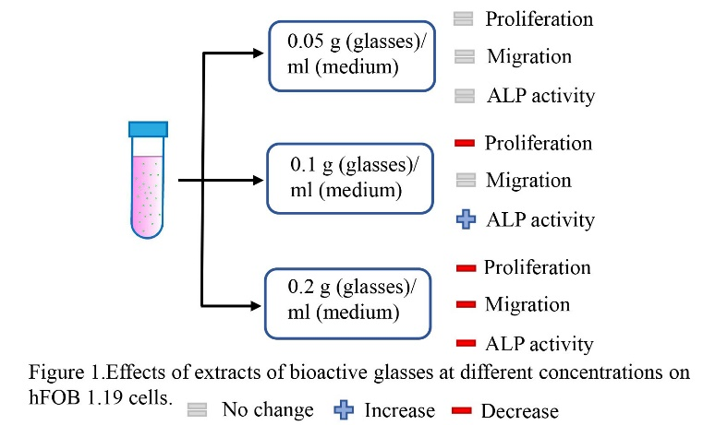
Recent Publications (minimum 5)
- Rui Li, Yu Li, and Xiaoyan Dong. Preconditioning mesenchymal stromal cells with flagellin enhances the anti-inflammatory ability of their secretome against lipopolysaccharide-induced acute lung injury. Molecular Medicine Reports.2020.10.
- Dingyu Wu, Yu Li, and Zhiyong Zhang. Development of a micro-tissue-mediated injectable bone tissue engineering strategy for large segmental bone defect treatment. Stem Cell Res Ther.2018.11.
- Yu Li, and Zhiyong Zhang. Sustained curcumin release from PLGA microspheres improves bone formation under diabetic conditions by inhibiting the reactive oxygen species production. Drug design,development and therapy.2018.5
- Yu Li, Yang Gao, and Jinbing Wang. Human adipose-derived mesenchymal stem cells-conditioned media suppresses inflammatory bone loss in a lipopolysaccharide murine mode. Experimental and Therapeutic Medicine. 2018.2
- Yu Li, Zhanzhao Zhang, and Zhiyong Zhang. Porous chitosan/nano-hydroxyapatite composite scaffolds incorporating simvastatin-loaded PLGA microspheres for bone repair. Cell Tissue Organs.

Biography (150 word limit)
Yu Li got his master degree from Shanghai Jiaotong University in 2017. He is a doctoral student at Heidelberg University now. He has published 5 papers as first author and 3 papers as co-author in reputed journals.

Email: yu315977@gmail.com

Notes/Comments:

