Metal oxide nanostructured organogel
Thiago Tabuti Galeote¹, Lorena Brazuna Portela¹, Dayane Batista Tada², Eduardo do Valle Ricardo², Eduardo Rezende Triboni¹
¹Lab Nanotechnology and Process Engineering – NEP, Brazil
²Lab Nanomaterials and Nanotoxicology, Brazil

Abstract

Inorganic sol-gel process is a recognized way to synthesize metal oxides within wet media, often leading to well-defined morphologies and size-distribution of particles. Herein, glycerol-based binary solvents allowed to obtain organogels comprising ZnO nanoparticles with narrow size distribution and high crystallinity. As a general procedure, 0.005 mol of the Zn(NO3)2 salt was dissolved in 30 mL of Glycerol-solvent 3:1 mol ratio at room temperature, then 0.01 mol NaOH solution (5 mL) was dropped into it at once under strong stirring, forming nearly immediately an organogel, Fig.1 The powder obtained after gel disruption, by adding isopropanol, was filtered off, washed (with H2O and EtOH) and characterized by DRX, SEM and TEM, showing up the ZnO wurtzite structure, good average-size distribution and crystallinity. Isopropanol, acetone and DMSO were chosen as co-solvents to carry out these preparations, and other parameters such as reagent/solvent proportions, Mg and Zn salt precursors, and temperature were evaluated as well, aiming at diversification, size/texture control, and better understanding of the gelation. Overall, we have got an unprecedent method to afford metal oxide organogels that can be of great value for further preparations of metal oxide nanostructures.



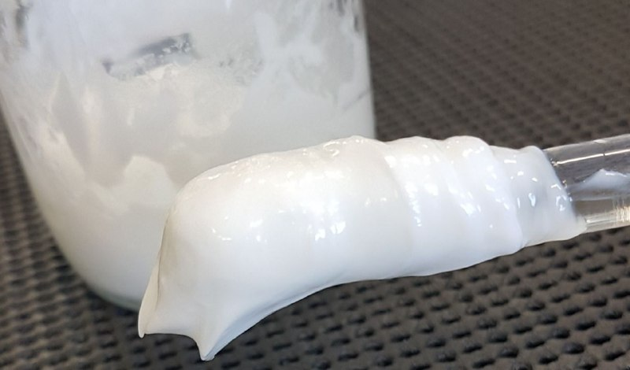

Fig.1. ZnO nanostructured organogel from Glycerol-Isopropanol.

Recent Publications
- Brazuna, L. P., Tabuti, T. G., de Paula Silva, A., Tada, D. B., Politi, M. J., Bacani, R., & Triboni, E. R. (2019). Effect of lithium and sodium ions on the size and morphology of ZnO nanoparticles synthesized by a glycerol–urea route. New Journal of Chemistry, 43(48), 18988-18995.
- Dias, J. S., Batista, F. R. M., Bacani, R., & Triboni, E. R. (2020). Structural characterization of SnO nanoparticles synthesized by the hydrothermal and microwave routes. Scientific Reports, 10(1), 1-11.
- da Silva, F. C., da Silva, M. F. P., Briotto Filho, D., Politi, M. J., Bacani, R., & Triboni, E. R. (2018). Tuned charge-transfer between ceria and 1, 4, 5, 8-naphthaldiimide as a function of pH. Journal of Luminescence, 194, 240-247.
- Segal, F. M., Correa, M. F., Bacani, R., Castanheira, B., Politi, M. J., Brochsztain, S., & Triboni, E. R. (2018). A novel synthesis route of mesoporous γ-alumina from polyoxohydroxi aluminum. Materials Research, 21(1).
- Silva, L. A., Silva, A. A., Rios, M. A., Brito, M. P., Araújo, A. R., Silva, D. A., Triboni, E. R. (2021). Insights into the Antimicrobial Activity of Hydrated Cobalt molybdate Doped with Copper. Molecules, 26(5), 1267.

Biography

Eduardo R Triboni has extensive experience in research on nanomaterial, organic physical chemistry, and molecular based materials. His research has led to significant improvements to these areas. His research interests are focused on sol-gel chemistry, soft and structural chemistry, self-assembly and crystallization, biomimetic systems, photo-responsive materials. His research encompasses metal and metal oxide particle preparations, naphthalimide based photo-responsive materials, and organic inorganic sol-gel process and hybrids. He has his position as associate professor at the University of Sao Paulo since 2014 where founded the Laboratory of Nanotechnology and Process Engineering -NEP. He has undertaken projects with FAPESP (São Paulo Research Funding Agency) on these subjects and kept international and national academic collaborations.
.
Email: tribonier@usp.br

