High-performance Photoresponse of ZnO Nanostructures Electrodeposited on Carbon Fiber Bundle
Murat GUNES, Ph.D., EBYU, Turkey

Abstract (300 word limit)

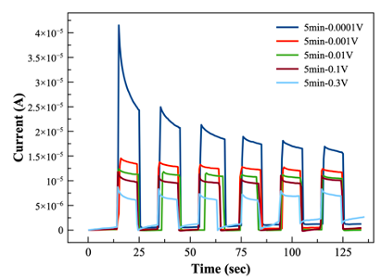
The controllable uniform growth of ZnO nanostructures is appealing for optoelectronic applications. For the first time, to our best knowledge, we have developed a strategy and a systematic process to obtain homogeneous brush-like ZnO nanorods growth of carbon-fiber bundle (CFB) by designing a method to align carbon fibers carefully to investigate its photocurrent properties. This approach allows high-content ZnO nanorods to grow uniformly over not only a few fibers, a fiber bundle using the electrodeposition process as an effective low-temperature synthesis method. The obtained ZnO-Carbon fiber composites can combine the strong optical response and photocatalytic activity with the high specific surface area and pore volume on carbon fibers, which could produce interesting photocurrent sensors. The deposition process was carried out at 70 °C temperature by using a GAmbry, and the deposition rates for each coating were chosen as 5, 10, and 20 min under -1.5 V deposition voltage. It can be concluded that different morphologies (corn-shaped and brush-shaped) can be obtained by adjusting electrodeposition time, which plays a significant role in the morphology of ZnO. The photoresponses of the nanorods under the illumination modulated at voltages ranging from 0.0001 to 0.3 V illustrate that the intensity of the photoresponse is dependent on the illumination time. It is observed that photoresponse intensity is reduced with increased voltage. It is also demonstrated that the brush-like ZnO on CFB is a promising light-absorbent with lightweight, small thickness, strong absorption, and broad bandwidth. By using various sizes of carbon fiber bundles and the duration of coating with different molarity, our approach can offer many opportunities to develop new types of composite materials that display enhanced photocurrent, photocatalytic, and many other behaviors.

Image
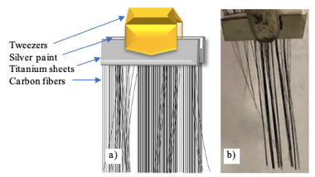
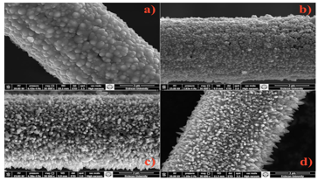
Figure: (Right-up) The representation of the samples for the experiments. (Left-up) SEM images of electrochemically grown ZnO nanorodes on CFB samples. (Below) Reversibility of ZnO nanorod-on-Carbon Fiber Bundles (CFBs) composite used for UV detector.

Recent Publications (minimum 5)
- M Gunes, et. al. (2017) A versatile system for Hall effect measurements at high temperature, MST 28, 105905.
- M Gunes, et. al. (2015) Effect of grain size and porosity on phonon scattering enhancement of Ca₃Co₄O9, J. of Alloy & Compd 626, 360.
- M Gunes , et. al. (2014) An instrument for the high temperature measurement of the Seebeck coefficient and electrical resistivity, MST 25 (5), 055901

Biography (150 word limit)
Murat Gunes is a physicist with a Ph.D. in Micro and Nanotechnology and is a researcher in the field of instrumentation, magnetic and thermoelectric materials. Before he has completed his Marie S. Curie Individual Fellowship in the University of Paris Sud in France, he was Assist. Prof. Dr. at EBYU. Dr. Gunes served as the Secretary of ExCom of the Marie Curie Alumni Association between 2018 and 2020. He co-founded an association helping Turkey's largest hospital with the transition to renewable energy by bringing together international companies and university experts. Dr. Gunes has started a spin-off and a startup in Turkey seeking a wider societal impact of research through novel technological devices. He was one of the Experts at the Warsaw Science Diplomacy School in 2020 and an invited speaker at the World Science Forum in 2019.

Email: mguness@gmail.com

Notes/Comments:

