Targeted Anticancer Drugs Nanohubs for Pulmonary Delivery
Mohd Basyaruddin Abdul Rahman, Universiti Putra Malaysia

Abstract (300 word limit)
Nanocolloidals and nanomaterials with unique effects and potency are increasingly being considered for application in lung pathologies especially lung cancer. Various anticancer drugs have been extensively investigated for its pharmacological effects on lung cancer. However, clinical applications of hydrophobic drugs are limited due to poor solubility and low stability in aqueous medium. Nanoemulsion provides several advantages for pulmonary application and need to be formulated using biocompatible excipients due to stability and toxicity concerns. Single and dual drugs nanoemulsion systems formulated using palm-based esters and further characterized physico-chemically and aerodynamically will be discussed. Development of nanohubs from graphene, iron oxides, mesoporous silica and reticular materials were also explored. Though, when the carrier is considered as a whole system, several requirements on its aerodynamic properties should be taken into account for effective pulmonary delivery. These preliminary screening on aerosolization performance of nebulized nanohubs can possibly correlates the deposition with in vivo studies and implies that the formulations can be deposited in deep lung region, where the tumors are normally found. A sustained release of drugs and their kinetics analysis suggested slow released of drugs to the targeted site at lower pH. Based on in vitro and ex vivo studies, it is interesting to relate on how the nano size may affect nanotoxicity of the cells. Inhalation therapy of lipid-based and solid nanocarriers has great potential in direct target towards the respiratory diseases.

Image
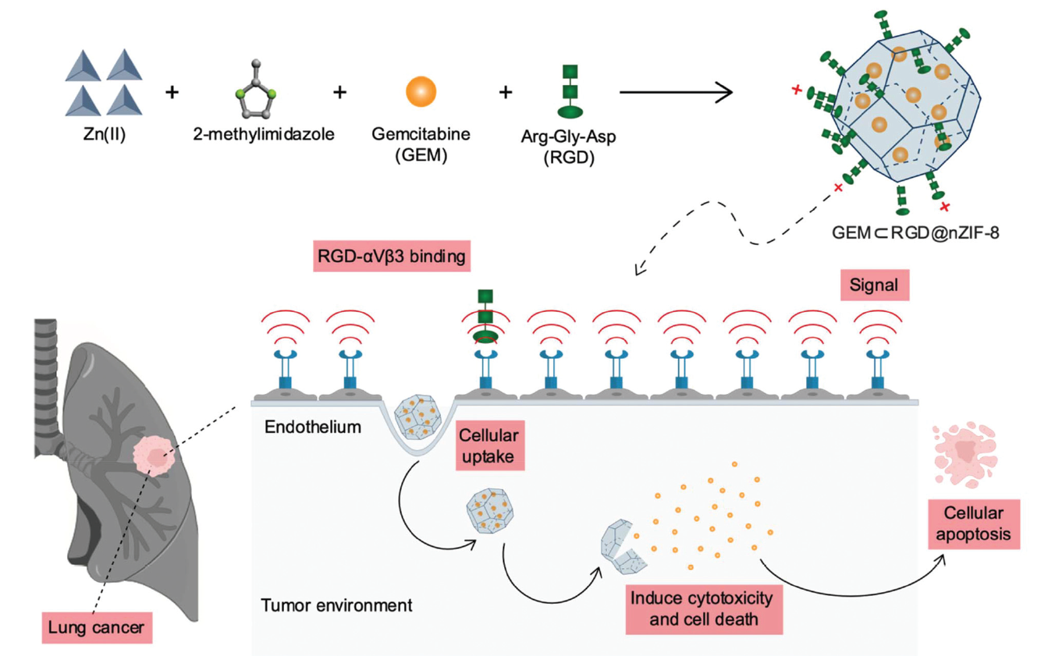
Recent Publications (minimum 5)
- Kamal NA et al (2021) Surface Peptide Functionalization of Zeolitic Imidazolate Framework-8 for Autonomous Homing and Enhanced Delivery of Chemotherapeutic Agent to Lung Tumor Cells, Dalton Transactions, 2021, in press. Cover page
- Isa ED et al (2021) Progress in mesoporous silica nanoparticles as drug delivery agents for cancer treatment. Pharmaceutics, 2021, 13, 152.
- Saimi NI et al (2021) Aerosolized Niosome Formulation containing Gemcitabine and Cisplatin for Lung Cancer Treatment: Optimization, Characterization and In-vitro Evaluation. Pharmaceutics, 2021, 13, 59.
- Lee XJ et al (2020) In-situ surface functionalization of superparamagnetic reduced graphene oxide–Fe₃O₄ nanocomposite via Ganoderma lucidum extract for targeted cancer therapy application. Applied Surface Science, 2020, 512, 145738.
- Asmawi AA et al (2019). Excipients selection and aerodynamic characterization of nebulized lipid based nanoemulsion loaded with docetaxel for lung cancer treatment. Drug Delivery and Translational Research, 2019, 9 (2), 543–554.

Biography (150 word limit)
Professor Dr. Mohd Basyaruddin Abdul Rahman is a Senior Professor of Chemistry at UPM and was appointed as a Distinguished Visiting Scholar at the University of California, Berkeley and Osaka University. He received his Ph.D in Catalysis Chemistry from the University of Southampton and post-doctoral in Structural Biology at the University of Edinburgh. He has secured more than RM25 million worth of research grants, published more than 200 cited papers and developed 20 patents. He has been received the Young Scientist award from various bodies including IUPAC, the American Chemical Society, and the InterAcademy Panel. He also won the National Intellectual Property Award 2009 and was named the most Outstanding Young Malaysian 2008 and Faces of Science@Malaysia. Currently, he is developing several translational researches on aerosolised nanoemulsion systems and reticular nanomaterials as nanohubs for delivery of drugs for cancer treatment and delivery of pesticides for sustainable agriculture.
Email: basya@upm.edu.my

Notes/Comments:

