Quantifying Coronal Tooth Discoloration Caused by Different Endodontic Materials
Shlomo Elbahary, DMD. Department of Endodontology, Maurice and Gabriela Goldschleger School of Dental Medicine, Tel Aviv University, Tel Aviv, Israel

Abstract (300 word limit)
Endodontic sealers, Bioceramic materials, gray and white mineral trioxide aggregate (GMTA, WMTA), have been shown to have high rates of success in various endodontic applications. A major drawback is their tendency to discolor teeth. Biodentine (BD), a recenlty developed bioceramic material, has been claimed not to discolor teeth. The aim of this studys was to compare tooth discoloration after applying different pulpotomy base materials (BD, GMTA and WMTA). Methods: ninety human fully developed permanent and primary incisors teeth were used in this study. Coronal access was achieved by a Tungsten Carbide drill, \and the pulp chambers were accessed and chemo-mechanically debrided. Each material was placed in the pulp chamber, up to the cervical sectioning level. All specimens were incubated at 37◦C and 100% humidity for 14 weeks and have been evaluated before the study and weekly. Color was assessed according to the CIE L*a*b* color space system. Results: The ∆E (delta E) of all experimental groups (GMTA, WMTA and BD) were significantly different from the control group at all time points. Color changes in the GMTA and WMTA groups showed significantly higher discoloration compared to BD group in the cervical part of the crown, since week 1. WMTA group showed significant discoloration in the cervical part as of week 1, and gradually increased over time. BD group showed no significant discoloration over time. GMTA group showed the most significant discoloration at week 1 and week 14 (P<0.05). Conclusions: both GMTA and WMTA pulpotomy materials may discolor tooth structure over time in an extracted primary anterior tooth model. When choosing bioceramic pulpotomy material, BD may be preferable, mainly in esthetic area.

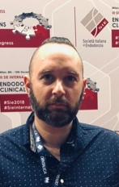
Image
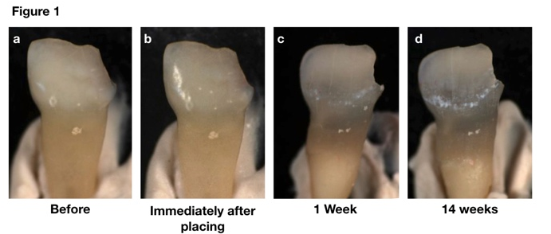

In the figure, central primary incisor, before treatment (a) and immediately after the medicament placement (b). Dark discoloration was noticed, mainly in the cervical part of the crown, after just 1 week (c), which appeared even more intense after 14 weeks (d).

Recent Publications (minimum 5)
- Elbahary S, Bercovich R, Flaisher-Salem N, Peretz B, Azem H. Quantifying Coronal Primary Tooth Discoloration Caused by Different pulpotomy Materials. Clin Pediatr Dent. 2020;44(3):142-147.
- Elbahary S, Bercovich R, Abboud Azzam N, Haj-yahya S, Shemesh H, Tsesis I, Rosen E. The Effect of Pulpotomy Base Material on Bacterial Penetration and Proliferation for Pulpotomized Primary Molar Teeth; a Confocal Laser Scanning Microscopy Study. Clin Pediatr Dent. 2020;44(2):84-89.
- Elbahary, S, Rosen, E., Haj-Yahya, S., Jammal, L., Shemesh, H., & Tsesis, I. (2020). The Invasion of Bacterial Biofilms into the Dentinal Tubules of Extracted Teeth Retrofilled with Fluorescently Labeled Retrograde Filling Materials. Applied Sciences, 10(19), 6996.‏
- Elbahary, S., Haj-yahya, S., Khawalid, M. et al. Effects of different irrigation protocols on dentin surfaces as revealed through quantitative 3D surface texture analysis. Sci Rep 10, 22073 (2020).
- Elbahary S, Zafrir G, Flaisher-salem N, Azem H, Shemesh H, Rosen E, Tsesis I. Influence of Irrigation Protocol on Peroxide Penetration into Dentinal Tubules Following Internal Bleaching: a Confocal Laser Scanning Microscopy Study. Clin Pediatr Dent. 2020
- Rosen E, Tsesis I, Elbahary S, Storzi N, Kolodkin-Gal I. Eradication of Enterococcus faecalis Biofilms on Human Dentin. Front Microbiol. 2016;7:2055. doi:10.3389/fmicb.2016.02055

Biography (150 word limit)
Shlomo Elbahary, is a dentist, endodontic specialist, his main research field is in microbiology, endodontic materials and histology studies using confocal laser microscopy. His main interest and work is in pediatric dentistry. Is always searching for new methods and materials in endodontic in general and specific in pediatric dentistry. Shlomo is a senior lecturer and instructor in Tel Aviv school of dentistry for undergraduate students and in the postgraduate endodontic department specialty program.
Email: shlomodent@gmail.com

