Landyne4, a software suite for electron diffraction simulation and crystallographic analysis
Xing-Zhong Li, PhD, University of Nebraska, Lincoln 68521, USA

Abstract (300 word limit)
Landyne4 is the recent version of the software suite for electron diffraction simulation and crystallographic analysis [1-5]. The software suite currently includes ten stand-alone computer programs. Each of them was designed for one topic of application in electron diffraction simulation, crystallographic analysis or experimental data processing and quantification. Figure 1 shows the example applications of three components in the Landyne suite. The computer programs have been grouped into a suite to increase the total usefulness and a launcher has been developed for the users to conveniently access all of the computer programs. The purpose of this software suite is twofold: i) as research tools to analyze experimental results, ii) as teaching tools to show students the principles of electron diffraction and crystallography. The software suite was programmed using Java SE Development Kit 8. It has been successfully tested on Microsoft Windows 7, 8 and 10 with a Java virtual machine, i.e. Java 2 Runtime Environment (J2RE). The executable codes, user manuals and a set of crystal structural data are available at
https://www.unl.edu/ncmn-enif/xzli/computer-programs
The design and functions of the computer programs will be elucidated in this presentation. Three examples are listed here: SPICA [1] is for the calculation of stereograms and related applications; SAED3 [2] is used for simulation and analysis of electron diffraction patterns including twins and two phases with a fixed orientation and the search for the zone axes of experimental patterns; SVAT4 [4] is for crystal structure visualization and analysis. The application of the Landyne suite in our recent research works will be also discussed [1, 2, 4].

Image

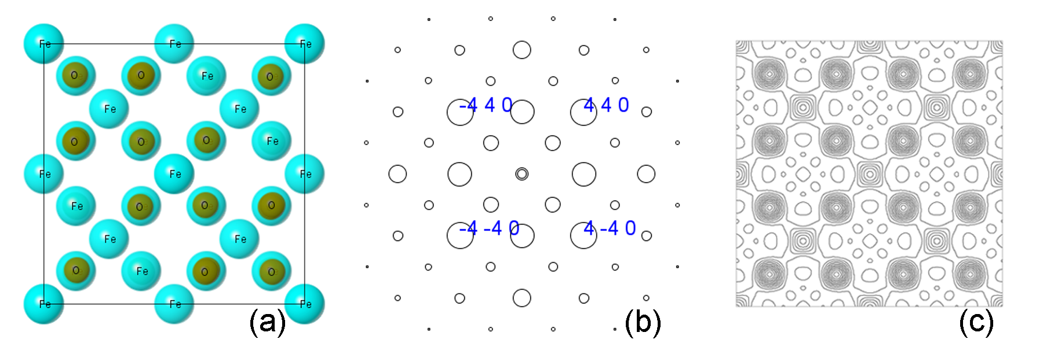

Figure 1: (a) A [001] projection of the Fe₃O₄ structure by using SVAT4, (b) simulation of selected-area electron diffraction by using SAED4 software and (c) projected atom potential map by using PAPM software.

Recent Publications
- Li, XZ (2016) SPICA - Stereographic Projection for Interactive Crystallographic Analysis. Journal of Applied Crystallography 49:1818-1826.
- Li, XZ (2019) SAED3: simulation and analysis of electron diffraction patterns. Microscopy and Analysis May:16-19.
- Li, XZ (2019) TEMUC3, a computer program for unit-cell determination of crystalline phases in TEM experiments. Micron 117:1-7.
- Li, XZ (2020) SVAT4- a computer program for crystal structure visualization and analysis. Journal of Applied Crystallography
53: 848-853.
5. Li, XZ (2020) On precise determination of crystal orientation with Kikuchi pattern. Journal of Materials Education 42: in press.

Biography
Xing-Zhong Li works at University of Nebraska. He manages an electron microscopy facility and joins in a research group focusing on the development of novel magnetic materials. He obtained his PhD degree in materials physics in 1993 and has interest in software development since 1999, especially on electron diffraction analysis and crystallography.
Email: xzli@unl.edu

Notes/Comments:

