Abstract Template

Title: On-site Gas Sensing by Surface-Enhanced Raman Scattering

Zhengjun Zhang¹, Lingwei Ma¹
¹School of Materials Science and Engineering, Tsinghua University, Beijing 100084, China

Keywords: Sensing, Gas, SERS, Ag nanorods

- Abstract Body (up to 250 words)
Ag nanorods coated with an ultrathin HfO₂ shell (AgNRs@HfO₂) were prepared for the synthesis of a versatile, robust, and easily recyclable surface-enhanced Raman scattering (SERS) substrate. This substrate maximizes the high melting point of HfO₂ shell and thus ensures the plasmonic efficiency of AgNRs. Therefore, it possesses extraordinary thermal stability and SERS activity, which could act as a reusable and cost-effective SERS detector. After SERS detection, the regeneration of AgNRs@HfO₂ was achieved by annealing the substrate within several seconds. This procedure led to the thermal release of adsorbed molecules and resulted in a refreshed substrate for subsequent measurements. The composite substrate maintained its SERS efficiency well during multiple “detection−heating” cycles, exhibiting good stability and recyclability. Furthermore, in addition to revealing the feasibility of SERS sensing in liquids, AgNRs@HfO₂ also provided continuous real-time monitoring of gas targets at ultralow concentrations. This work provides a robust and renewable SERS sensor with advantages of high sensitivity, stability, cost effectiveness, and easy operation, which can be implemented for both aqueous and gaseous analyte detection and is thus an intriguing candidate for practical applications in environmental, industrial, and homeland security sensing fields.

- Image:

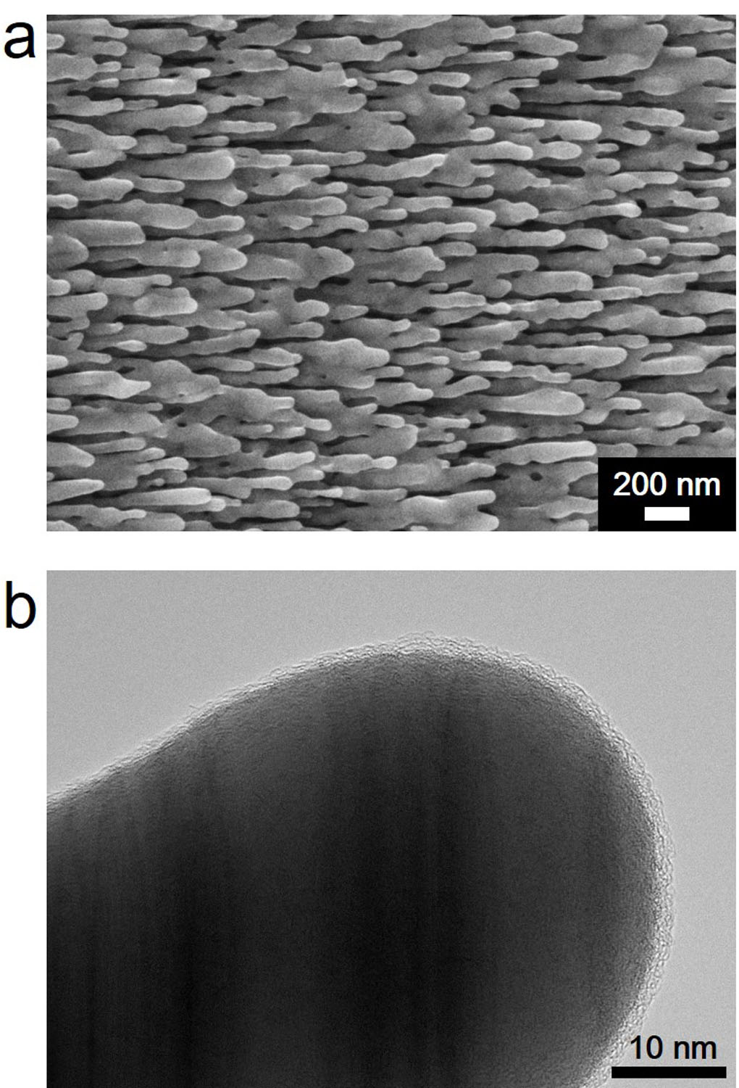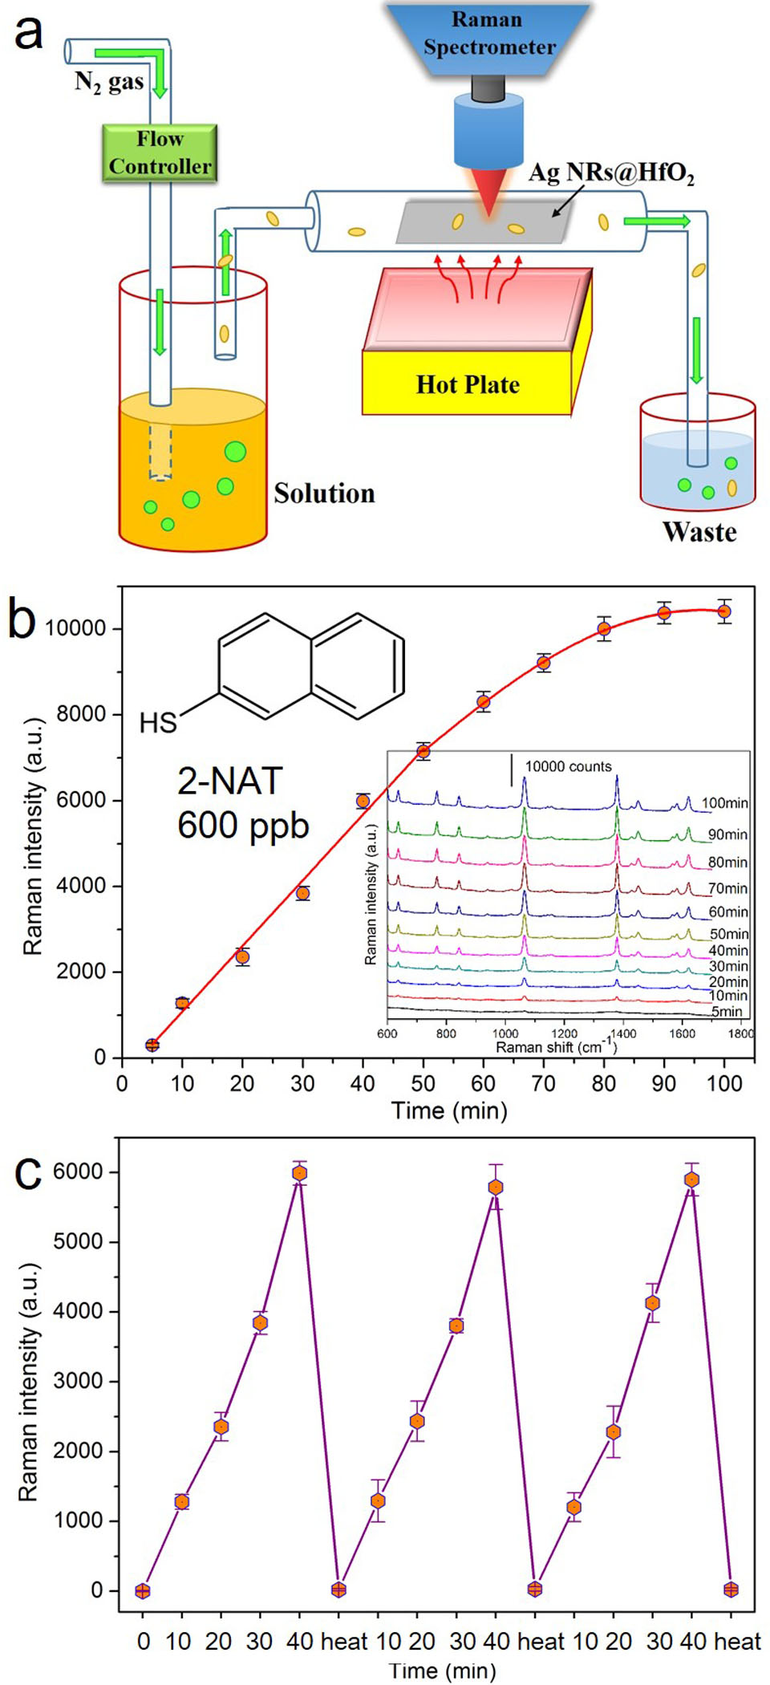

- Reference:
- Liz-Marzán, L. M. Langmuir 22, 32-41 (2006); doi: 10.1021/la0513353
- Ma L, Huang Y, Hou M, Xie Z, Zhang Z. Scientific Reports 5,12890 (2015); doi: 10.1038/srep12890

- Biography:
Zhengjun Zhang has completed his PhD in 1995 from Tsinghua University and Postdoctoral Studies from Rensselaer Polytechnic Institute, USA. He is now a full professor at School of Materials Science and Engineering, Tsinghua University. He has published more than 200 papers in reputed journals.

Presenting author details

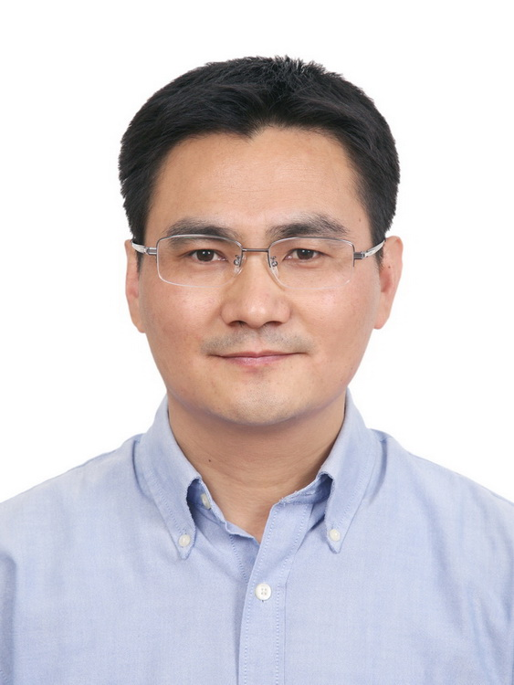
Full Name: Zhang Zhengjun
Contact number:+86 13911041311
Twitter account:
Linked In account:
Session name/ number: Advanced Optical Materials
Category: Oral presentation
Passport Number: PE1208572

