Application of Encapsulated Zero-Valent Iron on the Treatment of Cr(VI) in the Presence of Different Contaminants
Jong-Soo Choiª, Lakshmi Prasanna Lingamdinneª, Koduru Janardhan Reddyª, Yul-Lim Choiª, Su-Hyun Leeª, Jae-Kyu Yangª, Yoon-Young Chang^{a,*}
a Department of Environmental Engineering, Kwangwoon University, Seoul, Korea

Abstract (300 word limit)
The increasing contamination of urban and industrial wastewaters by toxic metal ions is a worrying environmental problem. Among them, Chromium (Cr) is a kind of redox-sensitive pollutants. Especially, hexavalent chromium (Cr(VI)) is known as carcinogen,¹ which is relatively toxic compared to trivalent chromium(Cr(III)).² Nano zero-valent iron (nZVI) has been proven to be an effective material for the reductive precipitation of Cr(VI).³ Inside the reactive barriers, both Fe⁰ and the Fe²⁺ can be released from aerobic corrosion of Fe⁰ as well as redox reaction between Fe⁰ and Cr(VI). The reduced chromium (Cr(III)) can be precipitated as Cr(OH)₃ or chromium-iron oxides / hydroxides / oxyhydroxides on the Fe⁰ surface.^{4,5} But, nZVI is easy to corrode by environmental impact due to its rapid reactivity. Considering this property, modification of nZVI is strongly needed. One of the modification methods is encapsulation of nZVI with polymeric material. The microcapsule containing nZVI can exhibit sustained releasing characteristics to enhance the stability and persistence of nZVI. Encapsulation is expected to ensure better contacts between contaminants and encapsulated nanoparticles. In addition successful encapsulation of nZVI is expected to lead to the development of more effective and robust environmental remediation techniques involving co-encapsulation of nanoparticles. The objective of this study is to examine the effectiveness of the encapsulated iron nanoparticles (@nZVI) for the treatment of wastewater contaminated with chromate. Furthermore, when the Cr(VI) is present together with various ions in the water, the reaction characteristics of the nZVI are also investigated. The @nZVI before and after reaction with chromium is characterized using X-ray photoelectron Spectroscopy (XPS), X-ray diffraction (XRD), Fourier transformer infrared spectroscopy (FT-IR) and Scanning Electron Microscope (SEM). Batch experiments are performed to investigate the effects of pH, Cr(VI) concentration, contact time and co-presented inorganic species on the removal kinetic and removal efficiency of Cr(VI) by @nZVI.

Image
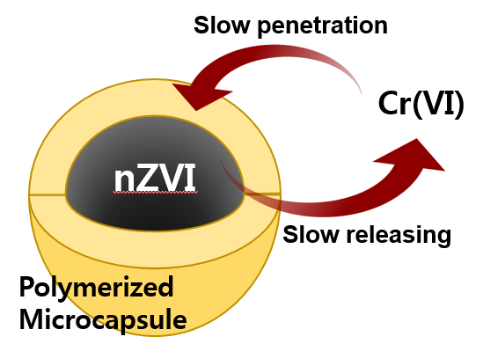
Figure 1. Mechanism for the treatment of Cr(VI) by encapsulated nano zero-valent iron

Acknowledgement
This work was supported by the National Research Foundation (NRF) of Korea, funded by the Ministry of Education (2018R1D1A1B07043096) of the Korean Government. It was also partially supported by Kwangwoon University, Seoul, Korea through a Research Grant in 2019
Recent Publications
- Kobya, M. (2004). Removal of Cr (VI) from aqueous solutions by adsorption onto hazelnut shell activated carbon: kinetic and equilibrium studies. Bioresource technology, 91(3), 317-321.
- Gikas, P., & Romanos, P. (2006). Effects of tri-valent (Cr (III)) and hexa-valent (Cr (VI)) chromium on the growth of activated sludge. Journal of hazardous materials, 133(1-3), 212-217.
- Lo, I. M. C.; Lam, C. S. C.; Lai, K. C. K. (2005) Competitive effects of TCE on Cr(VI) removal by zero-valent iron. J. Environ. Eng., 13 (11), 1598–1606.
- Lee, T. Y.; Lim, H. J.; Lee, Y. H.; Park, J. W. (2003) Use of waste iron metal for removal of Cr(VI) from water. Chemosphere, 53, 479–485.
- Karvonen, A. J. (2004) Cation effects on chromium removal in permeable reactive walls. Environ. Eng., 130 (8), 863–866.

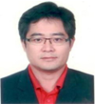
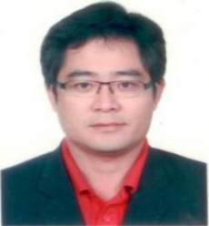
Biography (150 word limit)
Prof. Yoon-Young Chang is a Professor at Kwangwoon University, Seoul, Korea. His major is Environmental engineering, especially, physicochemical treatment of water and soil containing toxic heavy metals and organic pollutants. He has also made significant contribution in the development of an advanced technologies and reactive materials for surface and ground water remediation along with soil remediation. He has more than 150 publications in peer-reviewed international journals and more than 200 reports in international and national conferences.
Prof. Yoon-Young Chang is a Professor at Kwangwoon University, Seoul, Korea. His major is Environmental engineering, especially, physicochemical treatment of water and soil containing toxic heavy metals and organic pollutants. He has also made significant contribution in the development of an advanced technologies and reactive materials for surface and ground water remediation along with soil remediation. He has more than 150 publications in peer-reviewed international journals and more than 200 reports in international and national conferences.
Email: yychang@kw.ac.kr

Notes/Comments:

