Microwave irradiation: In-situ conversion of nanoflakes to nanoflowers of ZnCo₂O₄ on Ni foam for enhanced electro-catalytic activity
T.V.M. Sreekanth and Ki Soo Yoo
School of Mechanical and IT Engineering,
College of Mechanical Engineering, Yeungnam University,
Gyeongsan 38541, South Korea

Abstract

Spinel structure metal oxides provides the effective performance towards the electro-catalytic analysis. Among the spinel structure metal oxides, ZnCo₂O₄ has effective in the area of photocatalyst, gas sensor, li-ion batteries, supercapacitors and electro-oxidation. The performance of direct methanol fuel cells hinges on the activity of the catalyst. To enhance the electro-catalytic activity, a flower-like nanostructure of ZnCo₀O₄ assembled on nickel foam (NF) via microwave irradiation process, the whole process was finished within 15 min. The ZnCo₂O₄ nanoflower is successfully applied in the electro-catalytic oxidation of methanol and its electro-catalytic performance is investigated by cyclic voltammetry, chronoamperometry and electrochemical impedance spectroscopy, which exhibits excellent electro-catalytic activities towards methanol electro-oxidation in alkaline medium, including low onset potential (0.45 V), high current densities (222.3 mA cm-2) at 0.70 V (vs. SCE), and desirable electro-oxidation stability (91%) after 500 cycles in the presence of 1.0 M KOH mixed with 0.5 M methanol. The electrochemical oxidation of MeOH was also observed at higher concentration of MeOH up-to 4.0 M (0.5, 1.0, 2.0, 3.0 and 4.0 moles). The high electrochemical performance is mainly attributed to faster ion/electron transfer and an enhanced electrochemical kinetics. The present simple, and cost-effective synthesis approach can open new era for large-scale applications of the novel materials for different electrochemical applications.
Image
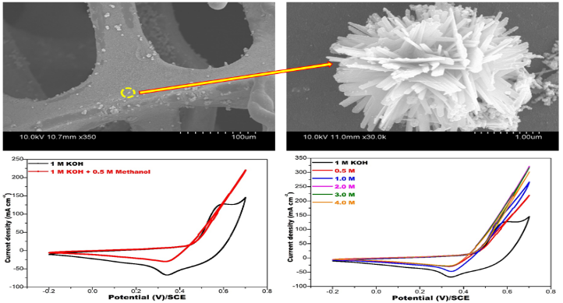
Recent Publications
1. Nagajyothi, PC. (2018) One-step engineered self-assembly Co3O4 nanoparticles to nanocubes for supercapacitors, Materials Research Express, 5: 02551.
2. Sreekanth, TVM (2017) Determination of Band Alignment in the Synergistic Catalyst of Electronic Structure-Modified Graphitic Carbon Nitride-Integrated Ceria Quantum-Dot Heterojunctions for Rapid Degradation of Organic Pollutants, The journal of Physical Chemistry C, 121: 25229-25242.
3. Dillip GR, (2017) Tailoring the bandgap of N-rich graphitic carbon nitride for enhanced photocatalytic activity, Ceramics International, 43: 6437-6445.
4. Sreekanth TVM, (2018) Determination of surface properties and Gutmann’s Lewis acidity–basicity parameters of thiourea and melamine polymerized graphitic carbon nitride sheets by inverse gas chromatography, Journal of Chromatography A, 1580: 134-141

Acknowledgement
This research was supported by the National Research Foundation of Korea (NRF-2017R1D1A1B03035957).



Biography
Dr. Sreekanth received his PhD in Chemistry from S.V. University, India, in 2009, under the supervision of Prof. K.S. Reddy. Afterthat, he joined as an Assistant Professor in the Department of Chemistry, Dongguk University, Gyeongju, South Korea, Later, he moved to College of Mechanical Engineering, Yeungnam University, South Korea. His research interests include metal / metal oxide nanoparticles for Catalytic applications. His recent research activities focus on electrochemical energy storage. Email: tvmsreekanth@yu.ac.kr Contact no: +82-10- 3493-0705
Notes/Comments: N/A

