Synthesis, Characterization and Magnetic Properties Studies on

NdCr_{1-x}Fe_{x}O₃ Perovskite Ceramic Compounds
Jada Shanker Department of Physics, Osmania University, Hyderabad, Telangana, India

Abstract (300 word limit)
The polycrystalline perovskite ceramic compounds NdCr_{1-x}Fe_{x}O₃ (x=0, 0.3, 0.5, 0.7, 1) were prepared by Sol-gel auto-combustion method and characterized by XRD and SEM. The preliminary structural analyses of the compound were analysed by X-ray diffraction technique, and it confirms single phase orthorhombic structure. A systematic investigation of temperature and field dependent magnetic measurements was performed on 900⁰C sintered pellets in the temperature range 1K to 400K at 100Oe, field ranges from -50kOe to 50kOe at 100K, 200K and 300K temperatures. The zero-field-cooled (ZFC) and field-cooled (FC) magnetization curves merge at a temperature well above the Neel’s one. This suggests the occurrence of short-range magnetic order, which is induced by frustration effects. The frustration in this case results from the structural disorder due to the random distribution of the magnetic ions in the octahedral sites of the lattice. The detailed investigation of magnetic measurements of NdCr_{1-x}Fe_{x}O₃ (x=0, 0.3, 0.5, 0.7, 1) perovskite ceramic compounds were discussed.

Image
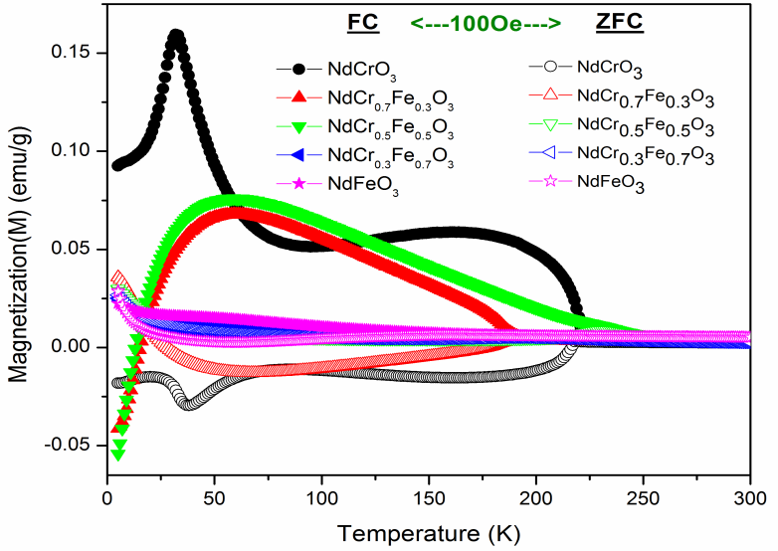Fig. Magnetization vs Temperature NdCr1-xFexO3(x=0, 0.3, 0.5, 0.7, 1) sintered pellet at 900⁰C

Recent Publications (minimum 5)
- Sujoy Saha, Sadhan Chanda, Alo Dutta, T.P.Sinha, J Sol-Gel Sci Technol (2014) 69:553–563.
- Yi Du, Zhenxiang Cheng, Xiaolin Wang, S X. Dou, Structure, magnetic, and thermal properties of Nd1-xLaxCrO3 (0≤x≤1), J. Appl. Phys. 108 (2010) 093914.
- Shuijin Lei,Lei Liu,a Chunying Wang, Chuanning Wang, Donghai Guo,Suyuan Zeng, Baochang Cheng,Yanhe Xiao and Lang Zhou.
- Jada Shanker, M. Buchi Suresh, P. Saravanan, D. Suresh Babu, Journal of Magnetism and Magnetic Materials, Journal of Magnetism and Magnetic Materials 477 (2019) 167–181.
- Jada Shanker, B. Vittal Prasad, M. Buchi Suresh, R. Vijaya Kumar, D. Suresh Babu, Electrical properties of NdCr1-xFexO3 perovskite ceramic nanoparticles—An impedance spectroscopy studies, Mater. Res. Bull. 94 (2017) 385–398.
- Jada Shanker, B. Vittal Prasad, K. Venkataramana, R. Vijaya Kumar, D. Suresh, Babu, Influence of Fe substitution on structural and electrical properties of Gd orthochromite ceramics, J. Alloy. Compd. 732 (2018) 314–327.

Biography (150 word limit)
Jada Shanker has well known in the field of magnetic and electric properties of perovskite ceramic nanoperticles. He published 10 international research articles, Also he has collaborated with more than 6 (six) collaborators from national and international research laboratories. He is a life member in various bodies like. Indian Scince Congress, Magnetic Society of India, Matrial Research Society of India.

Email: jadashanker.phd@gmail.com

Notes/Comments:

