Ultraviolet Laser Lithography of Ceramic Micro Lattices for Electromagnetic Wave Modulations
Soshu Kirihara, Osaka University, japan

Abstract
Dielectric ceramic components were fabricated by ultraviolet laser lithography. 2D cross sections were created through dewaxing and sintering by UV laser drawing on spread resin paste including ceramic nanoparticles, and 3D composite models were sterically printed by layer laminations. As the row material of the lithography, ceramic nanoparticles from 500 nm in average diameters were dispersed in to liquid resins from 50 % in volume fraction. The resin paste was spread on a glass substrate at 50 μm in layer thickness by a mechanically moved knife edge. An ultraviolet laser beam of 355 nm in wavelength was adjusted at 10 μm in spot diameter and scanned on the pasted resin surface. Irradiation power was changed from 600 to 700 mW for enough solidification depth for 2D layer bonding. Scanning speed was changed from 50 to 100 mm/s to create fine lattice structures as shown in Figs. 1 (a), (b) and (c). The half wavelength of the incident ultraviolet ray should be comparable with the nanoparticles gaps in the resin paste, therefore the dewaxing and sintering will be realized through the electromagnetic waves resonations and localizations as shown in Fig. 1 (c). Through the layer lamination, the 3D titania structures with 97% in volume fraction were successfully fabricated. The titania crystal structure was analyzed as dual phase of anatase and rutile. After the reheating treatment at 1350 °C for 2 hs, titania components with rutile phase was obtained. The linear shrinkage through the sintering was < 1 %. The diamond lattice with four coordination number of 270 μm in periodicity could diffract electromagnetic waves of 0.25 to 0.45 THz, and exhibit forbidden gaps in transmission spectra for all spatial directions. The dielectric lattice especially is called photonic crystal.

Image
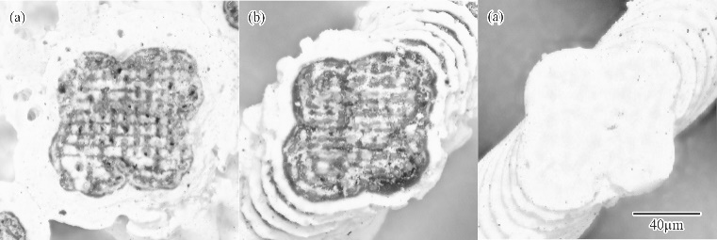

Recent Publications
1: S. Kirihara, Stereolithographic Additive Manufacturing of Ceramic Components with Micropatterns for Electromagnetic Wave Control, Ceramics in Modern Technologies, 1[2] (2019) 84-90.
2: S. Kirihara, Ultraviolet Laser Lithography of Titania Photonic Crystals for Terahertz-Wave Modulation, Materials, 11 (2018) 835-845.
3: K. Nonaka, S. Kirihara, Three Dimensional Smart Processing by Ultra Violet Laser Lithography of Ceramic Additive Manufacturing, Journal of Materials Science Forum, 941 (2018) 2196-2199.
4: S. Kirihara, Stereolithographic Additive Manufacturing of Ceramic Components by Using Nanoparticle Paste Feeding, Materials Science Forum, 879 (2016) 2485-2488.
5: S. Kirihara, Additive Manufacturing of Micro Functional Structures through Diameter Variable Laser Stereolithography and Precursor Sintering Heat Treatments, Ceramic Transactions, 258 (2016) 3-10.


Biography
Soshu Kirihara is a doctor of engineering and a professor of Joining and Welding Research Institute (JWRI), Osaka University, Japan. In his main investigation “Materials Tectonics” for environmental improvements of “Geotechnology”, multi-dimensional structures were successfully fabricated to modulate energy and materials flows effectively. Ceramic and metal components were fabricated directly by smart additive manufacturing, design and evaluation (Smart MADE) using high power ultraviolet laser lithography. Original stereolithography systems were developed, and new start-up company “SK-Fine” was established through academic-industrial collaboration.
Email: kirihara@jwri.osaka-u.ac.jp

Notes/Comments:

