Modification of Nanomaterial Surface through Functionalization
Sharda Sundaram Sanjay
Department of Chemistry, Ewing Christian College, Allahabad, India
(An Autonomous Constituent PG College of University of Allahabad)

Abstract (300 word limit)
Modification of nanomaterial surface through functionalization has created a great revolution in the field of nanotechnology specially in the field of pharmaceutical and biomedical sciences. The clinical results have suggested that functionalization of nanoparticles with specific chemical species yielded multifunctional nanoparticles with enhanced efficacy. Precisely engineered, functionalized nanoparticles are finding use as optical materials, components of sensors, catalyst precursors and a host for other applications. Functionalization of host molecules with inorganic/organic functional groups is a useful strategy in the preparation of advanced materials combining the optoelectronic and surface properties of the substrate with the molecular selectivity of the covering groups. Conjugation of these specific chemical functional groups create specific surface sites on nanoparticles with selective molecular attachment to perform specific functions viz. functionalization of gold nanoparticles with amino acids such as lysine, polylysine and glycine etc. bind DNA with higher efficiency for gene delivery without toxicity. Surface-functionalization firstly, links the nanoparticles with various organic and inorganic moieties, secondly, improves the solubility of nanoparticles so that they may be used as carriers for hydrophobic species and thirdly, they can be used for the homogeneous distribution in organic matrix. The surface functionalization can be done by any of the process, either (i) by post-functionalization , in which functionalization is generally done on the already formed inorganic nanoparticles or (ii) by in- situ functionalization, in which functionalization is done during synthesis. The functional groups generally used for tailoring surface functionality are hydroxy-, thio-, amino-, nitro-, carboxy-, or primary alkyl groups etc. The operating forces works for functionalization are mainly hydrophobic, hydrophilic, ionic, nonionic ,van der waal’s or hydrogen bond interactions.

Image
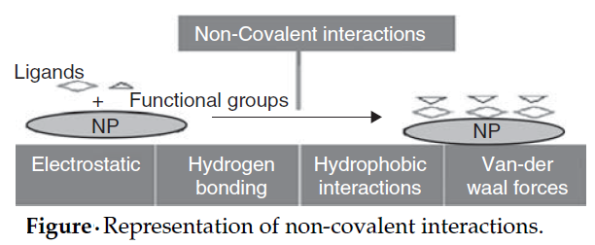
Recent Publications (minimum 5)
- Structural and Ionic transport study of naturally plasticized nanopolymer electrolyte for device application ; Innoriginal International Journal of Sciences 2020; VOl. 7 (2) ,pp.1-3, ISSN 2349-7041
- Study of Protonic Conduction in Aloe-Vera Pulp Based Green Electrolyte System, Elixir Appl. Chem.109 (2017) 48011-48014 ;ISSN:2229-712X
- Development of mica-based porous polymeric membrane and their application, Ionics DOI 10.1007/s11581-016-1808-9 , Ionics 23 (1), 113-120; ISSN: 0947-7047 (Print) 1862-0760 (Online)
- Study of Aloe Vera as a Natural Plasticizer in PEO based Polymeric Electrolyte, European Journal of Advances in Engineering and Tec\hnology, 2016, 3(1): 21-25, ISSN: 2394 - 658X
- Aqueous Chemistry of Some Bio-Metal (II) Complexes with Nicotinic Acid and Adenine, International Journal of Trend in Research and Development, Volume 3(4),pp.124-128, 2016, ISSN: 2394-9333

 Biography (150 word limit)
Dr. Sharda Sundaram Sanjay is working in capacity of Associate Professor in the department of Chemistry, Ewing Cristian College, ((An Autonomous Constituent PG College of University of Allahabad), Allahabad, India. Her research field is the studies of metal complexes and nanomaterials. She has published around 31 research papers in various national & international journals and around 9 book chapters and a book on nanotechnology. She has completed a major research project funded by University Grants Commission. She has delivered invited talks in many seminars, conferences and workshops and presented papers in more than 50 conferences. She has explored green chemistry and nanotechnology for the synthesis and application of nanoparticles especially in plants for enhancing the activity of enzymes that are responsible for driving many metabolic reactions in all crops. Secondly to bring attention to appropriate experimental designing of nanoparticles, this could provide a defensible scientific understanding of the biological effects of nanoparticles.

Email: sharda100@rediffmail.com,

Notes/Comments:

