EXPERIMENTAL DETERMINATION OF DENSITY, ROOT MEAN SQUARE AND MOLECULAR VELOCITY OF AN ATOM
Author: SALAKO N. OLATUNJI, MEDICINAL, PHYSICAL AND ANALYTICAL RESEARCH CHEMIST, Affiliation: FEDERAL INSTITUTE OF INDUSTRIAL RESEARCH OSHODI

Abstract: Each substance that crystallizes does so according to a particular geometric arrangement. The simple repeating unit in this arrangement is called unit cell. Atoms on the corner, edges, and faces of a unit cell are shared by more than one unit cell. An atom on an edge is shared by four unit cells and an atom on a corner is shared by eight unit cells. Thus, only a corner can be assigned to each of the unit cells that share these atoms. Let consider Calcium atom. Calcium is one of the metals that crystallized in a cubic closest – packed structure. When you consider that Calcium atom has a mass of 6.655264 × 10⁻²ᶟg and atomic radius of only 1.97 ×10⁻¹°m, it is remarkable achievement to be describe the structure of this metal. The obvious question is: How do we know that a Calcium pack is in a cubic closest – packed structure?
This could be known by studying the structure of the these atoms under a scale that is based on electromagnetic radiation such as X-ray, Magneto hydrodynamics(MHD),IR Spectrophotometer and others Analytical tools.
The length of a unit cell of an atom is equivalent to the 2.824 times the radius of an atom, a =2.8284rₐ, where a is the length of the unit cell, r_{a} is the atomic radius. Therefore, the Volume of the Unit Cell of an Atom Can be calculated as:
Volume of the Unit Cell of an Atom, V = a³.
Mass of a single unit cell calcium = 6.655264 X 10⁻²ᶟ g/atoms
Therefore, the equation that connects the volume of a unit cell of an atom and the radius of an atom will be;
V = (2.8284rₐ)ᶟ
V = 22.6268rᶟₐ
Approximately, V = 23rₐᶟ
The density of calcium, if crystallized in a simple cubic structure would therefore be 0.385g/cmᶟ ton three (3) significant figure.
Simple Cubic Structure(scs)
Density = Mass/Volume = 6.655264 x 10⁻²ᶟg
1.729949 x 10⁻²²cmᶟ

Therefore the density of simple cubic structure of calcium = 0.385g/cmᶟ
Body -Centered Cubic Structure(bcc).
To estimate the density of calcium for the Body – centered cubic structure. It was know that the number of the unit cell atom in the Body – Centered Cubic Structure is 2.
Therefore, Density ℓ = 2 x density of the simple cubic structure
ℓb =2ℓs
ℓb =2(mass of a single cell unit)/(volume of a unit cell)
ℓb of calcium = 2 × 0.385g/cmᶟ = 0.77g/cmᶟ
In other way, when ask to look for the density of a particular atom that is Body – Centered Closed Packed, it advisable to go for this formula;

Therefore, the density of the body – centered cubic for calcium is 0.77g/cmᶟ
Faced – Centered Cubic (fcc)
There would be four atom per unit cell in a faced – centered cubic structure and the density of calcium in this structure would be four times as large, I.e. it will be four times the density of the simple cubic structure.
Density ℓf = 4 x density of the simple cubic structure
ℓf = 4 × 0.385g/cmᶟ
ℓf of calcium = 1.54g/cmᶟ
When ask to look for the density of a particular atom that is faced – Centered Closed Packed, it advisable to go for this formula;

ROOT MEAN SOUARE VELOCITY AND MOLECULAR VELOCITY
Let now look for root mean square and molecular formula velocity for all chemical element.
Our study case is of calcium metal atoms. The pressure exerted on each atom p could be
p = conc. in mole/dm³ X mass X speed
3
The pressure P =$Nϱς$
3
C⁻² = 1.9773 × 10² (m/s) ²→Root mean square velocity of calcium
c⁻ = 1.406 × 10 m/s = 14.06m/s →molecular velocity of calcium.
This ROOT MEAN SQUARE VELOCITY AND MOLECUAR VELOCITY IS BEEN DETERMINE FOR ALL (118) CHEMICAL ELEMENTS. More than twenty (20) Intensive AND Extensive properties have been made in the below table.
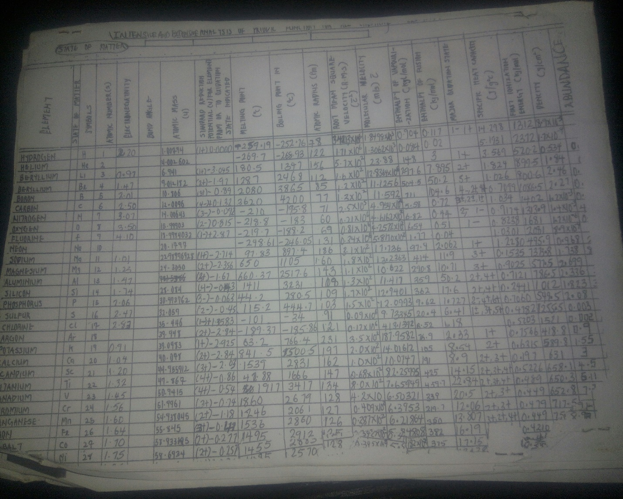
PUBLICATIONS:
- Chemical journal on the 10 most Dangerous Chemical. (2015)
- Research work on Density and its Structure. (2015)
- Chemical Journal on Antidote of Agent of Orange. (2016)
- Detoxification of Sodium Cyanide. Air as a “Ligands Molecules” not as” Mixture”. Solar chemical compound (alternative source of sun). (2016)
- Experimental determination of Root Mean Square Velocity and Molecular velocity of all chemical elements, (2017)
- Production and synthetic of SodaSulphanecobalamin ( an antidote of Chemical weapon) (2017)
BIOGRAPHY: expertise in quantum physics, also on determination of numerical value of dimension on physical quantities. Root mean square velocity and molecule velocity of all chemical elements which is never done before. stoichiometry and periodic properties table that shows the” INTRINSIVE AND EXTRINSIVE PROPERTIES” of all chemical elements. Determination of Molecular Mass and Formula for Air. Computational Mathematics and Application of Small organic Molecules. Antidote of chemical mass weapon (2, 3, 7, 8 - Tetrachlorobenzo-p-dioxin). Critical cGMP and ICH regulations for Pharmaceutical Laboratory. Pollution or environmental remediation studies, anthropogenic effect on petroleum. Synthetic of compound for biological evaluation. Synthetic of helium compound, which is another source of sun. Research on Oil Dispersant. Production of antidote of chemical and biological agent Poisoning.

