TITLE: RESEARCH ON ANTIDOTE OF CHEMICAL WEAPONS KNOWN AS SODASULPHANECOBLAMIN.

Author: SALAKO N. OLATUNJI, MEDICINAL, PHYSICAL AND ANALYTICAL RESEARCH CHEMIST, Affiliation: FEDERAL INSTITUTE OF INDUSTRIAL RESEARCH OSHODI

Abstract: SodaSulphanecobalamin (Na₄S₅ CoC₆₉N₁₅H₈₉O₂₆) is an antidote for Chemical weapons, which detoxify and decentralized the toxic substances in any chemical based threat mainly, classical chemical agent threat categories include vesicant or blister agents (e.g., sulfur mustard), blood agents (e.g., cyanide), respiratory agents (e.g., phosgene), and nerve agents (e.g., GA or Tabun, GB or Sarin, GD or Soman, and VX) as well as lung damaging agents (Chlorine, diphosgene). It dissociate the toxic components in each chemical weapons, either nerves agent, blister agent or mustard gas to a nontoxic substance when administered and doesn't have any adverse effects unlike Atropine (which has little effect on nicotinic effect, such as muscle twitching, flaccidity) and other antidotes been tested for neutralizing or countermeasures for a particular chemical based threat. It displaces the Cyanides to a free toxic compound, thiocyanocobalamin .It removes the burns when the sulfur mustard is been contacted through skin, and eye The antidote (SodaSulphanecobalamin) which is sulfur drug group (H-S) bends the mustard makes the anditodal removes mustard from the body, of which can be used as treatment for Organic Arsenical. It also added the amide group of protein when used. However, recent studies shows that this antidote can serve as a replacement for the antidote of Orange agent (2, 3, 4, 7-tetra chlorobenzodioxin) which displaced millions of Vietnam Citizens during the World War II and displaces chlorobenzo to sodium benzoate and saline. Though Mercury (I) Oxalate is been used for this antidote for the orange agent, but we all know that Mercury is highly toxic and poisonous to the human .Nerve agents developed in the 1930s and 1940s were stockpiled during the Cold War. More recently, nerve agents have been used in the Iran–Iraq War in the 1980s, the Japanese terrorist attacks by the Aum Shinrikyo cult in 1995 and attacks in Syria in 2017.
Recently, the Salisbury Nerve attack on March 4th 2018,when SodaSulphanecobalamin is been used for nerves agent antidotal , it dissociates organophosphate to phosphoric acid which helps in metabolism of the body.
(Na₄S₅ CoC₆₉N₁₅H₈₉O₂₆) is produce by dissolution of hydroxocobalamin with the decomposition of Sodium nitrite and Sodium thiosulfate, then treated with the acidified Sodium bicarbonate, which led to a faster return to baseline mean arterial pressure compared with sodium nitrite with sodium thiosulfate; however, there was no difference between the antidote combinations in mortality, serum acidosis, or serum lactate (TERTSodium1,2-diithiosulphite-3,4diiintroso Co-α(α-5,6diimethlybenzylmizazonly)co-β-hydroxocobalamin)
NO + HOcbl +2NaoH + NO₂ +3Na₂SO₄ + Na₂S₅ 2Na₂S₂O₃ + 2NaNO₂ + 4NaOH +HOSCb1 +SO_{2 (g)} ------------------------- Na₄ (S₂O₃)₂ (NO₂)₂ C₆₂H₈₇SC_{O}N₁₃O₁₆P
This Research helps to develop the concepts, therapeutic regimens and procedures for the management of chemical warfare agent casualties; developing diagnostic and prognostic indicators for chemical warfare agent casualties; and developing life-support equipment for definitive care of chemical warfare agent casualties.
The most efficient and reliable way to treat chemical weapons is by using SodaSulphanecobalamin. It is non-carcinogenic, non-mutagenic and non-teratogenic compound which is composition doesn’t has any toxicity and health effect when administered. It can also be used as any chemical based threat
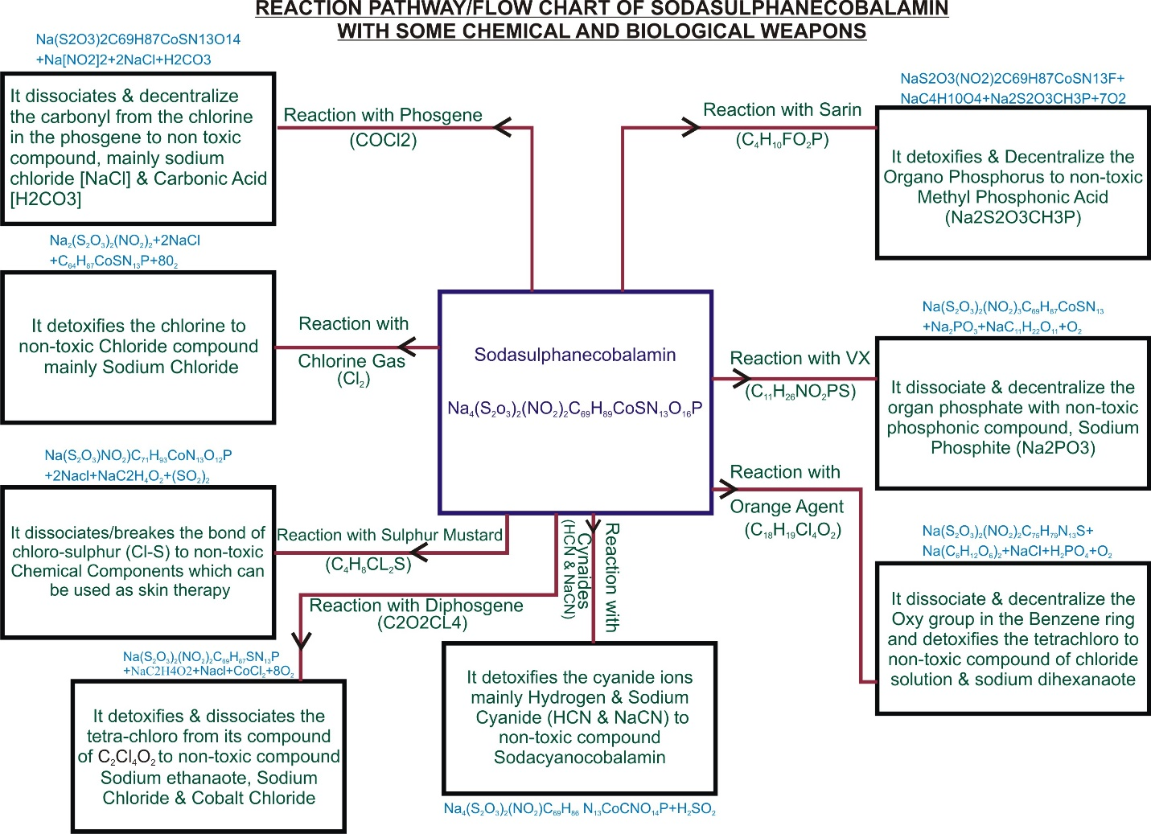

PUBLICATIONS:
- Chemical journal on the 10 most Dangerous Chemical. (2015)
- Research work on Density and its Structure. (2015)
- Chemical Journal on Antidote of Agent of Orange. (2016)
- Detoxification of Sodium Cyanide. Air as a “Ligands Molecules” not as” Mixture”. Solar chemical compound (alternative source of sun). (2016)
- Experimental determination of Root Mean Square Velocity and Molecular velocity of all chemical elements, (2017)
- Production and synthetic of SodaSulphanecobalamin ( an antidote of Chemical weapon) (2017)

 BIOGRAPHY: expertise in quantum physics, also on determination of numerical value of dimension on physical quantities. Root mean square velocity and molecule velocity of all chemical elements which is never done before. stoichiometry and periodic properties table that shows the” INTRINSIVE AND EXTRINSIVE PROPERTIES” of all chemical elements. Determination of Molecular Mass and Formula for Air. Computational Mathematics and Application of Small organic Molecules. Antidote of chemical mass weapon (2, 3, 7, 8 - Tetrachlorobenzo-p-dioxin). Critical cGMP and ICH regulations for Pharmaceutical Laboratory. Pollution or environmental remediation studies, anthropogenic effect on petroleum. Synthetic of compound for biological evaluation. Synthetic of helium compound, which is another source of sun. Research on Oil Dispersant. Production of antidote of Cyanide Poisoning.

