Abstract

Title: Three-dimensional artificial scaffold for the applications of neuroscience

Sofia El-Ghazali^{1,2}, Shunichi Kobayashi ¹,
¹Department of Biomedical Engineering and Robotics Shinshu University,Ueda, Japan
²Advanced Graduate Leading Program Shinshu University, Ueda, Japan

Keywords: Electrospinning, nanofibers, biomedical, scaffolds, blood vessel.
- Abstract Body (up to 250 words)
Electrospinning technique is being widely used recently because of its potential applications and bulk productivity[1].. High surface area, light weight and ease of manufacturing three dimensional structures are the most attractive features for the biomedical field and applications such as skin regeneration, controlled drug release and artificial scaffolds [2]. In particular, artificial blood vessels aim to replace an injured area of a given blood vessels for a temporary period, and this can be reached using nanofibers as they are structurally able to mimic the behavior of the extracellular matrix. The composition of co-electro spun nanofibers blend is a new technique that helps in achieving different properties from different polymers such as strength, biocompatibility and rate of biodegradation [3]. We tried co-electrospinning of Cellulose acetate, Poly L-lactic Acid and Polycaprolactone and successfully obtained good results in the shape of artificial blood vessels with smooth morphology.

Image:
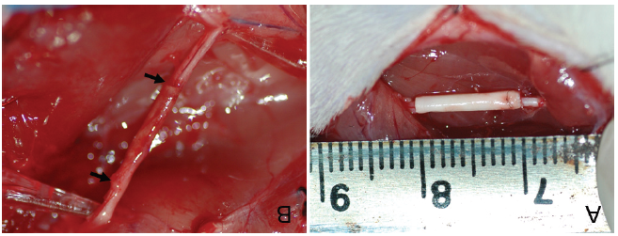
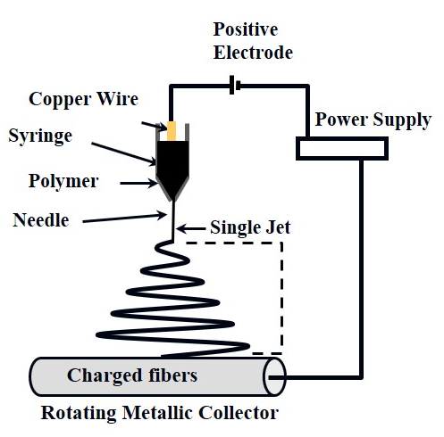

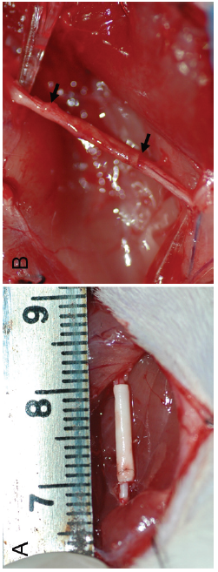

- Reference:

- Ramakrishna, S. (2005). An introduction to electrospinning and nanofibers. World Scientific.

- Barnes, C. P., Sell, S. A., Boland, E. D., Simpson, D. G., & Bowlin, G. L. (2007). Nanofiber technology: designing the next generation of tissue engineering scaffolds. Advanced drug delivery reviews, 59(14), 1413-1433.
- Obregón, R., Ramón-Azcón, J., & Ahadian, S. (2017). Nanofiber composites in blood vessel tissue engineering. In Nanofiber Composites for Biomedical Applications (pp. 483-506).

- Biography:
Ms. Sofia El-Ghazali is a second-year masters student at Shinshu University, Japan; after completing bachelor’s in mathematics and Physics at Ibn Abdoun Center of preparatory classes at Khouribga, Morocco and master’s in international Logistics at ESITH university, Morocco.

- Presenting author details

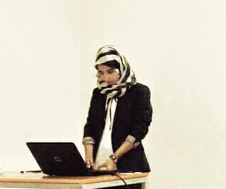
Full Name: Sofia El-Ghazali
Contact number: +8170-4125-1810
Twitter account:
Linked In account:
S Session name/ number:
Category: Poster presentation)
Passport Number: JZ5343839

