Chemical Modification of Polyethylene Terephthalate Nanofibers by Aminated With Ethylenediamine

JAMAL A. ABBAS¹ , IBTISAM A SAID², MANAF A MOHAMED³ SUHAD A YASIN*⁴,ZERAVAN A ALI⁵ and IDREES H AHMED⁶
1Department of chemistry, University of Duhok/College of Science, Duhok, Kurdistan region, Iraq.
2Department of Physic, University of Duhok/College of Science, Duhok, Kurdistan region, Iraq 3Department of Physic, University of Duhok/College of Science, Duhok, Kurdistan region, Iraq 4Department of Chemistry, University of Duhok/College of Science, Duhok, Kurdistan region,
5Department of Chemistry, University of Duhok/College of Science, Duhok, Kurdistan region, Iraq
6Department of Chemistry, University of Duhok/College of Science, Duhok, Kurdistan region, Iraq

Keywords:
Nanotechnology, Electrospinning, Nanofibers, Applications of nanofibers, PET, waste plastic, aminated, surface modification

Abstract:
Polyethylene terephthalate (PET) is a semi-crystalline polyester, which is formed from ester monomers by condensation polymerization reaction. PET become the most common polyester for food and liquid packaging. In the last decade, electrospinning technique has been acknowledged as an effective way for the formation of nanofibers. Spun nanofibers offer several characteristics such as extremely high surface to volume ratio, high porosity, and small pore size interconnection. Aminolysis has many application, Aminolysis of polyester is considered as a nucleophilic reaction between amine and ester bonds of polymer chain. For using west PET to treat wastewater from heavy metals, it is necessary to modify by introducing with functional groups on the surface. Polyethylene terephthalate fibers (PETFs) were modified by grafting amine group on the surface of nanofibers mat by ethylene diamine(EDA) in two different concentrations (1.5% and 2.5%) in ethanol at different times (2,5,8,10and 15 min) with fixed temperature. Staining nanofibers with acid fuchsin dye used to investigate the amount of amine group that has been grafted by aminolysis. The concentration (1.5%) with shorter contact time (5 min.) at 40 C^{ᵒ} is resulted in a more efficient aminolysis process.

Graphical abstract:

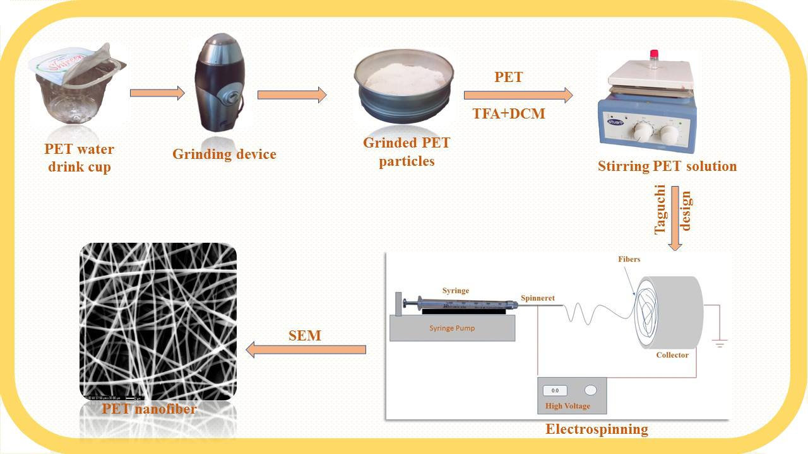

References:
1. Nikalje, A.P., Nanotechnology and its applications in medicine. Med chem, 2015. 5(2): p. 185-189.
2. Yousaf, S. and A. Salamat. Effect of heating environment on fluorine doped tin oxide (f: SnO/sub 2/) thin films for solar cell applications. in Proceedings of the International Conference on Power Generation Systems Technologies. 2011.
3. Hanus, M.J. and A.T. Harris, Nanotechnology innovations for the construction industry. Progress in materials science, 2013. 58(7): p. 1056-1102.
4. Sozer, N. and J.L. Kokini, Nanotechnology and its applications in the food sector. Trends in biotechnology, 2009. 27(2): p. 82-89.
5. Huang, Z., et al., Longitudinal patent analysis for nanoscale science and engineering: Country, institution and technology field. Journal of Nanoparticle research, 2003. 5(3-4): p. 333-363.
6. Sanguansri, P. and M.A. Augustin, Nanoscale materials development–a food industry perspective. Trends in Food Science & Technology, 2006. 17(10): p. 547-556.
7. Fang, J., et al., Applications of electrospun nanofibers. Chinese science bulletin, 2008. 53(15): p. 2265.
8. Roso, M., et al., Multifunctional membranes based on spinning technologies: the synergy of nanofibers and nanoparticles. Nanotechnology, 2008. 19(28): p. 285707.
9. Bhardwaj, N. and S.C. Kundu, Electrospinning: a fascinating fiber fabrication technique. Biotechnology advances, 2010. 28(3): p. 325-347.
10. Zeleny, J., The electrical discharge from liquid points, and a hydrostatic method of measuring the electric intensity at their surfaces. Physical Review, 1914. 3(2): p. 69.
11. Persano, L., et al., Industrial upscaling of electrospinning and applications of polymer nanofibers: a review. Macromolecular Materials and Engineering, 2013. 298(5): p. 504-520.
12. Li, D. and Y. Xia, Electrospinning of nanofibers: reinventing the wheel? Advanced materials, 2004. 16(14): p. 1151-1170.
13. Ramakrishna, S., An introduction to electrospinning and nanofibers2005: World Scientific.
14. Ksapabutr, B., T. Chalermkiti, and M. Panapoy, Effect of Nozzle Shapes on the Formation of Taylor Cone and the Oscillation of Fibers During Electrospinning Process. Chiang Mai University Journal, 2005. 4(1): p. 115-119.
15. Zander, N.E., M. Gillan, and D. Sweetser, Recycled PET nanofibers for water filtration applications. Materials, 2016. 9(4): p. 247.
16. Liang, D., B.S. Hsiao, and B. Chu, Functional electrospun nanofibrous scaffolds for biomedical applications. Advanced drug delivery reviews, 2007. 59(14): p. 1392-1412.
17. Dzenis, Y., Spinning continuous fibers for nanotechnology. Science, 2004. 304(5679): p. 1917-1919.
18. Luu, Y., et al., Development of a nanostructured DNA delivery scaffold via electrospinning of PLGA and PLA–PEG block copolymers. Journal of controlled release, 2003. 89(2): p. 341-353.
19. Wu, C.M., et al., Effects of electrostatic polarity and the types of electrical charging on electrospinning behavior. Journal of Applied Polymer Science, 2012. 126(S2).
20. Greiner, A. and J.H. Wendorff, Electrospinning: a fascinating method for the preparation of ultrathin fibers. Angewandte Chemie International Edition, 2007. 46(30): p. 5670-5703.
21. Feng, C., K. Khulbe, and T. Matsuura, Recent progress in the preparation, characterization, and applications of nanofibers and nanofiber membranes via electrospinning/interfacial polymerization. Journal of Applied Polymer Science, 2010. 115(2): p. 756-776.
22. Pillay, V., et al., A review of the effect of processing variables on the fabrication of electrospun nanofibers for drug delivery applications. Journal of Nanomaterials, 2013. 2013.
23. Marsh, K. and B. Bugusu, Food packaging—roles, materials, and environmental issues. Journal of food science, 2007. 72(3).
24. Siracusa, V., et al., Biodegradable polymers for food packaging: a review. Trends in Food Science & Technology, 2008. 19(12): p. 634-643.
25. Ma, Z., et al., Surface engineering of electrospun polyethylene terephthalate (PET) nanofibers towards development of a new material for blood vessel engineering. Biomaterials, 2005. 26(15): p. 2527-2536.
26. Strain, I., et al., Electrospinning of recycled PET to generate tough mesomorphic fibre membranes for smoke filtration. Journal of Materials Chemistry A, 2015. 3(4): p. 1632-1640.
27. Ding, Y., et al., Electrospun polyimide nanofibers and their applications. Progress in Polymer Science, 2016. 61: p. 67-103.
28. Dong, Y., et al., Development and characterisation of novel electrospun polylactic acid/tubular clay nanocomposites. Journal of materials science, 2011. 46(18): p. 6148-6153.
29. Sun, B., et al., Advances in three-dimensional nanofibrous macrostructures via electrospinning. Progress in Polymer Science, 2014. 39(5): p. 862-890.
30. Bartolome, L., et al., Recent developments in the chemical recycling of PET, in Material Recycling-Trends and Perspectives2012, InTech.
31. Khoonkari, M., et al., Chemical recycling of PET wastes with different catalysts. International Journal of Polymer Science, 2015. 2015.
32. Sinha, V., M.R. Patel, and J.V. Patel, PET waste management by chemical recycling: a review. Journal of polymers and the environment, 2010. 18(1): p. 8-25.
33. Liao, Y., et al., Progress in electrospun polymeric nanofibrous membranes for water treatment: fabrication, modification and applications. Progress in Polymer Science, 2017.
34. Fridrikh, S.V., et al., Controlling the fiber diameter during electrospinning. Physical review letters, 2003. 90(14): p. 144502.
35. Kumar, A., et al., Structural and optical properties of electrospun TiO2 nanofibers. Chemistry of Materials, 2007. 19(26): p. 6536-6542.
36. Lee, Y.H., et al., Electrospun dual-porosity structure and biodegradation morphology of Montmorillonite reinforced PLLA nanocomposite scaffolds. Biomaterials, 2005. 26(16): p. 3165-3172.
37. Hardick, O., B. Stevens, and D.G. Bracewell, Nanofibre fabrication in a temperature and humidity controlled environment for improved fibre consistency. Journal of materials science, 2011. 46(11): p. 3890-3898.
38. Ghani, J.A., I. Choudhury, and H. Hassan, Application of Taguchi method in the optimization of end milling parameters. Journal of materials processing technology, 2004. 145(1): p. 84-92.
39. Pang, J., et al., Taguchi design optimization of machining parameters on the CNC end milling process of halloysite nanotube with aluminium reinforced epoxy matrix (HNT/Al/Ep) hybrid composite. HBRC Journal, 2014. 10(2): p. 138-144.
40 Zhu,Y.,Mao,Z.,Gao,C.,Aminolysis -based surface modification of polyesters for biomedical applications, RSC Adv.,2013.(3),2509-2519
41Avny, Y., & Rebenfeld, L. (1986). Chemical modification of polyester fiber surfaces by amination reactions with multifunctional amines. Journal of Applied Polymer Science, 32(3), 4009–4025. https://doi.org/10.1002/app.1986.070320318

Biogroghy
Suhad A.Yasin has completed her MSc( polymer chemistry) in 2009 from University of Duhok/ IRAQ. She is a phD student at the University of Duhok also she is a principal investigator at Partnerships for Enhanced Engagement in Research (PEER) under cycle 6 / IRAQ. The name of her project is (removal of heavy metals using nanofibers membrane).

Presenting author details


Full Name: Suhad Abdulrahman Yasin
Contact number:07504327220
Twitter account: suhad_ssm
Linked In account:suhad yasin
Session name/ number:
Category: (Oral presentation)
Passport Number:A12789829

