Novel strategies towards surface modification of polymeric biomedical devices based on Nylon 6 and polycaprolactone
, Sumita Swar³, ^{1,2*}Barbora Holubová, Jana Müllerová^{1,2}, Petra Šubrtová^{1,3}, Jana Horáková⁴ and Veronika Máková^{1,2}
¹Institute for Nanomaterials, Advanced Technologies and Innovation, Technical University of Liberec, Bendlova 1409/7, 46001 Liberec, Czech Republic
²Department of Chemistry, Faculty of Science, Humanities and Education, Technical University of Liberec
³Department of New Technologies and Applied Informatics, Faculty of Mechatronics and Interdisciplinary Studies, Technical University of Liberec
⁴Department of Nonwovens and Nanofibrous Materials, Faculty of Textile, Technical University of Liberec

Abstract
With the aid of surface chemistry, the modern biomedical polymer devices may be made biocompatible, non-cytotoxic, antibacterial and resistant to pathogenic bacteria. Hence, a proper choice of surface modification of polymeric nanomaterials used in various biomedicine applications gained nowadays a very close attention. Further modification of polymeric surface by introducing specific functional groups may improve performance of polymeric implants or implant devices as half of all nosocomial infections are now device related.
Newly developed man-made synthetic polymers like polyamides or polyesters rapidly entered medical application field already during the second half of the 20th century. The biomedical applications include suture material, coated textile for skin infection, wound dressing, catheters, bone tissue scaffolds and dialysis membranes. But the modification of their surface is crucial as a bare polymers represent a high risk for patients (i.e.: thrombogenesis etc.).
In our study, the chemical method was used to modify the surface of one polyamide (Nylon 6) and one polyester (polycaprolactone (PCL)) material in order to create a resistant surface against the formation of a harmful biofilm caused by pathogenic bacteria. On Nylon 6 surface, the amide functional groups were successfully converted into secondary amine. Modified Nylon 6 has been found to be antibacterial particularly due to the presence of hydrophilic poly(ethylene glycol) methyl ether (H3C-PEG) chains, and moreover, due to the subsequent physical deposition of copper nanoparticles among the PEG chains. In the second case, tannin coating on PCL (polycaprolactone) nanofibrous membrane was applied and the antibacterial tests focused on the gram negative bacterial strain confirmed the significant effect on the bacterial adhesion to the modified surface as well.
Acknowledgement:

Authors acknowledge to the project SGS 21207, Faculty of Science, Humanities and Education, Technical University of Liberec and the European Union - European Structural and Investment Funds in the framework of the Operational Programme Research, Development and Education project “Hybrid Materials for Hierarchical Structures (HyHi)”, Reg. No. CZ.02.1.01/0.0/0.0/16_019/0000843

Image

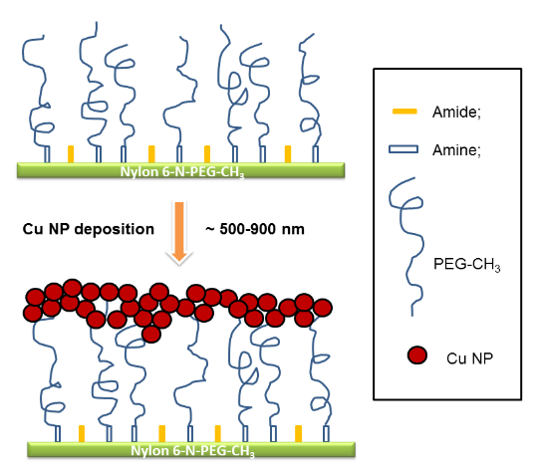

Scheme 1: Conversion of Nylon 6 into Nylon 6-NH, followed by grafting on Nylon 6-NH via H₃C-PEG-OTs and Cu NPs to form Nylon 6-N-PEG-CH₃- Cu

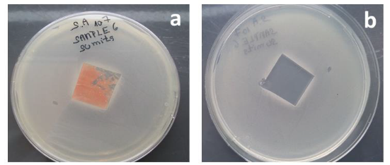

Fig. 1.: Inhibiting zones of S. aureus, exposed to Nylon 6-N-PEG-CH3-Cu a); after removal of Nylon 6-N-PEG-CH3-Cu b).

Recent Publications
- M.F. Maitz, Biosurface and Biotribology (2015),1, 161–176.
- M. Jassal, Text. Hyg. Infect. Control. (2011) 3–13.
- F. Abedini, A. Ahmadi, A. Yavari, V. Hosseini, S. Mousavi, Int. Wound J. (2013), 10, 573–578.
- C. Mao, W. Zhao, C. Zhu, A. Zhu, J. Shen, S. Lin, Carbohydr. Polym. (2005), 59, 19–25.
- S.Swar, V. Zajícová et al., J. Mater. Sci. (2018), DOI: 10.1007/s10853-018-2636-2.


Biography
Dr. Barbora Holubová has gained her MSc. and Ph.D. at the University of Chemistry and Technology, Prague in the programme: Chemistry and Technology of Materials. Her professional experience is focused on chemistry and technology of inorganic non-metallic materials (especially glass and ceramics); sol-gel process in the field of functional hybrid inorganic-organic coatings on glass and sol-gel process of organosilane hybrids in general, characterization techniques and kinetic studies.

Email: barbora.holubova@tul.cz
Notes/Comment

