Multifunctionalized Gold Nanorods for a Potential Treatment of Alzheimer Disease
Francisco Morales-Zavala, PhD, ACCDiS, Universidad de Chile, Chile
Ernest Giralt, PhD, Institute for Research in Biomedicine, Barcelona, España
Macarena Sanchez-Navarro, PhD, Institute for Research in Biomedicine, Barcelona, España
Pedro Jara, licensed in pharmacy, ACCDiS, Universidad de Chile, Chile
Pablo Cabrera, Licensed in pharmacy, ACCDiS, Universidad de Chile, Chile
Rebeca Aldunate, PhD, Universidad Santo Tomás, Santiago, Chile
Alejandra Alvarez, PhD Universidad Católica de Chile, Santiago, Chile
Marcelo Kogan,PhD, ACCDiS, Universidad de Chile, Chile

Abstract
The Alzheimer Disease (AD) is the most common form of dementia. One of the main characteristics of AD is the loss of cognitive capacity and memory, and the most relevant hypothesis for the developments of this symptoms is the amyloid hypothesis. This hypothesis states that the pathological production and accumulation of the amyloid β (Aβ) peptide and their different aggregated states produce the neurotoxicity that characterize the AD. Our research group postulate the use of gold nanoparticles (GNP) as a drug delivery device for their photothermal properties that eliminate the Aβ aggregates and the potential applications in detection in CT, RAMAN, fluorescence, among others. In this work, we present a drug delivery system for the central nervous system (CNS) based on Gold Nanorods (GNR) stabilized with poly ethylene glycol and functionalized with two peptides. The first one is Angiopep 2 (Ang2), used as a shuttle to the CNS and the second is a beta sheet breaker peptide that has the ability to recognize the Aβ aggregates and induce the disaggregation or prevent it (D1 peptide). The nanosystem GNR-D1/Ang2 was characterized physicochemically and the toxicity and cellular penetration were evaluated in the cell line bEnd.3. We observed that GNR-D1/Ang2 was not cytotoxic and the cellular penetration of the nanosystem was improved with respect to the control GNR. The ability to reduce the cytotoxic effects of Aβ aggregates was evaluated in the AD model C. elegans 2120, where we observed that the treatment with GNR-D1/Ang2 reduce the toxics effects of the Aβ aggregates on the nematode. Finally, to evaluate the ability of GNR-D1/Ang2 to improve the delivery to the brain we used the mouse model APPswe/PSEN1dE9 observing that GNR-D1/Ang2 was delivered to the amyloid plaques.
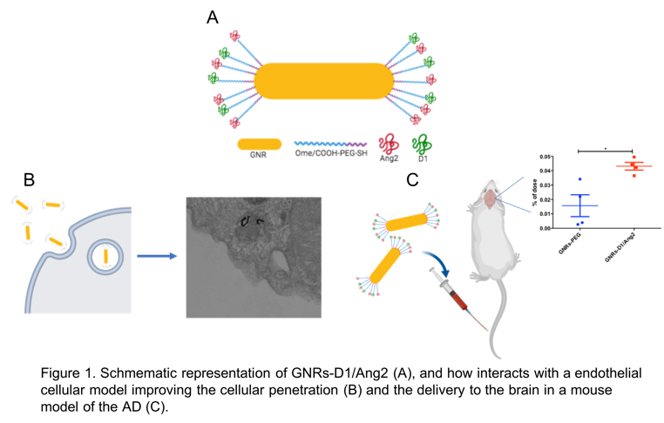
Recent Publications (minimum 5)
1- Adura, C., et al. (2013). "Stable conjugates of peptides with gold nanorods for biomedical applications with reduced effects on cell viability." ACS Appl Mater Interfaces 5(10): 4076-4085.
2- Morales-Zavala, F., et al. (2017). "Peptide multifunctionalized gold nanorods decrease toxicity of β-amyloid peptide in a Caenorhabditis elegans model of Alzheimer's disease." Nanomedicine: Nanotechnology, Biology and Medicine 13(7): 2341-2350.
3- J Bejarano, et al. Nanoparticles for diagnosis and therapy of atherosclerosis and myocardial infarction: evolution toward prospective theranostic approaches Theranostics 8 (17), 4711.
4- Velasco-Aguirre, C., et al. (2017). "Improving gold nanorod delivery to the central nervous system by conjugation to the shuttle Angiopep-2." Nanomedicine 12(20): 2503-2517.
5- J Ruff et al. CLPFFD–PEG functionalized NIR-absorbing hollow gold nanospheres and gold nanorods inhibit β-amyloid aggregation. Journal of Materials Chemistry B 6, 16, 2432-244

Biography (150 word limit)
Prof. Dr. Marcelo J. Kogan was born in Buenos Aires, Argentina in 1964. He is Professor at the Department of Pharmacology and Toxicology of the School of Pharmacy at the University of Chile and Principal Investigator at the Advanced Center for Chronic diseases (ACCDiS). He is the Coordinator of the Pharmaceutical Sciences Program of the University of Chile. He is the Director of the Laboratory of NANOMEDICINE AND NANOTHERANOSTICS at this center. He is Biochemist and Pharmacist at the University of Buenos Aires and PhD in Organic Chemistry from the same University. He did his postdoctoral research at the Institut of Biomedical Research Barcelona in the field of peptides. His interest is centered on applications of nanobiomaterials and peptides in biomedicine for diagnosis and treatment of conformational diseases including drug delivery, Alzheimer, Cancer and cardiovascular diseases. He is a pioneer in the field of use nanoparticles for disaggregation of amyloids.
Email: mkogan@ciq.uchile.cl

