Interplay between amyloid fibrillation hysteresis and degradation by magnetic nanoparticles
¹ KLEONIKI GIANNOUSI, ¹ ORESTIS ANTONOGLOU, ¹ CATHERINE DENDRINOU-SAMARA

¹ Laboratory of Inorganic Chemistry, Department of Chemistry, Aristotle University of Thessaloniki, Thessaloniki, 54124 Greece

Abstract
The main pathological hallmark of central nervous system (CNS) disorders is amyloidosis, caused by the aberrant aggregation of naturally soluble proteins into insoluble fibril deposits. Nanomedicine has recently opened a new theranostic (therapy and diagnosis) avenue for CNS diseases overcoming the limitations of conventional strategies. Magnetic nanoparticles (MNPs) are protagonists in various bioapplications, one of them being effective transverse (spin-spin) T₂ imaging agents in magnetic resonance imaging (MRI) with many in clinical trials as well as commercial products (e.g. Ferridex). MNPs can serve as agents to induce a magnetomotive force in the presence of a low-frequency magnetic field. A variable either in the frequency (0-20 Hz) and/or in the amplitude (up to 200 mT) of the magnetic field dictates magnetic nanoparticles’ (MNPs) movements and these “dancing” modes could affect the protein fibrils. Thus, the external magnetic field gradients can potentially be used to induce degradation of amyloid plaques via exerting magnetomechanical effects. We have undertaken a modified microwave-assisted polyol process, where one-step synthesis takes place in the sole presence of a polyol under rapid nucleation and short growth time to provide in-situ formulated small hybrid organic/inorganic zinc ferrite (Zn_{x}Fe_{3-x}O₄) MNPs with high crystallinity, hydrophilic biocompatible polyol coating, high magnetization (>120 emu/g) and T₂ imaging ability (r₂>200 mM⁻¹s⁻¹. The effect of the MNPs in the fibrillation process was monitored in two model proteins (insulin and albumin) in the presence/absence of external magnetic fields by fluorescence Thioﬂavin T (ThT) measurements and optical fluorescence microscopy. The MNPs were either injected in protein oligomers solution or in formed amyloid plaques to study both the kinetics of amyloid growth and their anti-amyloidogenic/degradation properties. The ultimate goal is to present zinc ferrite MNPs as new theranostic candidates for administration in different stages of amyloid diseases in order to retard amyloidosis or degrade the protein fibrils.

Image
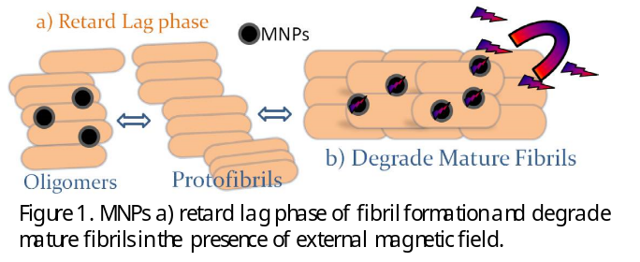
Recent Publications
- K. Giannousi, E. Koutroumpis, V. Georgiadou, V. Karagkounis and C. Dendrinou-Samara, Eur. J. Inorg. Chem., 2019, 1895-1903.
- O. Antonoglou, K. Giannousi, J. Arvanitidis, S. Mourdikoudis, A. Pantazaki, C. Dendrinou-Samara, J. Inorg. Biochem. 2017, 177, 159-170.
- K. Giannousi, M. Menelaou, J. Arvanitidis, M. Angelakeris, A. Pantazaki, C. Dendrinou-Samara, J. Mater. Chem. B 2015, 3, 5341-5351.
- A. Antosova, Z. Bednarikova,M. Koneracka et al. Journal of Magnetism and Magnetic Materials 2019, 471, 169–176.
- L.O. Sillerud, N.O. Solberg, R. Chamberlain et al. Journal of Alzheimer’s Disease 2013, 34, 349–365.

Biography
Dr. Kleoniki Giannousi,is a postdoctoral researcher in C. Dendrinou-Samara’s team. She is currently working on functionalization of MNPs for use as nano-theranostics in Alzheimer's Disease.The interdisciplinarity accompanies her studies even during her masters. As a biologist (Biology Department, AUTh), she has built suitable biochemical protocols for assessing the biological activity of NPs, while her experience in the synthesis and characterization of nanoparticles is proved by her Master (Physics Department, AUTh) and PhD dissertations (Chemistry Department, AUTh) in the fields of nanotechnology and nanoscience and Bio-Inorganic Nanochemistry. She has worked on multiple projects; Nanoplatforms for Drug Delivery, Anticancer and anti-inflammatory activity of NPs, Nano-antimicrobials, Hetero-nanocomposites, Nano-agrochemicals. Additionally, her publications in international journals and books (number:10, citations >150) feature her skill to organize the writing of research papers in an efficient manner, while her participations in numerous international conferences highlight her ability for dissemination and public presentation of the research outcomes.
Email: klegia@chem.auth.gr

Notes/Comments:

This project «Functionalized Magnetic Nanoparticles candidates for Alzheimer's disease» is implemented through /has been co-financed by the Operational Program "Human Resources Development, Education and Lifelong Learning" and is co-financed by the European Union (European Social Fund) and Greek national funds.

