Developing Bioorthogonal Smart Polymers for Cancer Therapy
Gayathri R. Ediriweera^{1,2}, Zachary Houston^{1,2}, Craig A. Bell^{1,2}, Kristofer J. Thurecht^{1,2}

¹Australian Institute of Bioengineering and Nanotechnology and Centre for Advanced Imaging,
University of Queensland, Brisbane, 4072, Australia
²ARC Centre of Excellence in Convergent Bio-Nano Science and Technology

Abstract (300 word limit)
The selective delivery and effective localisation of drugs is crucial in cancer therapy. The efficacy of existing therapeutic systems is limited by the challenges such as, determining the actual drug release profile in vivo as well as reducing side-effects for increased standard of care.¹ The use of bioorthogonal chemistry is a versatile and promising tool to overcome such drawbacks, as it can be tailored to develop theranostic systems where the drug release stimulus is controlled only by the addition of an exogenous molecule, providing more direct control over in vivo drug release and minimising toxic side-effects.² This can create more effective drug delivery systems with better therapeutic design. In this work, a ⁶⁴Cu radiolabelled tetrazine probe (tetrazine-PEG₄-NOTA) was synthesised, that showed rapid pharmacokinetics in healthy mice when tested in positron emission tomography/computed tomography (PET/CT). Critically, almost all of the tetrazine radioligand was cleared into the bladder within 20 minutes. A PEGylated hyperbranched polymer tagged with bispecific antibodies as targeting ligands and trans-cyclooctene bearing the anti-cancer drug doxorubicin was synthesised. The in vitro reaction of this conjugate and tetrazine showed rapid and instantaneous doxorubicin release when tested in HPLC. A preliminary in vivo study was carried out with mice bearing MDA-MB-468 breast cancer xenograft using PET/CT that showed successful in vivo click reaction and doxorubicin release. In this way, the click reaction will facilitate pro-drug activation as well as provide a means to quantify the amount of drug administered at site via PET/CT (Figure 1). This approach carries the potential to be a significant addition to the currently available “bioorthogonal-click” toolkit that is yet to be improved before translating it to the clinic, as it affords enormous prospective to create quantitative theranostic systems that can determine the actual drug release profile in vivo at the same time reducing toxic side-effects.

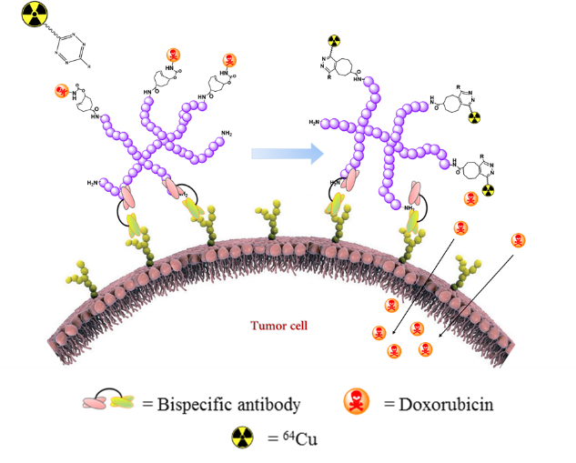
Figure 1: Hyperbranched polymer-drug conjugate activation via bioorthogonal reaction on a tumour cell
Recent Publications (minimum 5)
- Seluanov A, Gladyshev VN, Vijg , Gorbunova , (2018) Mechanisms of cancer resistance in long-lived animals, Nature Reviews Cancer, 18: 433-441.
- Rossin R, van Duijnhoven SM, ten Hoeve , Janssen HM, Kleijn LH, Hoeben FJ, Versteegen RM, Robillard MS, (2016) Triggered Drug Release from an Antibody–Drug Conjugate Using Fast “Click-to-Release” Chemistry in Mice. Bioconjugate Chemistry, 27:1697-1706.
- Rossin R, Versteegen RM, Wu J, Robillard MS., (2018) Chemically triggered drug release from an antibody-drug conjugate leads to potent antitumour activity in mice. Nature Communications 9 (1):1484
- Khan I, Agris PF, Yigit MV, Royzen M. (2016) In situ activation of a doxorubicin prodrug using imaging-capable nanoparticles. Chemical Communications. 52:6174–6177.
- Versteegen RM, Ten Hoeve W, Rossin R, de Geus MAR, Janssen HM, Robillard MS. (2018) Click-to-Release from trans-Cyclooctenes: Mechanistic Insights and Expansion of Scope from Established Carbamate to Remarkable Ether Cleavage. Angewandte Chemie (International ed. in English) 57 (33): 10494-10499.

Gayathri Ediriweera is currently undertaking her PhD under the guidance of Associate Prof. Kristofer Thurecht in both the Centre for Advance Imaging and the Australian Institute for Bioengineering and Nanotechnology at the University of Queensland. She completed her B.Sc. (Hons) from University of Sri Jayewardenepura, Sri Lanka. She received several awards including Prof. Tuley de Silva Gold medal and Alles Memorial award for her outstanding performance in B.Sc. (Hons) degree. She started her career as an Assistant Lecturer in the University of Sri Jayewardenepura, Sri Lanka. Then she received the opportunity to peruse her Doctor of Philosophy (PhD) in the University of Queensland. Her current research interest is on developing polymeric theranostics using bioorthogonal chemistry.
Email: a.ediriweera@uqconnect.edu.au

