Electrochemical properties of nanoporous based materials doped with metal oxide nanoparticles for potential application as sensors
OMOLOLA ESTHER FAYEMI
Eno.E EBENSO

Abstract (300 word limit)

Nanotechnology is playing an increasing important role in the development of nanosensors. Recently, electrochemical biosensors based on nanostructured metal oxides gained much attention in the field of health care for the management of various important analyte in a biological system. The unique properties of nanostructured metal oxides offer excellent prospects for interfacing biological recognition events with electronic signal transduction and for designing a new generation of bioelectronics devices. The purpose of the study is to evaluate the sensing properties of different nanoporous based materials doped with different metal oxide nanoparticles towards the electrochemical detection of various biological and environmental molecules and how such devices have enabled the achievement of high sensitivity and selectivity with low detection limits. Conclusion and the significance of the study produced an observation that the sensitivity and performance of nanostructured metal oxide based sensors is improved in the presence of these materials. The use of these metal oxide nanostructured materials has allowed the introduction of many new signal transduction technologies in biosensors.

Image
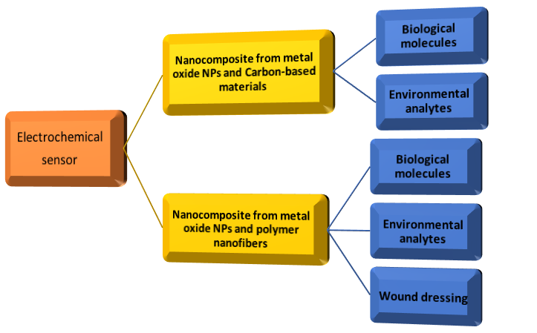
Recent Publications (minimum 5)
- Omolola E. Fayemi, Adeniyi S. Ogunlaja, Pierre F.M. Kempgens, Edith Antunes, Nelson Torto, Tebello Nyokong, Zenixole R. Tshentu (2013). Adsorption and separation of platinum and palladium by polyamine functionalized polystyrene-based beads and nanofibers. Minerals Engineering. 53: 256-265, DOI:10.1016/j.mineng.2013.06.006
- Tebogo P. Tselea, Abolanle S. Adekunle, Omolola E. Fayemi, Eno E. Ebenso. (2017). Electrochemical detection of Epinephrine using Polyaniline nanocomposite films doped with TiO₂ and RuO₂ Nanoparticles on Multi-walled Carbon Nanotube, Electrochimica Acta 243: 331–348.
- Ntsoaki Mphuthi, Abolanle S. Adekunle, Omolola E. Fayemi, Eno. E. Ebenso. (2017). Phthalocyanine Doped Metal Oxide Nanoparticles on Multiwalled Carbon Nanotubes Platform for the detection of Dopamine, Scientific Reports 7: 43181
- Elias E. Elemike , Damian C. Onwudiwe, Omolola E. Fayemi, Louwrens R. Tiedt (2016). Biosynthesis, Electrochemical, Antimicrobial and Antioxidant Studies of Silver Nanoparticles Mediated by Talinum triangulare Aqueous Leaf Extract, Journal of Cluster Science.
- Elias E. Elemike, Omolola E. Fayemi, Anthony C. Ekennia , Damian C. Onwudiwe, Eno E. Ebenso (2017). Silver Nanoparticles Mediated by Costus afer Leaf Extract: Synthesis, Antibacterial, Antioxidant and Electrochemical Properties, Molecules 22: 2017, DOI: 10.3390/molecules22050701

Biography (150 word limit)
Omolola Esther Fayemi has her expertise in synthesis, characterization and application of nano-based materials as electrochemical sensors and wound dressing. She is very passionate about her work and aspire to develop novel materials that can be use as sensors to monitor the concentration of biological molecules in pharmaceutical samples, food and organochlorine pesticides for environmental pollution control. She is a young researcher ready for collaborations that can be of mutual benefits to both parties involved.
Email:omololaesther12@gmail.com

