Control of Mesoporous Silica Nanoparticles physicochemical properties through control of synthetic parameter using Box-Behnken design
Mpho P Ngoepe, MSc (Med), Chemistry Department, Rhodes University, SA
Rui MW Krause, PhD, Chemistry Department, Rhodes University, SA

Abstract
Statement of the Problem: Mesoporous silica nanoparticles (MSN) have been utilized in drug delivery due to their controllable release kinetics. The control of the physicochemical properties of nanoparticles for applications is stated to be complex despite the use of computational model. The pH, molar ratio of silica source and water and calcination temperature impact in drug delivery have not been studied before. Understanding of these critical synthetic parameters can aid in controlling the particle size, pore structure and size, surface chemistry and drug loading capacity. Methodology & Theoretical Orientation: Box-Behnken design was utilized for evaluation of these parameters. Whereby, post-grafting of amine, surface chemistry post calcination, drug loading particle size and pore structure were studied. For application in drug delivery, rifampicin was loaded into the particles followed by capping with pH responsive chitosan. Findings: Based on the surface response plot from the experimental design, the size of the particle indicates to be dependent on the amount of water available for hydrolysis and dissolution to occur at a near neutral pH. The highest size obtained was 609±44.44 (n=3), whereby pH 8 and molar ratio of 126 was used. The smallest size was observed was observed at pH 12. The calcination temperature played a role in condensation of the free silanols which lead to changes in the grafting potential of the silica surface to (3-Aminopropyl) triethoxysilane. The amount of drug entrapped indicates can be improve though increase in particle size and increase in the porous particle structure. Conclusion & Significance: This works adds to previous work that indicate that TEOS: water ratio plays a role in particle size, pH plays a role in the control of the network structure, whilst calcination temperature affects the degree of post synthesis silanol condensation.

Image

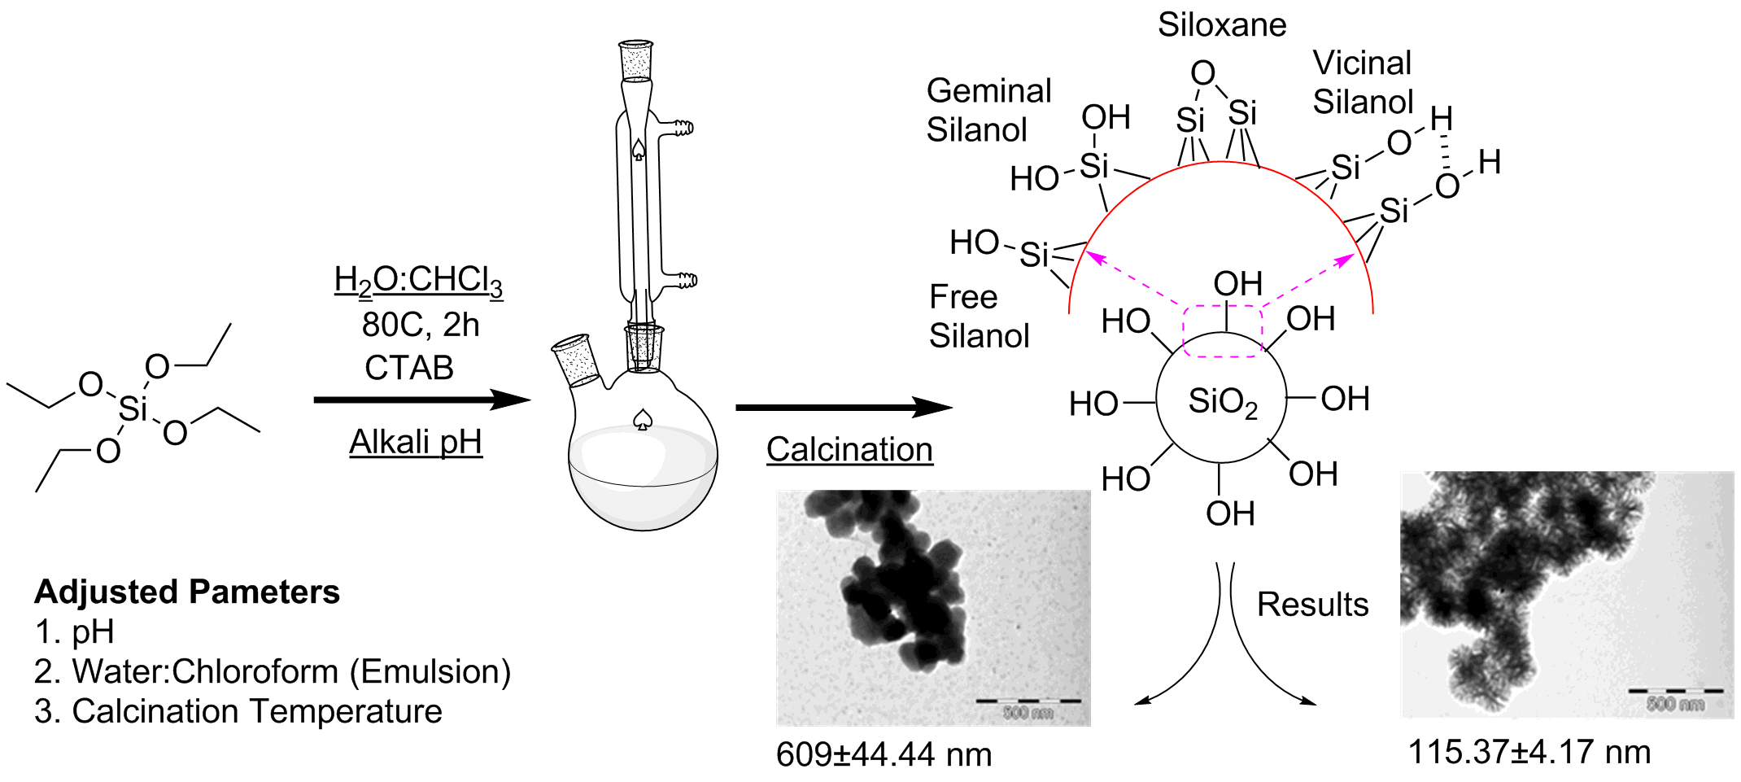
Figure 1: Synthetic procedures for MSNs for control of particle size, porosity and surface chemistry.
Recent Publications (minimum 5)
- Barbé, C.J, Bartlett, J., Kong, L., Finnie, K., Lin, H.Q., Larkin, M., Calleja, S., Bush, A & Galleja, G (2008). Advanced Materials, 16:1959-1966.
- Barbé, C.J, Cassidy, D.J., Triani, G., Latella, B.A., Mitchell, D.R.G., Finnie, K.S., Short, K., Bartlett, J.R., Woolfrey, J.L., & Collins, G.A. (2005). Sol–gel bonding of silicon wafers: Part 2. Influence of the sol–gel chemistry on bond morphology and interfacial energy. Thin Solid Films, 488:153-159.
- Brinker C (1988). Hydrolysis and condensation of silicates: effects on structure. Journal of Non-Crystalline Solids, 100:31-50.
- Malay, O., Yilgor, I. & Menceloglu, Y.Z (2013). Effects of solvent on TEOS hydrolysis kinetics and silica particle size under basic conditions. Journal of Sol-Gel Science and Technology, 67:351-361.
- Wang, X., Zhang, Y., Luo, W., Elzatahry, A.A., Cheng, x., Alghamdi, A., Abdullah, A.M., Deng, Y & Zhao, D. (2016). Synthesis of Ordered Mesoporous Silica with Tunable Morphologies and Pore Sizes via a Nonpolar Solvent-Assisted Stöber Method. Chemistry of Materials, 28:2356-2362.

 Biography
Mpho Phehello Ngoepe has experience in pharmaceutical formulation and design for drug delivery system. Obtained an MSc(Med) in Pharmaceutics at the University of the Witwatersrand (South Africa). Currently doing a PhD in Chemistry at Rhodes University (South Africa), to better understand and gain experience in nanomaterial chemistry. Using experimental design, various synthetic parameters can be used to improve the performance of currently utilized drug delivery carriers. The understanding of material chemistry and physics can aid in improving drug delivery systems.
Email: mphongoepe@hotmai.com

Notes/Comments:

