Zinc oxide nanostructures grown p-Si electrodes for photo-electrochemical water oxidation
Devika Mudusu, School of Mechanical Engineering, Sungkyunkwan University, Suwon, South Korea. Koteeswara Reddy Nandanapalli, Center for Nanoscience and Engineering, Indian Institute of Science, Bangalore, India.

Abstract
Recent years, the production of hydrogen fuels by adopting different semiconductor materials, Sunlight, and water, has received great attention as an alternative route for the harvesting of solar energy. Among various materials, a highly conductive silicon (Si) is considered as a suitable photoelectrode due to its availability, excellent crystallinity, optimum band gap, and well established processing technology [2]. However, in real practice Si suffers with poor stability and light conversion efficiency due to its chemical degradation and chemical kinetics. Surface protection or functionalization is one of the ideal route to overcome the chemical degradation of Si. Thus, we have developed ZnO protected Si electrode and studied their water splitting performance. Zinc oxide (ZnO) nanostructures (nanoparticles and nanorods) grown p-type Si based electrodes have been developed and studied their photoelectrochemical performance. Nanostructured ZnO films were deposited on highly conductive Si substrates by pulsed spray pyrolysis (PSP) method at a temperature of 400 °C, and then, vertically aligned ZnO nanorods were grown by chemical bath deposition (CBD) method at a bath temperature of 70-80 °C. After a thorough investigation of physical and chemical properties, the photoelectrochemical water oxidation performance of ZnO structures grown Si substrates were studied in an alkaline electrolyte (pH=10) solution under dark and illumination [3]. The as-deposited ZnO films over Si substrate by PSP possess uniform nanoparticles like surface morphology (Figure 1a), whereas the nanostructures developed by CBD over ZnO coated Si substrates consist of vertically aligned nanorods morphology. Both the structures exhibited hexagonal crystal structures and have a preferential growth direction of <001>. The photoelectrochemical water oxidation studies show that the Si/ZnO/ZnO nanorods structures exhibited higher current (nearly ten times) than that of Si/ZnO structures. Unfortunately, both the structures exhibited poor sustainability probably due to the photodegradation of ZnO [4].

Image
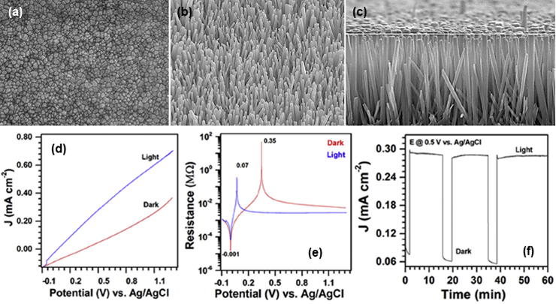
Figure 1: (a) Nanoparticles films, (b) Titled nanorods structures, (c) Cross-sectional FESEM images of ZnO over p-Si and (d-f) current density (J) versus applied bias-potential, Resistance (in log-scale) versus bias-potential, and Chronoamperometry (current density versus time) plots of Si/ZnO nanoparticles films based PEC device under dark and illumination conditions [1].
Recent Publications
1. Mitta SB, Murahari P, Nandanapalli KR, Mudusu D, Karuppannan R, Whang D (2018) Si/ZnO heterostructures for efficient diode and water-splitting applications. Int J Hydrogen Energ 43:16015-16023.
2. Hong WT, Cai Q, Ban RC, He X, Jian CY, Li J, Li J, Liu W (2018) High-Performance Silicon Photoanode Enhanced by Gold Nanoparticles for Efficient Water Oxidation. Acs Appl Mater Inter 10:6262-6268.
3. Reddy NK, Winkler S, Koch N, Pinna N (2016) Electrochemical Water Oxidation of Ultrathin Cobalt Oxide-Based Catalyst Supported onto Aligned ZnO Nanorods. Acs Appl Mater Inter 8:3226-3232.
4. Fekete M, Riedel W, Patti AF, Spiccia L (2014) Photoelectrochemical water oxidation by screen printed ZnO nanoparticle films: Effect of pH on catalytic activity and stability. Nanoscale 6:7585-7593.

 Biography
Devika Mudusu is Postdoctoral Researchers at School of Mechanical Engineering, Sungkyunkwan University (SKKU). She received Ph.D degree in Materials Science from Sri Venkateswara University, India in 2007. Prior to joining SKKU, she worked as a Postdoctoral Fellow at Indian Institute of Science, India (2012-2013), Gwangju Institute of Science and Technology, South Korea (2010-2011), Tel Aviv University, Israel (2009-2010). She is majorly focusing on the synthesis of chemically gradiant materials in the form of thin films and 1D, 2D and 3D strucutres. Further, development of devices for energy harvesting applications and flexible electronics are additional interests. She has published more than fifty articles in SCI journals and her work has received an h-index of 19.
Email: devikareddy@gmail.com

Notes/Comments: Devika acknowledges the partial financial support of national research foundation of Korea (NRF), South Korea (No. 2017R1A2B4012119).

