Characterization of polyurethane nanofoams prepared from bio-polyol and nanocellulose
Rabi Behrooz, Nahid Rastegarfar
Department of Wood and Paper Science, Faculty of Natural Resources, Tarbiat Modares University, Tehran, Iran

Abstract
Currently, the PU industry is heavily petroleum-dependent, because its two major feedstocks, i.e. polyols and isocyanates, are largely petroleum-derived. Due to concerns over the depletion of fossil resources, pollution, waste disposal issue, there has been a great deal of interest in developing bio-based polyols from renewable resources. One common method used to produce bio-polyols is the liquefaction of lignocellulosic biomass by different solvents such as crude glycerol that this bio solvent has defects such as weak efficiency. In this research, polyethylene glycol (PEG) was used as co-solvent to increase efficiency of crude glycerol in sawdust liquefaction process. The influence of process variables were measured on the polyol properties, namely biomass conversion ratio, acid number, hydroxyl number and viscosity. Then, rigid polyurethane foam will be prepared under optimum conditions. Also, for promotion of PU foams properties, nanocrystal cellulose was added as an additive to pure foam in three different levels 1, 3 and 5%. The structural characteristics of nanoparticles were determined by atomic force microscopy (AFM). The properties of polyurethane foams were investigated by scanning electron microscope (SEM), fourier transform infrared spectroscopy (FT-IR), thermogravimetric analysis (TGA) and differential scaning calorimetry (DSC). Also the density, impact strength, compression strength and thermal conductivity of the foams were measured according to predetermined standards. The results showed that the best type of polyol was obtained in the optimum conditions of sawdust liquefaction with a weight ratio of PEG/CG (20/80) at 200 °C and after 200 minutes. The addition of nanocrystalline cellulose improved the mechanical and thermal properties of foams. In addition, increasing the percentage of nanocrystals reduced the size of cell pores, increased density, compressive and impact strength. Also, the minimum thermal conductivity and the highest degradation temperature were obtained for 5% nano cellulose reinforced foams.

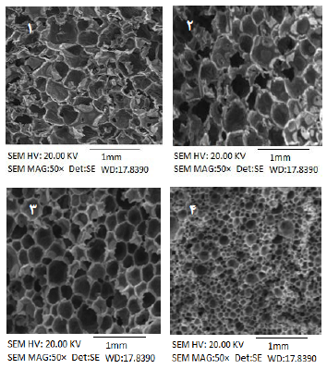
Fig. SEM micrographs of nanocomposite foams with various nanocellulose content, a: Control, b: 1%, c: 3% and d: 5%
Recent Publication
1. Benhamou, K., Kaddami, H., Magnin, A., Dufresne, A., Ahmad, A., 2015. Bio-based polyurethane reinforced with cellulose nanofibers: A comprehensive investigation on the effect of interface, Carbohydrate Polymers, 122, 202-211.
2. Faruk, O., Sain, M., Farnood, R., Pan, Y. F., Xiao, H., 2014. Development of lignin and nanocellulose enhanced bio PU foams for automotive parts, Polymer Environment, 22, 279–288.
3. Hu, S., Li, Y., 2014. Two-step sequential liquefaction of lignocellulosic biomass by crude glycerol for the production of polyols and polyurethane foams, Bioresource Technology 161: 410–415.
4. Li, Y, Luo, X, Hu, S, 2015, Bio-based Polyols and Polyurethanes, Chapter 2, pp, 15-30.
5. Mahmood, N., Yuan, Z., Schmidt, J., Tymchyshyn, M., Xu, C., 2015. Hydrolytic Liquefaction of Hydrolysis Lignin for the Preparation of Bio-based Rigid Polyurethane Foam, Green Chemistry, 1, 2-24.

 Rabi Behrooz obtained his ph.D. from Grenoble University of Technology in France in 2006. At now he is associate professor in Wood and Paper Science and Technology Department of Tarbiat Modares University. His research area is on wood and lignocellulosic chemistry and nanotechnology especially nanocellulose preparation and characterization and nanocomposite from lignocellulose-based bio polymers : rabi.behrooz@modares.ac.ir

