Antagonist effect of ZnONPs on Adipocytes through the inhibition of Peroxisome Proliferator-Activated Receptor gamma (PPARγ)- a Novel Approach

Manikandan A¹, Balaji.P², Srinivasan.V¹, Arun .S¹, Rajkumar.K.S¹, Dinesh Babu M, Thirumurugan.R^{1, 2}
¹Laboratory of Aquabiotics/Nanoscience, Department of Animal Science, School of Life Sciences, Bharathidasan University, Tiruchirappalli-620 024, India.
²National Centre for Alternatives to Animal Experiments, Bharathidasan University,
Tiruchirappalli-620 024, India.

Abstract
Nanotechnology is a fast emerging field which deals with the synthesis of nanoparticles having a variety of applications in various fields. Zinc oxide nanoparticles were synthesized biologically using plant leaf extract of Syzygium cumini (Java plum) as a reducing agent. This medicinal plant has various properties attributed to the presence of bioactive compounds such as phenols, flavonoids, and tannins in different parts of the plant, although lack in the knowledge on their action of mechanisms. Synthesis of nanoparticles was confirmed by the UV- Vis peak at a specific wavelength and characterized by X-ray diffractometer (XRD), Fourier transform infrared spectroscopy (FT-IR), Scanning electron microscopy (SEM) and Transmission Electron Microscope (TEM). The bio stabilized nanoparticles were studied as a potential antioxidant, antimicrobial agent. ZnoNPs improve many of the indices in various diabetic dysfunctions. In vitro models will be the best option for the screening phase of drug discovery and testing the pharmacological activity of the compound. With this evidence, this study was designed to evaluate the invitro anti- diabetic nature of the ZnONPs in Adipocytes, particularly PPARγ (peroxisome proliferator-activated receptor gamma) which plays a critical role in peripheral glucose homeostasis and insulin sensitivity. PPARγ was inhibited by ZnONPs and enhance the insulin sentivity and lipid accumulation. This study confirmed the efficiency of ZnONPs as the potential anti-diabetic agent.

Keywords: Nanoparticles, Anti-diabetic, Adipocytes, PPARγ

Graphical abstract
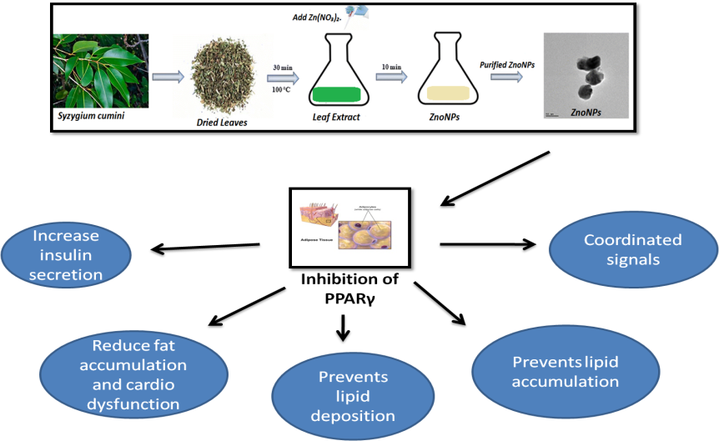

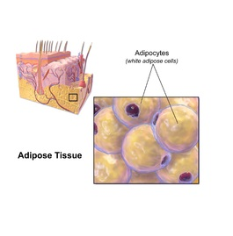

Recent Publications (minimum 5)
- Hasegawa, Y., Ikeda, K., Chen, Y., Alba, D. L., Stifler, D., Shinoda, K, & Chi, J. (2018). Repression of adipose tissue fibrosis through a PRDM16-GTF2IRD1 complex improves systemic glucose homeostasis. Cell metabolism, 27(1), 180-194.
- Russo, L., & Lumeng, C. N. (2018). Properties and functions of adipose tissue macrophages in obesity. Immunology.
- Jang, J. Y., Bae, H., Lee, Y. J., Choi, Y. I., Kim, H. J., Park, S. B., ... & Han, B. W. (2018). Structural Basis for the Enhanced Anti-Diabetic Efficacy of Lobeglitazone on PPARγ. Scientific reports, 8(1), 31.
- Mishra, P. K., Mishra, H., Ekielski, A., Talegaonkar, S., & Vaidya, B. (2017). Zinc oxide nanoparticles: a promising nanomaterial for biomedical applications. Drug discovery today.
- Kusminski, C. M., Bickel, P. E., & Scherer, P. E. (2016). Targeting adipose tissue in the treatment of obesity-associated diabetes. Nature reviews Drug discovery, 15(9), 639.


Biography
Manikandan Arumugam has completed his M. Tech Biotechnology, and joined as research scholar in the department of Animal Science, school of Life Sciences,Bharathidasan University, Tiruchirappalli-24, Tamil Nadu, India. He is working on synthesizing nanoparticles from various plant extracts and evaluate its biomedical applications Email: manikandan0312@gmail.com

