Rubroboletus himalayensis: A new species of Boletes from coniferous forests of Pakistan
Samina Sarwar, PhD, Assistant Professor, Department of Botany, LCWU, Lahore
Zeb Siddique, PhD, Professor, Department of Botany, LCWU, Lahore
Aysha Bashir, MS Researcher, Department of Botany, LCWU, Lahore
Sobia lyas, , PhD, Assistant Professor, Department of Botany, LCWU, Lahore
Abdul Nasir Khalid, Professor, Department of Botany, University of the Punjab, Lahore
Bryn Masson Dentinger, Natural History Museum of Utah, University of Utah, Salt Lake City, UT, USA

Abstract (300 word limit)
Rubroboletus himalayensis (Boletes) is described as new species from Himalayan range of Pakistan. A comprehensive description, photographs, and comparisons with morphologically similar and phylogenetically related species are provided. Conclusions of its phylogenetic relationships within the genus are provided based on the sequence of the nuclear internal transcribed spacer (ITS) region.

Image
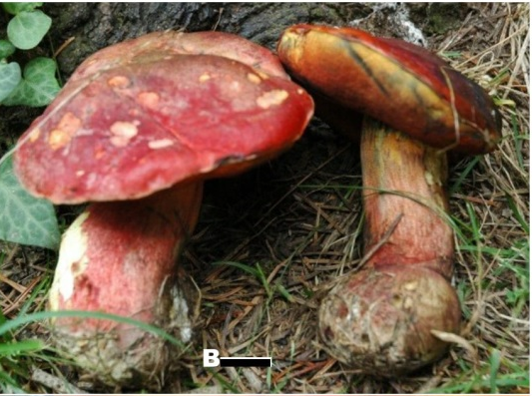

Recent Publications (minimum 5)
- AROOJ NASEERª, SAMINA SARWAR^{b,*}, ABDUL NASIR KHALID^{c}, ROSANNE HEALY^{d} & MATTHEW E. SMITH^{d}. 2019. Hortiboletus kohistanensis: a new species from temperate and subalpine oak forests of Pakistan. Phytotaxa. 388 (3): 239–246.
- Samina Sarwar*, Sana Jabeen, Ishtiaq Ahmed, Bryn M. Dentinger & Abdul Nasir Khalid (2018). Boletus himalayensis (Basidiomycota; Boletales), a new porcini species from Pakistan. Turkish Journal of Botany. 42, 790-800.
- S. Sarwar*, M. Saba, A.N. Khalid and B.M. Dentinger. (2018). Suillus himalayensis (Boletales; Basidiomycota; fungi) and first report of its ectomycorrhizae with pinus wallichiana from coniferous forests of Pakistan. The Journal of Animal and Plant Sciences, 28(2): 576-584.
- Samina S, Tahreem M, Shabnum S, Farah K, Qudsia F, Muhammad H 2017 – Micromycete diversity associated with the rhizospheres of plants from different polluted soils of Lahore, Pakistan. Current Research in Environmental & Applied Mycology 7(3), 193–202, Doi 10.5943/cream/7/3/6
- Hernández-Restrepo, M., Schumacher, R. K. Wingfield, M. J. Ahmad, I, Cai, L., Duong, T, A. Edwards, J., Gené, J., Groenewald, J. Z., Jabeen, S., Khalid, A. N. Lombard, L. Madrid, H., Marin-Felix, Y., Marincowitz, S., Miller, A. N. Rajeshkumar, K. C., Rashid, A., Sarwar, S., Stchigel, A. M., Taylor, P. W. J., Zhou, N. & Crous, P. W. 2016. Fungal Systematics and Evolution: FUSE 2. Sydowia, 68: 193–230. (Impact Factor: 0.7)
- Samina Sarwar*, Sana Jabeen, Abdul Nasir Khalid and Bryn Masson (2016). Molecular and phylogenetic analysis of fleshy pored mushrooms: Neoboletus luridiformis and Hortiboletus rubellus from western Himalayan range of Pakistan. Pakistan Journal of Botany, 48(5): 2077-2083 (Impact factor: 0.822).
- Samina Sarwar*, Malka Saba, Abdul N. Khalid & Bryn M. Dentinger. (2015). Suillus marginielevatus, a new species and S. triacicularis, a new record from Western Himalaya, Pakistan. Phytotaxa 203 (2): 169–177.http://dx.doi.org/10.11646/phytotaxa.203.2.6 (Impact Factor: 1.38)
- Jabeen S, Sarwar S*, Niazi ARK, Khalid AN. 2014. Checklist of Ectomycorrhizae from Pakistan. Annals of Applied Bio-Sciences.1:R10-R20 (Impact Factor: 0.158) DOI: 10.21276/aabs
- S. Sarwar*, A. N. Khalid & A. R. Niazi. (2014). Tylopilus: a new species and a new record from Pakistan. Mycotaxon. 128: 1-10. (Impact Factor: 0.64)
- S. Sarwar*, A. N. Khalid. (2014). Boletus pakistanicus sp. nov. from coniferous forests of Pakistan based on molecular characterization. International Journal of Agriculture & Biology 16: 663‒667.(Impact Factor: 0.90)
- S. Sarwar*, A.N. Khalid. (2014). Diversity and phylogeny of genus Suillus (Suillaceae, Boletales) from coniferous forests of Pakistan (Asia). International Journal of Agriculture & Biology, 16: 489‒497.(Impact Factor: 0.90)
- S. Sarwar*, S. Jabeen¹ and A.N. Khalid¹. (2013). Additions to Ectomycorrhizae associated with Populus ciliata Wall. Ex Royle from Pakistan. Journal of Yeast and Fungal Research 4(3): 26-32.
- S. Sarwar*¹, A.N. Khalid², M. Hanif³& A.R. Niazi⁴. (2012). Suillus flavidus and its ectomycorrhizae with Pinus wallichiana in Pakistan. Mycotaxon 121: 225-232. (Impact Factor: 0.64)
- S. Sarwar*, A.N. Khalid. (2012). A checklist of Boletales in Pakistan. Mycotaxon121: 12pp (Impact Factor: 0.64)
- S. Sarwar*, M.Hanif, A.N.Khalid & J. Gulnberteou. (2011). Diversity of boletes in Pakistan, focus on Suillus brevipes and Suillus sibiricus. Proceedings of 7thinternational conference on Mushroom Biology and Mushroom Products, Arcachon, France. Volume 1: pp 123-133.
- M.Hanif, A.N.Khalid and S. Sarwar (2011). Additions to the ectomycorrhizae associated with Himalayan Cedar (Cedrus deodara) using rDNA –ITS. International Journal of Agriculture & Biology 14(1): 101-106. (Impact Factor: 0.90)



Biography
Dr. Samina Sarwar is a young mycologist from Pakistan. She did her Ph.D. from University of the Punjab, Pakistan in 2013 in Botany with specialization in Mycology. She has completed her part of research (Molecular analyses of mushrooms) in Royal Botanic Gardens, Kew, UK. She published a number of research articles in scientific journals of national and international repute. She is the reviewer and as well as member of the editorial board of different journals. She is external examiner in different universities of Pakistan. She has supervised many research students in her career. She is an active researcher and good Mycologist.
Email: samina_boletus@yahoo.com

Notes/Comments:

