The Expanding World of SUMO: from Epigenetics to Adaptive Mechanisms and Cellular Aging

Hong-Yeoul Ryu^{1,}*
¹School of Life Sciences, College of National Sciences, Kyungpook National University, Daegu 41566, Republic of Korea. *Correspondence

Abstract (300 word limit)

Environmental changes induce many acute and long-term adaptive cellular responses. Mammals have diverse adaptive mechanisms for stress resistance, such as immune responses to pathogens or hormone-mediated homeostatic processes. At the cellular level, acute changes in the local microenvironment, such as changes of pH or temperature, oxidative stress, or nutrient limitation, may induce programmed cell death or trigger adaptive changes that include gene mutation, aneuploidy, changes in gene expression or epigenetic alterations. The small ubiquitin-like modifier (SUMO) protein is a conserved post-translational modifier that regulates a host of proteins in eukaryotic cells and maintains cell homeostasis when the cell encounters endogenous or environmental stress, such as osmotic stress, hypoxia, heat shock, genotoxic stress, and nutrient stress. In response to acute loss of the Ulp2 SUMO-specific protease, yeast become disomic for chromosome I (ChrI) and ChrXII. Here we report that ChrI disomy, which creates an adaptive advantage in part by increasing the dosage of the Ccr4 deadenylase, was eliminated by extended passaging. Loss of aneuploidy is often accompanied by mutations in essential SUMO-ligating enzymes, which reduced polySUMO-conjugate accumulation. The mRNA levels for almost all ribosomal proteins increase transiently upon initial loss of Ulp2, but elevated Ccr4 levels limit excess ribosome formation. Notably, extended passaging leads to increased levels of many small nucleolar RNAs (snoRNAs) involved in ribosome biogenesis, and higher dosage of three linked ChrXII snoRNA genes suppressed ChrXII disomy in ulp2Δ cells. Our data reveal that aneuploidy allows rapid adaptation to Ulp2 loss, but long-term adaptation restores euploidy. Cellular evolution restores homeostasis through countervailing mutations in SUMO-modification pathways and regulatory shifts in ribosome biogenesis.
Image
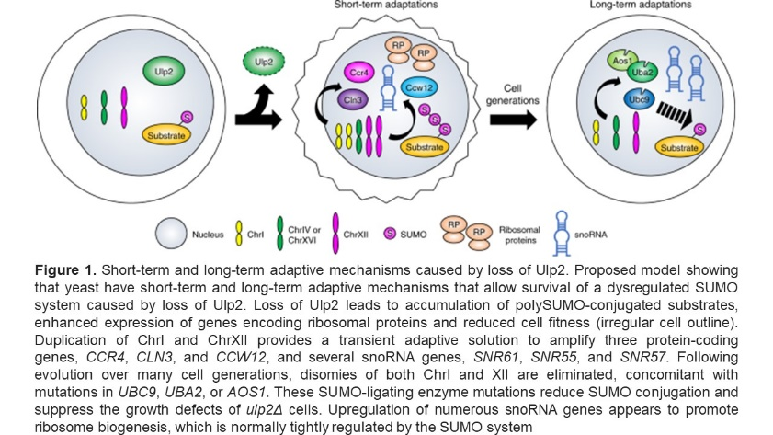
Recent Publications (minimum 5)

Ryu, et al. (2020). SUMO and cellular adaptive mechanisms. Experimental & Molecular Medicine 52, 931-939

Ryu, et al. (2019). The Ulp2 SUMO Protease Promotes Transcription Elongation through Regulation of Histone Sumoylation. EMBO journal 38, e102003.

Ryu, et al. (2018). Distinct adaptive mechanisms drive recovery from aneuploidy caused by loss of the Ulp2 SUMO protease. Nature Communications 9, 5417.

Ryu, et al. (2016). Loss of the SUMO protease Ulp2 triggers a specific multichromosome aneuploidy. Genes & Development 30, 1881-1894.

Ryu, et al. (2014). Yeast histone H3 lysine 4 demethylase Jhd2 regulates mitotic rDNA condensation. BMC Biology 12, 75.

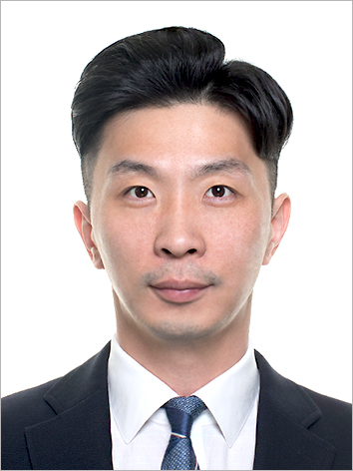Biography (150 word limit)
Hong-Yeoul Ryu is a professor of School of Life Sciences at Kyungpook National University. He studied biochemistry and obtained his Ph.D. from Hanyang University (2015), and his dissertation was on Regulation of Heterochromatic Silencing by JmjC-domain Containing Histone Demethylases. As a postdocoral fellow in the laboratory of Mark Hochstrasser at Yale University (USA), he studied the role of ubiquitin and SUMO (small ubiquitin-like modifier) systems in transcription and adaptive mechanisms to cellular stress. Since 2020, he has worked as a professor at Kyungpook National University, South Korea. The major focus of his current research is to determine the role of SUMO in the field of epigenetics and cellular aging and to unravel the correlation between SUMO and adaptive mechanisms by applying the in vitro evolution technique.
Email: rhr4757@knu.ac.kr

Notes/Comment

