Mitogen-Activated Protein Kinase Kinase (MAPKK) : A Signaling Molecule confers salt tolerance in plants
Nazia Rehman
National Institute for Genomics and Advanced Biotechnology (NIGAB), NARC, Islamabad Pakistan
Muhammad Ramzan Khan
National Institute for Genomics and Advanced Biotechnology (NIGAB), NARC, Islamabad Pakistan

Abstract (300 word limit)
- Statement of the Problem: Plants are directly influenced by abiotic and biotic stresses due to a sessile lifestyle. Stresses adversely affect the growth and productivity of plants. Methodology & Theoretical Orientation: Mitogen-activated protein kinase (MAPK) cascade is conserved in eukaryotic organisms and plays a crucial role in signal transduction pathways, related to biotic and abiotic stress responses. The current study was aimed to target at cloning, structural and functional characterization of 1023bp SeMAPKK gene from Salicornia europaea. Findings: A SeMAPKK polypeptide chain of 340aa has eleven sub-domains, and S/TXXXXXS/T residues are conserved in the activation loop site between VII-VIII sub-domains. We identified TVY and MEY motifs at N-terminus and LKY, CAY and SKY motifs at C-terminus. Phylogenetic relationship revealed that SeMAPKK belongs to group D. Highest transcript signals were recorded in 0.75 M salt level stress, and down-regulation was observed in 1.0 M salt concentration. Overexpression of SeMAPKK gene in Arabidopsis conferred salt tolerance. Results of different salt tolerance assays revealed that transgenic plants were more tolerant and exhibited better growth than nontransgenic plants under salt stress. Conclusion & Significance: SeMAPKK gene is recruited in salinity tolerance as evident from overexpression in Arabidopsis, transgenic plants exhibited high tolerance response than wild plant under salt treatments. Expression analysis revealed induction and up-regulation of SeMAPKK transcripts under salt stress. Genes of MAPK cascade are categorized into four groups (A-D), the phylogenetic study has classified the SeMAPKK in group D and made a lineage with SbMAPKK. These findings support the study of salt tolerant genes and their potential employment for metabolic engineering in agriculture.

Image
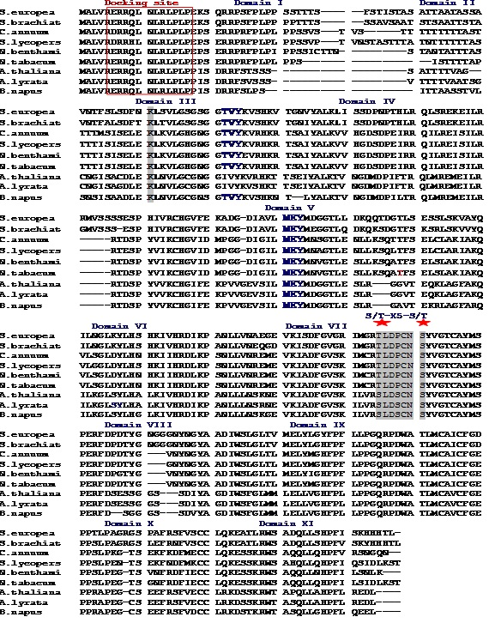
Figure 1. Conserved domains and motif in MAPKs protein.
Protein multiple alignments revealed 11 conserved subdomains. In the activation loop between VII and VIII subdomain S/T-X5-S/T motif is present highlighted by grey color and with red asterisk. At N-terminus TVY and and MEY motifs are presently shown by blue bold letters. Conserved docking domain is marked by a red box.

Recent Publications (minimum 5)
- Rehman N., Inam, S Khan M R (2020) Speed Cloning Leading to Speed Breeding Through Genome Editing. Adv Crop Sci Tech. 8:442. DOI: 10.35248/2329-8863.20.8.442
- Rehman N. Khan M R, Abbas Z, Raja Sheraz Rafique, et al., (2020). Functional characterization of Mitogen-Activated Protein Kinase Kinase (MAPKK) gene in Halophytic Salicornia europaea against salt stress. Environmental and Experimental Botany 171 (2020) 103934
- Hussain T., Rehman N., Inam S., Farahat UM., Ibrahim S., Afroz A., Ali GM., Khan M R (2019). Homotypic cis clusters in the large intron of AGL24 MADS-BOX gene recruited in the enhancement of floral expression. PMBR DOI 10.1007/s11105-019-01136-7.
- Rehman, N., Khan, MR., Ali, G.M. (2017): Novel phytoene synthase paralog from halophytic Salicornia plant confers salinity tolerance.Turkish Journal of Botany, doi:10.3906/bot-1605-18.
- Proteomics approach to address low seed germination in Cyclobalnopsis gilva (2017) Zaynab M., Kanwal S.,Furqan M.,AliG.M., Rehman N., Zafar S., Sughra S., Jahanzab M. Biotechnol Lett., DOI 10.1007/s10529-017-2393-3.



Biography (150 word limit)

Dr. Nazia Rehman serving as a senior scientific officer, in National Institute for Genomics and Advanced Biotechnology (NIGAB), Pakistan. My principal expertise and interests are in the area of Plant Molecular Biotechnology. I have cloned and functionally characterized the stress and related genes from halophytic Salicornia plant. Moreover, I was involved in isolation and characterization of vitamin related genes from Sea buckthorn.
Currently, I am working on Genome editing of wheat through CRISPRcas9/dCas9 for yield enhancement. I have presented my Scientific work at different forum.
Email: naziarehman96@yahoo.com

Notes/Comments:

