Transcriptional regulation of the genes involved in skin-regeneration using protein delivery

Jee-Eun Yang, Sang-Kyou Lee*
Yonsei University, Seoul, Republic of Korea

Abstract (300 word limit)
Photoaging caused by UVB-irradiation leads to extracellular matrix damage. Most of the skin aging phenomenon is due to the loss of collagen and elastin fibers in dermal layer. ICE-1 and ICE-2 are important transcription factors involved in type Ⅰ collagen synthesis. To increase type Ⅰ collagen synthesis by regulating the activity of these transcription factors, we designed the intranuclear transcription modulation domains (TMD) of ICE-1 and ICE-2 which can be delivered effectively into the nucleus by being conjugated with protein transduction domain (PTD). Overexpressed ICE-1 and ICE-2 gene through transient transfection and treatment of purified recombinant proteins, pICE-1and pICE-2 upregulated type Ⅰ collagen synthesis on UVB-damaged human dermal fibroblast. In conclusion, transcriptional regulation of type Ⅰ collagen gene by using transcription modulation domains of ICE-1 and ICE-2 may have a significant anti-photoaging effects in human dermal fibroblast.

Keyword: skin aging, photoaging, type Ⅰ collagen, TMD, PTD

Image
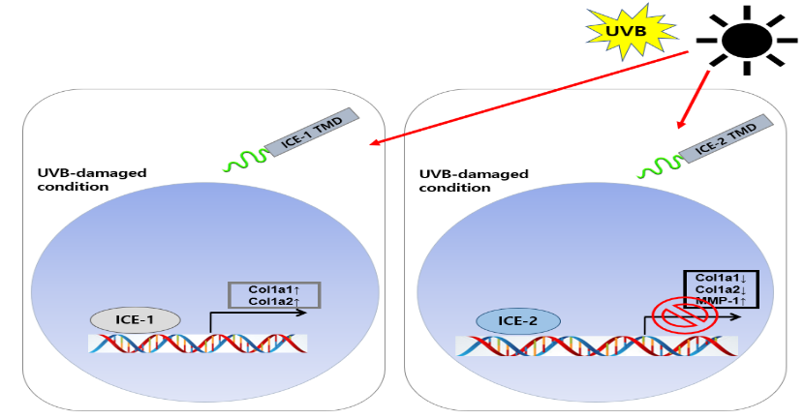

Figure 1: Anti-photoaging effects of TMD of ICE-1 and ICE-2 on UVB-damaged human dermal fibroblast

Biography (150 word limit)
Jee-Eun Yang
Department of Biotechnology, College of Life science and Biotechnology, Yonsei University, Seoul, Republic of Korea
Master’s course in Biotechnology
Email: lovableboby@naver.com

Notes/Comments:

