Automatic Spot Search and Color Classification in ELISPOT Assay
Sergey S. Zadorozhnyy, PhD,
Moscow State University, Russia

Abstract
Accuracy of spot detection and classification plays a critical role in the analysis of ELISPOT data. Differences in staining intensities of spots and their morphological variations make it difficult developing a reliable software application. We developed an image recognition method allowing the automatic detection and classification of round objects (spots) on ELISPOT images independently of the registration conditions. The emphasis is done on objects of elliptical shape, which is typical for a wide range of spots. Since it is required to analyze both monochrome and bicolor objects, we developed the method of object subdivision into groups according of their color attributes.
It is known that identical objects can look dramatically different depending on illumination conditions and optical characteristics of objects. This hinders the analysis and interpretation of the objects when image processing must be independent of its registration conditions. Morphological image analysis methods proved their efficiency for solving such problems,
Mathematical notion of the form comprises the foundation of such methods. The form (e.g., spot shape) is the maximum invariant of image transformations under various registration conditions. That is why the form is defined not only by the analyzed object and by the scene it is on, but is also connected with the model of scene (or object) registration.
In some practical cases, the profiles of objects are predefined. For example, the spots in ELISPOT assay (including dual-color ELISPOT assays) are either round or have a concentric profile. This makes it possible to solve a variety of application problems related to detecting and classifying such objects.

Morphological image analysis combined with the image recognition method allows automatic detection and counting a spots on ELISPOT images with two spots types, independently of the registration conditions and I will present the software what apply it.

Images
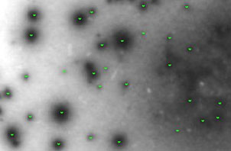
Fig 1. Spots recognition in monochrome ELISPOT image.
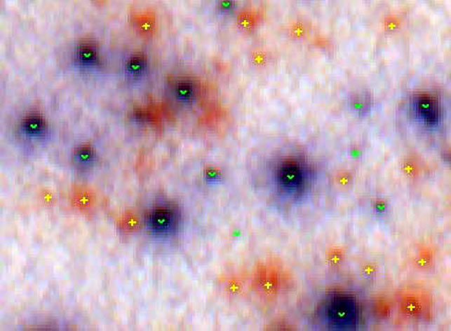
Fig 2. Spots recognition in bicolor ELISPOT image.
Publications
- Pyt'ev Yu.P. Morphological Image Analysis.
Pattern Recognition and Image Analysis.
1993, vol. 3, no 1, pp. 19-28.
- Zhuravlev J. I. An algebraic approach to recognition or classifications problems.
Pattern Recognition and Image Analysis.
1998, vol. 8, no 1, pp. 59–100.

S. S. Zadorozhny, Yu. P. Pyt’ev, A.I. Chulichkov, Morphological methods in automatic recognition of cars’ license plates from their video-images.
Pattern Recognition and Image Analysis.
2000, vol. 10, no 2, pp.288–292.
- Zadorozhny SS, Martynov NN. Mathematical algorithms for automatic search, recognition, and detection of spots in ELISPOT assay.
Methods Mol Biol. 2012, vol. 792, pp 145-53.
doi: 10.1007/978-1-61779-325-7_12.

Zadorozhny SS, Martynov NN. Automatic Search of Spots and Color Classification in ELISPOT Assay.
Methods Mol Biol. 2018, vol. 1808, pp 43-50.
doi: 10.1007/978-1-4939-8567-8_4.

 Biography
Sergei S. Zadorozhnyy. Born 1954, graduated Moscow State University in 1977, and received PhD degree in 1990. Senior Instructor at the Moscow State University, scientiﬁc interests: analysis and interpretation of experimental data, image processing.
Email: zss@mail.ru
Notes/Comments:

