Abstract Template

Title: creation of the “paradict-o” center in Orleans to prevent maternal drug toxicity in breastfed neonate

SERREAU Raphael (MD, PhD, HDR)1, BAJJOU Nacera1, RIGOURD Virginie2, RAI Balwant ³
1Department Clinical Research Institute, “PARADICT-O”, Orléans, France
2Department of Neonatology and Milk Bank, Paris, France
3Department of Dentistry, Copenhaguen , Denmark

Keywords: Breastmilk, xenobiotics, drugs, premature babies

- Abstract Body (up to 300 words)
We studied ibuprofen and ketoprofen, drugs of the class of NSAIDs (profen) at risk during pregnancy. We performed the assays in colostral milk and mature breast milk to verify its compatibility during breastfeeding. The study included 20 breastfeeding mothers, treated orally by a minimum of 3 x 200 mg tablets of ibuprofen in order to reach steady state at least on the 7th day after the delivery. Ibuprofen half-life (t1/2) is previously documented in the literature 114 minutes21. Steady state concentration is achieved when ibuprofen is administered at a constant rate (5 x t1/2 ~ 10 hours), at a minimum of 3 tablets/day of 200 mg ibuprofen.
Women included in our study were among those who seeked information on the compatibility of ibuprofen and breastfeeding by contacting the Medic-Al network. Women below 18 years of age and/or treated by naproxen and/or who have not given their informed written consent were excluded. This study took place from the 1st of January 2011 till the 30th of September 2012.
We want to offer breast milk as a occupationnal medicine health matrix that would be suitable for monitoring the effects of toxins as endocrine disruptors. A network of pharmacologists and perinatology toxicologists should make it possible to optimize the pursuit of knowledge in this still little studied field.
For this purpose, the "PARADICT-O" Department of Preventive Medicine was created on January 28, 2018 in Orleans to continue the pharmacological research activities set up with the "Médic-Al" network in Paris.

Profenes:
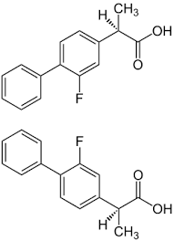
- Reference:

- Rigourd V, de Villepin B, Amirouche A, et al. Ibuprofen concentrations in human mature milk. First data about pharmacokinetics study in breast milk with AOR-10127 "Antalait" study. Ther Drug Monit 2014;36:590-6.
- Serreau R, Boissinot C, Sibony O et al. Drugs and breastfeeding : a French collaboration in a pharmacoepidemiology study. Pharmacoepidemiology and Drug Safety 2004;13:S222.
- Rigourd V, Meritet JF, Seraissol P, Amirouche A, Hachem T, Serreau R. Rapid and sensitive analysis of polymorphisms from breastmilk shows that ibuprofen is safe during certain stages of breastfeeding. Acta Paediatr. 2015;104:e420-1.

Biography:
Upon completion of his doctorate in Pharmacology at the University of Paris V René Descartes in 2007 about Risk Management Plan during pregnancy and breastfeeding, he joined the Center of Clinical Research in Cochin and Necker Hospital in Paris in 2005 where he directed research combining Perinatology and Pharmacology researchs. (www.premup.org). This led to the development of a structure in “Institut de Puériculture de Paris”. He works also as a permanent scientist in Necker University in EA 3620 “VIH Child-Mother Unit”
He became full professor of clinical research in May 2016, ILV University Paris la Defense.
In 2012 with Prof Tabassome Simon (St Antoine Hospital, Paris), Prof Robert Barouki (Necker Hospital, Paris) and Jean-Luc Volatier (ANSES, Maisons - Alfort), Dr Serreau obtained a grant for his research fields about contaminants and breastmilk. He ‘s team got half million euros to do contalait study. 180 women were included in 6 milk banks in France (Lyon, Paris, Lille, Montpellier, Bordeaux and Nantes) during 18 months. Heavy metals, PCB, furans, dioxins and different contaminants were dosed in breastmilk. Tuna Fish consumption and dental filling were responsible of high methyl mercury concentrations in breastmilk. Contaminants should be assess regularly in lactating women.

Presenting author details
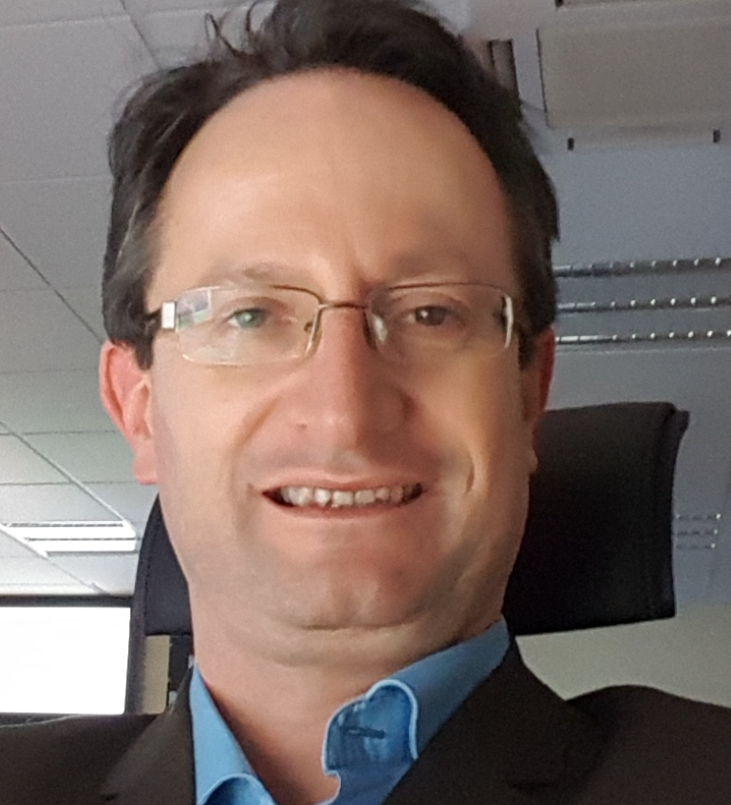
Full Name: Prof R SERREAU
Contact number: +33616386878
Twitter account: Linked In account: https://www.linkedin.com/in/dr-rapha%C3%ABl-serreau-05073118/
Session name/ number:
Category: (Oral presentation/)
Passport Number 18CE67113

