Title: Expansion of Essential RMNCAH Services through Midwifery-Led Health Facilities called Family Health Houses (FHHs) in Rural Remote Areas of Afghanistan

Ahmadullah Molakhail, MD, MPH, UNFPA-Afghanistan, Kabul, Afghanistan

Abstract (300 word limit)
Statement of the Problem: Afghanistan established a network of health facilities under the BPHS since 2003 to ensure equitable access in the country. Still approximately 18% of the Afghan population resides in un(der)served areas mainly because the populations are scattered, distance to facilities, an absence of female health workers, and cultural limitations. Therefore, UNFPA, and MoPH developed &introduced a new model called the Family Heath House (FHH).
Pockets of populations living in very remote areas don’t have access to the essential RMNCH services due to the following reason: 1) Lack of access to health faculties; 2) the literacy rates are quite low; 3) the poverty; poor infrastructure--tertiary roads leading to high maternal and child morbidities and mortalities. The purpose of FHH is to ensure UHC in remote areas through education and deployment of community midwives in un(der)served areas.
Methodology: Both qualitative and qualitative approached were utilized. That is, participant observation, in- depth interviews and focus groups were utilized. In addition, the HMIS data was analyzed and compared with the functional BPHS health facilities. Findings: For the women in this study, the services offered at FHHs were more acceptable compared to other facilities for the following reasons: the health service provider is from their area, privacy, no-stock-out, and sufficient time in consultation by the midwives. Overall the utilization is very high compared to BPHS health facilities. Conclusion & Significance: Expansion of FHH offers a unique opportunity to increase equity in access to essential RMNCH services. Prior to FHH those deliveries were less likely receiving and used to give birth at home. It is realized by all that FHH Model is a strong intervention that could ensure UHC in the country. FHHs are functional even in very insure areas.
Recommendations: the FHH should be scaled-up throughout the country to ensure UHC

Image

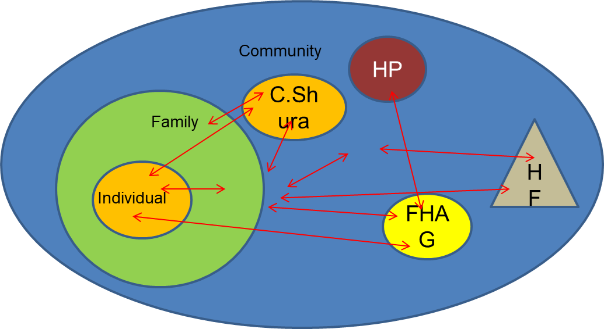

Recent Publications (minimum 5)
- Sherratt D, and Sharifi Khalid, the Mid-term Review (MTR of FHH, 2015
- Afghanistan Maternal Mortality Survey (AMS), 2010-2011
- Demographic Health Survey (DHS) (2015), the Ministry of Public Health
3. Central Statistics Organization. National Risk and Vulnerability Assessment 2011-12. Afghanistan Living Condition Survey. Kabul: CSO, 2014. [NRVA 2011-12]. Afghanistan Mortality Survey (AMS) (2010), the Ministry of Public Health
5. Islamic Republic of Afghanistan, Ministry of Public Health, Johns Hopkins Bloomberg School of Public Health, Indian Institute of Health Management Research. Afghanistan Health Survey 2012. Kabul: MoPH 2013. [AHS 2012]


Biography ):

Ahmadullah Molakhail has his expertise in RMNCAH in improving the health and wellbeing of mothers, newborn and children in developing countries. Being with UNFPA since 2009, he has developed and introduced a new model of health service delivery called Family Health House (FHH) in partnership with the Community-based Healthcare Department of the Ministry of Public Health of Afghanistan. He has developed and introduced this model after having education, and years of experience and experience in heath service delivery, teaching and administration in community health care. This approach is a completely new one and responsive to the needs of the communities for the essential RMNCH services in remote areas of Afghanistan. UNFPA-Afghanistan works with the Ministry of Public Health (MoPH) of Afghanistan in policy development and health service delivery.
Email: molakhail@unfpa.org, molakhail1971@gmail.com

Notes/Comments:

