Midwifery and Women`s Health
London, United Kingdom October 25-27, 2018
. June 28 – July 3, 2015
 | PARTICIPANT’S PROFILE
Name and surname: | Dr Ahmadullah Molakhail
Current position: | National Program Coordinator for the Community-based RMNCH Program called Sub-national Program
Organization: | UNFPA-Afghanistan
Country: | Afghanistan
Participant’s Picture | 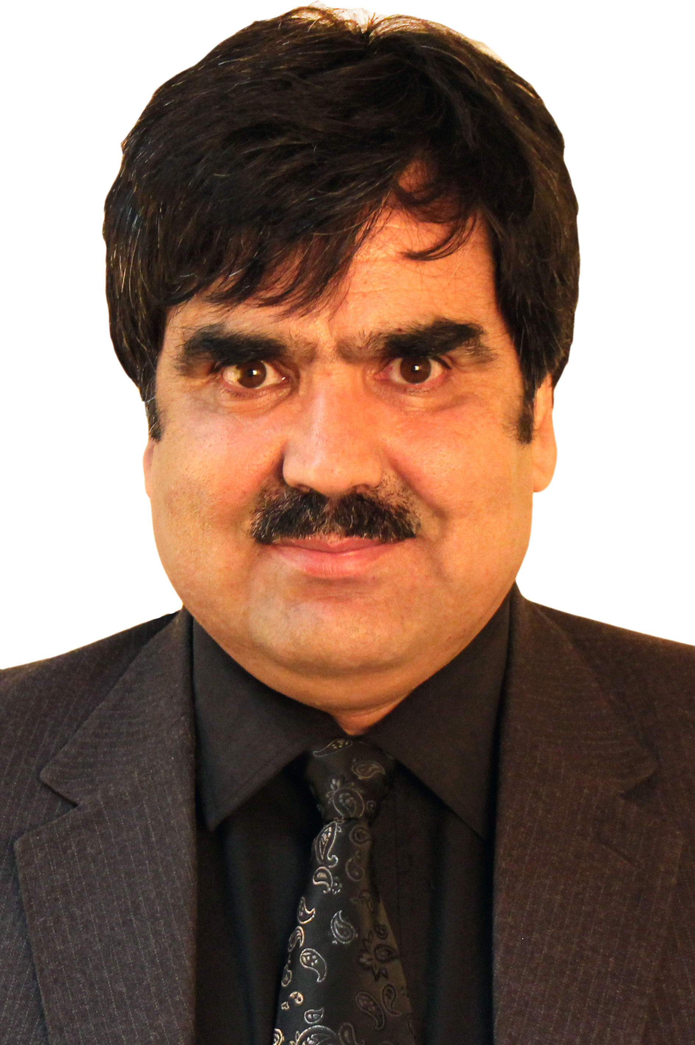
Short bio-sketch:  (250-500 words) | Dr. Ahmadullah MOLAKHAIL, MD, MPH  Name: Ahmadullah Molakhail  Age: 47 years old (Born on July 06, 1971)  I Did residency at Attaturk Children’s Teaching Hospital in Kabul  In Jan 2002, I joined Aide Medical International (AMI) and French INGO as Program Coordinator for its Nutrition Program. I established 4 Therapeutic Feeding Centers (TFCs) and run 14 Supplementary Feeding Centers (SFCs) and one Day Care in seven provinces of the country.  In January 2003, I joined International Medical Corps (IMC) and American INGO as Provincial Program Coordinator, and then promoted to the position of Provincial Program Manager in Khost Province, in South-east of Afghanistan. In Khost, we had C1 clinics and CEmONC.  In April 2004, I joined Management Sciences for Health (MSH), for USAID-REACH program as public health advisor (PHA) for the south-eastern region. I was advisor to three provinces for USAID-Reach Program in South-eastern region where we a multi-million dollar and Health, Midwifery Education and Literacy for Life Program  In 2005, I received a one year Fellowship from US Embassy in Kabul from the US Embassy in Kabul to study Public Health Policy with fous on RMNCH in developing countries at Gillings School of Global Health at the University of North Carolina, Chapel Hill, NC, USA.  In 2006, I got another short-term fellowship called Summer School of Public Health Fellowship from Boston University, MA, USA. I studied Foundations of International Health and Community Health.  In Sep 2006, I joined Social and Health Development Program (SHDP) as Health and Community Development Director till September 31, 2009. We had health, community development and research projects.  In 2008, I received an 8 month UNITAR fellowship from Hiroshima University where and studied Leadership, organizational development, and project management.  From Oct 01, 2009 until now I work as Program Coordinator-Community Development Specialist with UNFPA-Afghanistan for its community-based Sub-national Program, which is focused on RMNCH.  In my current Job which is mainly focused on RMNCaH Services and Human Resource Development for Health through training of community midwives in five provinces of the country, I have designed and initiated a new model of RMNCH service delivery called Family Health Houses-Mobile Support Teams (FHH-MST). This is being piloted in five provinces of the country. Its mid-term review is ongoing. Following gaining favorable results, the model will be integrated into Basic Package of Health Services (BPHS) which will be replicated in other parts of the country as well.  This will substantially increase access to RMNCAH services in remote and hard-to-reach areas which will subsequently contribute in reducing the maternal, neo-born and child morbidities and mortalities in this country.  I will share the concept of FHH Model and MTR Report upon request  Membership in Professional Associations:  - Co-founder and Member of Social Development Association (SDA)  - Member of International Society on Child Abuse and Neglect (ISPCAN)  Publications:  - New ways of Access to SBA through Family Health Houses in Afghanistan at 6th APCRSHR in Yogyakarta, Indonesia in 2011  - Community Midwifery Education (CME) program and its role in human resource development (HRD) and SBA in health facilities in Afghanistan , selected and presented at 5th APCRSHR in Beijing, China in 2009  - Violence Against children in Afghanistan and its compression with its neighboring countries: selected and presented as oral presentation at 18th ICAPAP Conference, Istanbul, Turkey  - HIV/AIDS in rising Afghanistan: poster presentation at 8th ICCAP Conference on HIV/AIDS in Colombo, Sri Lanka  - Emergence of HIV/AIDS in Afghanistan, my paper was published in Abstract Book of XVI International AIDS Conference that was held in Toronto, August 13-18, 2006

