Reference ranges and trajectories for blood pressure in pregnancy: findings from a follow-up study based on China Maternal and Newborn's Health Monitoring System
Yijie Ma, MS, School of Public Health, Peking University, China
Keye Wu, MS, School of Public Health, Peking University, China
Wei Zhao, MS, National Center for Women and Children's Health, China
Huanqing Hu, MS, National Center for Women and Children's Health, China
Qi Yang, MD, PhD, National Center for Women and Children's Health, China
Aiqun Huang, MD, PhD, National Center for Women and Children's Health, China
Dafang Chen, MD, PhD, School of Public Health, Peking University, China

Abstract:
Objectives: The aims of this study are to establishing blood pressure reference ranges across pregnancy for different subgroup women without adverse birth outcomes, and to guide pregnant women to regulate and control their blood pressure rationally with the reference ranges.
Methods: The study was a follow-up study. Data for this analysis was obtained from Maternal and Newborn’s Health Monitoring System including 46428 pregnant women who delivered live singletons between October 2013 and September 2015 among 6 provinces in China. The blood pressure reference ranges were developed by multilevel restrictive cubic spline model.
Results: The reference range of the SBP of pregnant women with healthy birth outcomes increased with the gestational weeks. The reference range of diastolic blood pressure decreased after the pregnant metaphase, and then increased, and the lowest point was about 19 weeks. Compared with normal group, SBP were lower for underweight group, higher for overweight group, and higher for obese group. Similarly, compared with normal group, DBP were lower for underweight group, higher for overweight group, and higher for obese group. SBP and DBP of older women were higher than middle-aged women while young women lower than middle-aged women. There was no much difference between nulliparous women and multiparous women.
Conclusion: This study gave the reference ranges for blood pressure in pregnancy of Chinese women, which may instruct doctors and pregnant women to control the blood pressure of pregnant women legitimately.
Key worlds: pregnancy blood pressure; reference range; Chinese women;

Image:
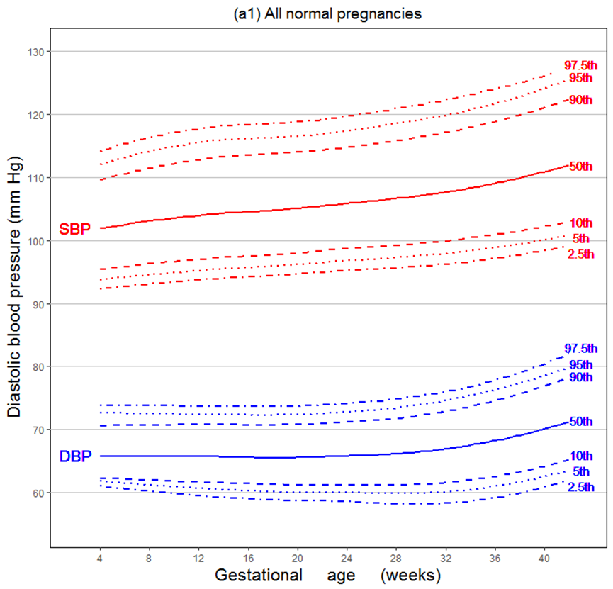

About the author:
Yijie Ma graduated from the School of Public Health, Peking University and now doing some postgraduate research of maternal and child health under the guidance of professor Chen.
Dafang Chen, PhD, professor and doctoral supervisor in the department of epidemiology and health statistics at the school of public health, Peking University. Chen's main research direction is chronic disease molecular epidemiology, medical research data mining, and maternal and child health research. Chen organized and participated in a number of international scientific research projects, published more than 200 scientific papers, including 86 SCI papers.

