Abstract Template

Title: A Practical System for the Quantitative Determination of Nitrate and Nitrite in the Field

Amer Charbaji, Hojat Heidari-Bafroui, Constantine Anagnostopoulos, Mohammad Faghri
Microfluidics Laboratory, Department of Mechanical, Industrial and Systems Engineering, University of Rhode Island, Kingston, RI 02881, USA

Keywords: Paper-based devices, Nitrate detection, Nitrite detection, Griess reaction, Low-cost platforms

- Abstract Body (up to 250-300 words)

As paper-based devices have been gaining interest over the past several years, so has the color analysis techniques broadly utilized for measuring signal intensity in colorimetric sensors. Therefore, it is critical to properly analyze the colored signal that forms so as to gain as much information as possible and properly characterize the concentration of the analyte. Of particular interest is paper-based devices for measuring the concentrations of nitrate and nitrite using the Griess assay. Most of the paper-based devices utilizing the Griess reaction have used a desktop scanner to capture the signal formed and a computer image processing software to digitize the signal and quantify it. Digitizing the colorimetric signal left room for the operator to choose the color channel to be used in measuring the concentration of the analyte of interest. In this paper, we provide a comparison between the response of the different color channels that can be used with their corresponding limits of detection and quantification for the signal produced on a commercially available dip strip and a paper-based device utilizing the Griess assay for detection. Our analysis shows that the green channel in the red, green and blue color breakdown provides the largest difference in signal over concentration of nitrate or nitrite which makes it easier to differentiate between concentrations and yields the best limits of detection and quantification. Also, drying a solution of sulfanilamide and citric acid on chromatography paper and storing under cold conditions (≤ 4 °C) showed minimal change in color over 100 days compared to storing under room conditions. Lastly, we propose using a lightbox with green LEDs (λ ≈ 540 nm) that can be remotely controlled via a cellphone for infield analysis of paper-based devices utilizing the Griess assay for detecting nitrate and nitrite.

- Image:
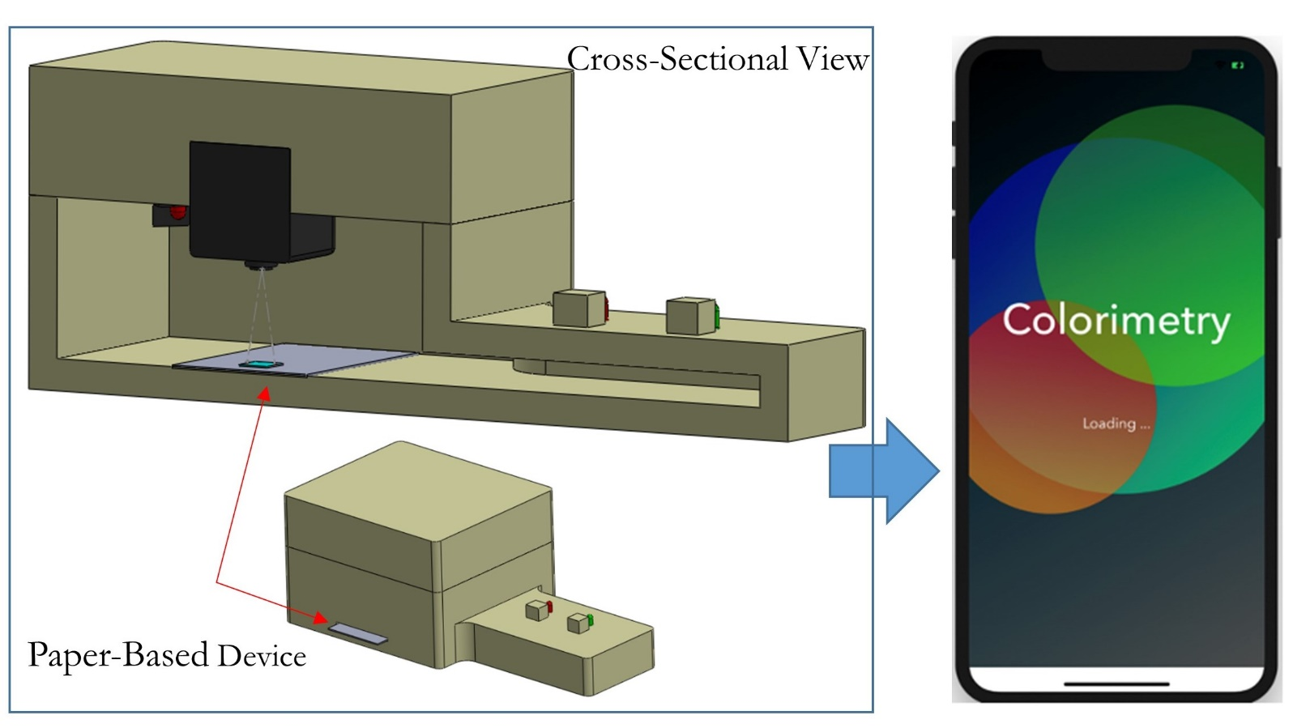

IV. Biography:

Amer Charbaji is a research assistant at the Microfluidics Laboratory at the University of Rhode Island where he is currently pursuing his PhD. His research work includes developing paper-based microfluidic devices for nutrient detection in marine environments. He received his Bachelor of Engineering degree from the American University of Beirut and his Master of Science degree from the University of Maryland at College Park, both in mechanical engineering. He also worked in the industry in Nigeria and Dubai before joining the PhD program at URI.

    - Presenting author details

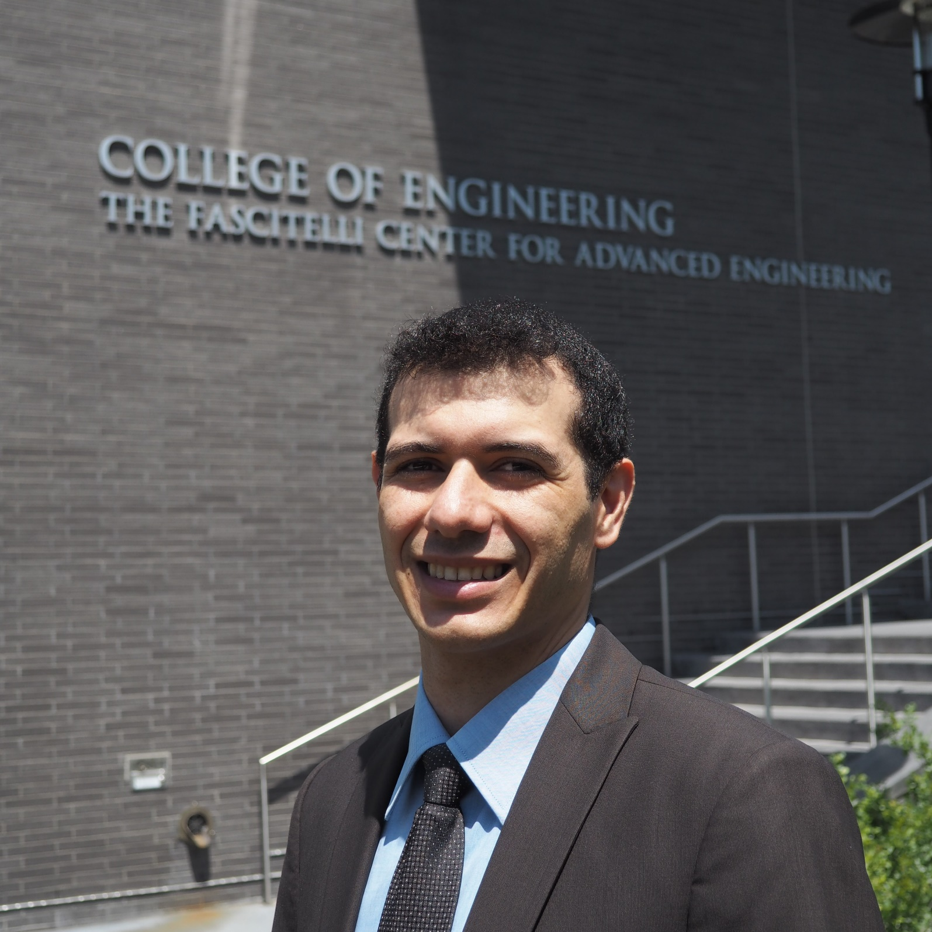

Full Name: Amer Charbaji
Email id: charbaji@uri.edu

Contact number:

Linked In account: Micro/Nanofluidics Research and Advances
Session name/ number:

Category: Oral presentation

