Title: High-precision MSM micropumps for integration on lab-on-chips

Hu Hao¹, Andrey Saren¹, Kari Ullakko¹
¹Lappeenranta-Lahti University of Technology, Finland

Keywords: Microfluidic, Micropump, Lab-on-chips, Magnetic shape memory, Ni-Mn-Ga

- Abstract

Controlling the flow of fluids at a high precision has been a technological challenge in microfluidics. There is an increasing need in the market for pumps that can be integrated on lab-on-chips. We report on a design of an integratable, wireless micropump made that from the magnetic shape memory (MSM) alloy Ni-Mn-Ga. The working principle of the MSM pump is based on the magnetic field-induced deformation of Ni-Mn-Ga alloy by a rotating magnetic field [1-3]. The pump is a piece of MSM alloy placed inside a plastic housing with inlet and outlet holes, with an elastic sealing between the MSM material and the housing. The MSM pump can also be placed in a fluid channel of the lab-on-a-chip. When actuated by a rotating magnet, the MSM material shrinks forming a cavity that transports a portion of fluid, similarly to peristaltic pumps. Pumping volume per cycle is largely scalable, from ca. 0.1 to 100 nL, and is dependent on the MSM element size and the magnetic field strength. MSM pump provides highly repeatable and reversible cycling flow thus allowing precise fluid dosing. With a permanent cylindrical magnet connected to a servo motor, we ran the pump at speeds up to hundreds of cycles per second. We demonstrated pumping of high-viscous fluids and pressure up to 10 bar. As an example of high accuracy, we pumped water with a resolution of about 0.2 nL per cycle.

- Image:
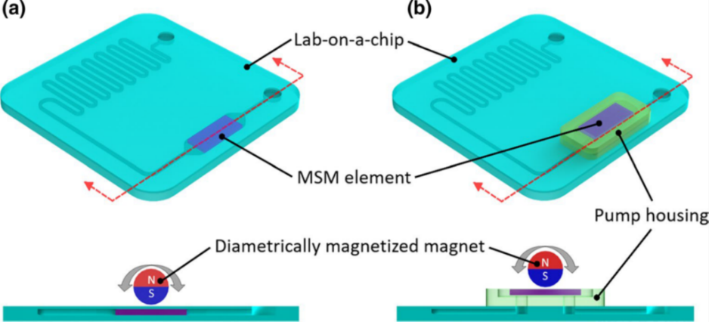

IV. Biography:

Ullako Kari is the Professor of Material Physics (Tenured full professor) at Lappeenranta University of Technology, Finland. He invented Magnetic Shape Memory (MSM) materials that introduce significant movement without any of the typical mechanical components associated with motion. Prof. Ullako Kari is an author or co-author of over 300 publications and an inventor of 14 patents. The number of citations to his publications is about 10035. He has given several invited and keynote lectures and two plenary lectures in international conferences.

    - Presenting author details


Full Name: HU Hao
Email id: hao.h.hu@lut.fi

Contact number: +65-96742196

Linked In account: https://www.linkedin.com/in/hiroshi-hu/
Session name/ number:

Category: (Oral presentation/ Poster presentation)

