Abstract Template

Title: Rapid and low-cost prototyping of lab-on-a-chip devices for inertial microfluidic applications

Luis Flores-Olazo^{1,2}, Nicolas Thorne^{1,2}, Luis Alvarado ², Emir A. Vela ^{2,3}, Julien Noel^{2,3} , and Julio Valdivia-Silva^{1,2}.
¹Bioengineering Department, Universidad de Ingenieria y Tecnologia - UTEC, Lima, Peru
²Center BIO, Universidad de Ingenieria y Tecnologia - UTEC, Lima, Peru
³Department of Mechanical Engineering, Universidad de Ingenieria y Tecnologia - UTEC, Lima, Peru

Keywords: Microfluidics, BioMEMS, Lab-on-a-chip, inertial effect, 3D print

- Abstract Body (up to 250-300 words)

In this work, three inertial microfluidic devices were developed with rapid and low-cost prototyping techniques (rapid soft lithography). The moulds were printed with a desktop 3D-SLA printer with two types of resin. The chips were manufactured by pouring PDMS in the 3D-printed moulds, and then, dried in an oven at 80 °C. Once the PDMS part was removed from the mould, two types of bonding with a flat surface counterpart were tested: plasma and spin coating. Computational simulations of laminar flow and particle trajectories were performed using COMSOL Multiphysics. These simulations were used to identify the steady state flow of particles of different sizes and diameters. The devices were tested with distilled water with Sodium dodecyl sulfate (SDS) containing fluorescent PS microparticles; we observed a line of microparticles focused in the center of the microchannel due to inertial effects, and also flow output switching control was performed. In addition, some advantages of using 3D printed moulds are shown, such as the incorporation of pillars (eliminates the need for a biopsy-puncher), repeated use of a single mould without damaging the microchannels’ walls, and the possibility of easily manufacturing lateral tubing interfaces. Simulations of the steady state flows have so far been 100% in agreement with the experimental results.

- Image: A. Mould CAD design. B. Manufactured microfluidic device. C. Device Testing
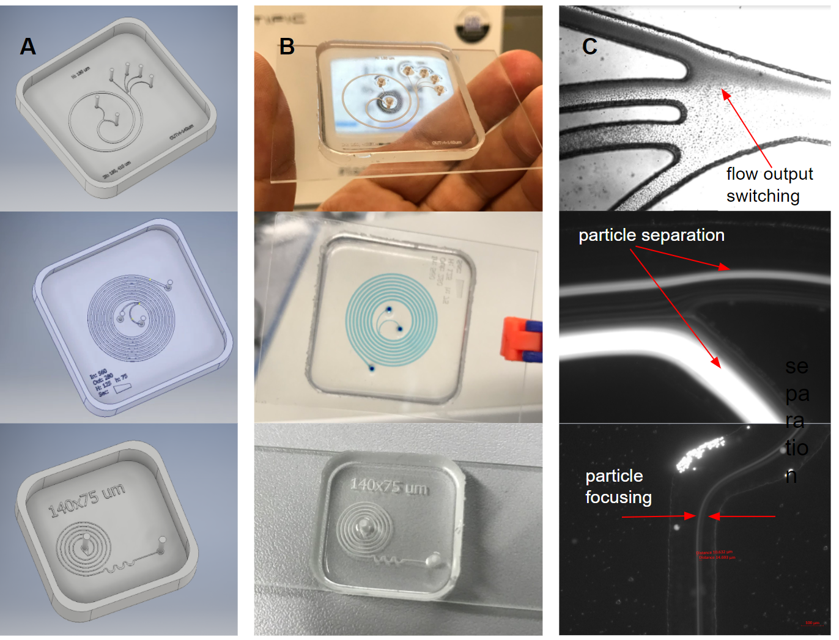

IV. Biography:

Luis Flores-Olazo is a distinguished graduate in electronic engineering from Pontificia Universidad Católica del Perú-PUCP and was part of the Postgraduate Programs in digital Fabrication and synthetic biology from Fab Foundation & CBA-MIT. He was recognized by MIT Technology Review as an Innovator under 35 in LATAM. He is a researcher at Center BIO and BioMEMS-Lab, Bioengineering Department, Universidad de Ingeniería y Tecnología - UTEC, Perú.

    - Presenting author details

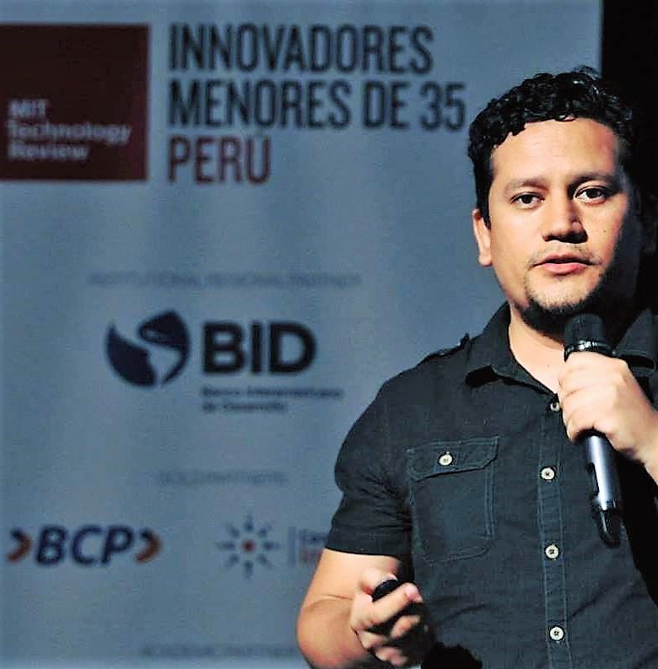

Full Name: Luis Flores-Olazo
Email id: lflores@utec.edu.pe

Contact number:+51 995162134

Linked In account: https://www.linkedin.com/in/luis-ernesto-flores-olazo-lefo-40036635/
Session name/ number:

Category: (Poster presentation)

