Title: A Numerical Study of a Stretchable Microfluidic-Based Strain Sensor

Jiayue Shen¹, Minghao Geng²
¹ Department of Engineering Technology, SUNY Polytechnic Institute, Utica, NY, USA;
² Department of Computer Science, SUNY Polytechnic Institute, Utica, NY, USA

Keywords: Flexible electronics, Stretchable strain sensor, Microfluidic device, Wearable device, Strain sensor, Electrolyte-enabled transducer

- Abstract Body (up to 250-300 words)

With the rising interest from many areas, such as human motion detection, human health monitoring, wearable devices, robotics, and structural health monitoring, strain sensors with the features of high flexibility, stretchability, sensitivity, stability, and low cost attract considerable attention. This paper aims to introduce a low cost, highly stretchable microfluidic-based strain sensor capable of detecting strain change up to 160%. The sensor is comprised of a electrolyte-enabled long winding microchannel integrated with a pair of interconnects and a silicone-based packaging. While the sensor is stretched along the sensor length, the transducer pair's overall resistance increases due to the elongation of the microchannel length and reduce of the microchannel cross-section. As a proof-of-concept study, a numerical model is created in COMSOL Multiphysics to evaluate the sensor performance. To choose the optimal geometry parameters of the strain sensor, the study first investigates the relationship between the gauge factor and four key design geometries, including the primary microchannel(PM,along x-axis) length, PM width, the secondary microchannel(SM, along y-axis) to PM width ratio, and the number of grid lines. The data indicate that optimum values of PM length, PM width, width ratio, and number of grid lines should be 20mm, 200µm, 2, and 10, respectively. Second, the study builds the sensor with the optimum geometries and evaluates the sensor’s sensitivity with two electrolytes that hold a low evaporation rate at room temperature: Gallium-Indium eutectic (EGAIn) and 1-Ethyl-3-methylimidazolium dicyanamide electrolyte (EMIDCA). The results show that although the strain sensor with EMIDCA is more sensitive but less stretchable than the one filled with EGAIn.

- Image:
- 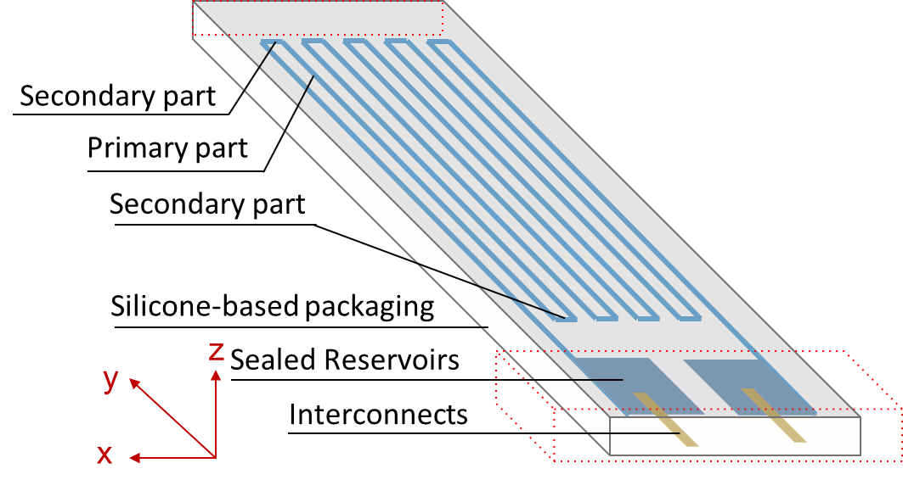
- Figure 1. Configuration of the strain sensor
- 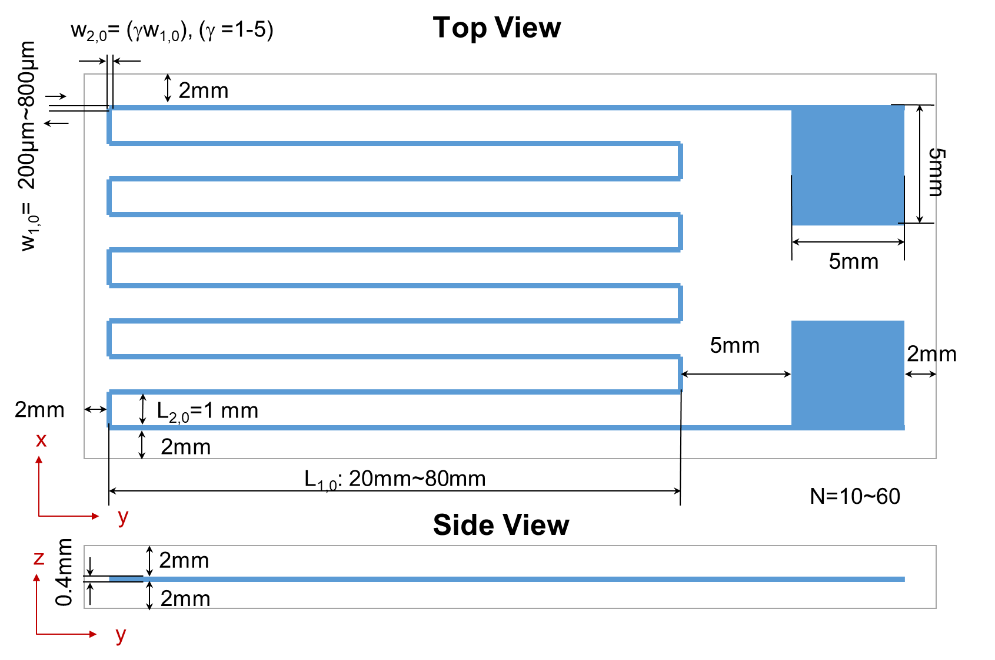
- Figure 2. Key geometrical dimension of the strain sensor

IV. Biography:

Dr. Jiayue Shen received her Ph.D. degree in Mechanical Engineering from Old Dominion University, U.S., in 2018. In the same year, she joined the engineering technology department at SUNY Polytechnic Institute as an Assistant Professor. Her main research interests are microfluidic devices, flexible electronics, and wireless sensing systems. She has published more than 18 papers/proceedings in reputed Journals and conferences, has been actively working with the state and federal agencies on the funded projects, and has been serving as reviewers and committee members for reputed journals and international conferences.

    - Presenting author details


Full Name: Jiayue Shen
Email id: shenj@sunypoly.edu

Contact number: 315-351-3531

Linked In account: https://www.linkedin.com/in/jiayue-s-930284138/
Session name/ number: 6th International Conference on Microfluidics/Track 1

Category: (Oral presentation/ Poster presentation)

