Abstract Template

Title: 3D Microwave Integrated Absorption Module for Toxic Gas Detection

Sadabadi H^{1,2}, Bostani A³, Esmaeli A⁴
¹ Wireless Fluidics Inc, Edmonton, Canada
² Department of Mechanical and Manufacturing Engineering, University of Calgary, Calgary, Canada
³ American University of Kuwait, AUK, Salmiya, Kuwait
⁴ School of Engineering Technology and Industrial Trades, College of the North Atlantic-Qatar, Doha, Qatar

Keywords: Toxic gas detection, Microwave sensing, 3D microwave resonator, Spiral microfluidics, Microfluidic particle separation, Integrated platform, Adsorption, Dusty environment

- Abstract

Gas detectors attract many research interests due to their wide applications in the areas of environmental monitoring, homeland security, anti-terrorism, industrial quality control, etc. In this work, presents the development of a sensitive integrated and in-line modular platform for detection of toxic gases in a dusty environment where many microscale particles are presenting in the environment. The platform encompasses three main modules including a microfluidic system for in-line and continuous filtering of the dust from the inlet gas, an adsorption unit for toxic gas adsorption encompasses a reservoir filled with Zeolite X13 nanoparticles and a novel 3D microwave circuit for the gas detection. Gas sensing is performed using microwave resonators based on the gas adsorption-induced change in the permittivity of the adsorbent material. The proposed platform is specifically designed for harsh environment where the high humidity, high temperature and dusty and polluted air results in numerous false positive and true negative errors. Simulation study of the gas filtering (for dust removal) and microwave-resonator sensitivity study have been performed and optimized. The results showing high dust separation from the main inlet flow with performance of ~90%. Furthermore, the microwave resonator simulation results show that at 2.5 GHz, we can see a clear contrast that can be used for toxic gas detection. The presented results showing a proof-of-principal that the proposed platform as a sensitive platform for toxic gas detection.

- Image:
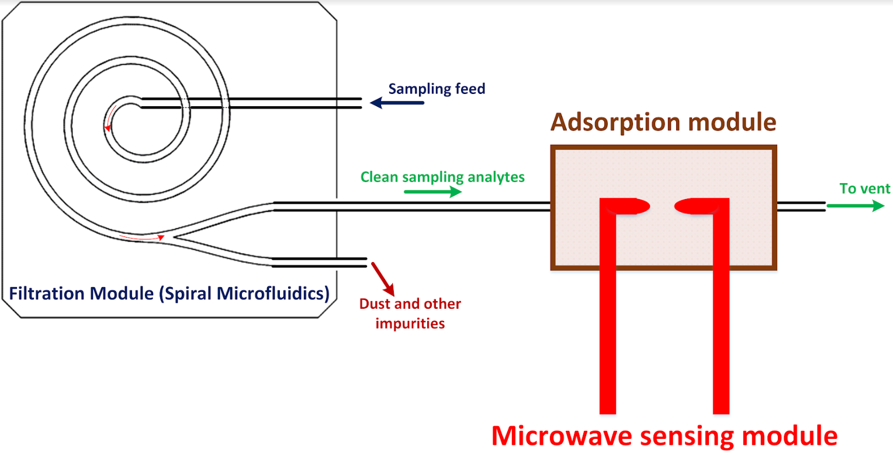 | 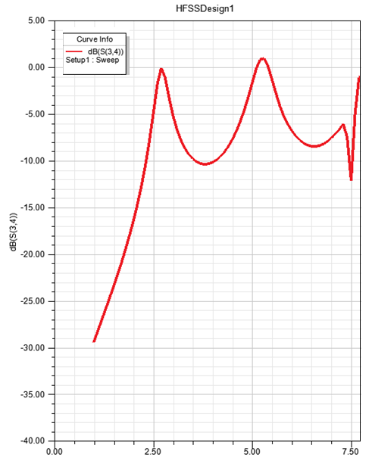
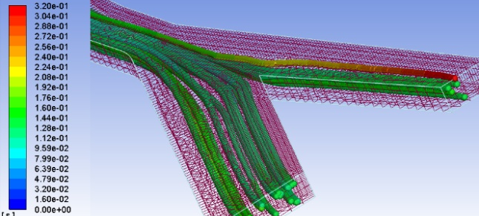

IV. Biography:

Hamid Sadabadi is an entrepreneur and researcher in the field of Microfluidics, Lab-on-a-chip, sensors, and biosensors. He has completed his PhD in microfluidic from Concordia University in Montreal. He is recipient of 8 prestigious awards/scholarships inducing Quebec Doctoral Merit Scholarship and University of Calgary Eyes High Postdoctoral Fellowship where he did his postdoc research. He is a co-founder and principle microfluidic engineer at Wireless Fluidics, a sensing technology development start-up). His main research interests are developing biosensing technologies at Wireless Fluidics. He has published more than 12 US patents, one book chapters, and more than 16 articles in reputed journals.

    - Presenting author details

Full Name: Hamid Sadabadi
Email id: hamid.sadabadi@ucalgary.ca

Contact number: +1-780-716-6461

Linked In account: https://www.linkedin.com/in/hamid-sadabadi/
Session name/ number:

Category: (Oral presentation/ Poster presentation): Oral – (online-maybe)

