Abstract

Title: Design and characterization of an on-chip continuous microdistillation tool.

EL MASRI F^{1, 2}, BONNIN C¹, BERGEOT G¹, NGUYEN O², AYMONIER C², MARRE S²
¹ IFP Energies nouvelles, Rond-Point de l’Echangeur de Solaize, BP3, 69360 Solaize, France
² CNRS, Univ. Bordeaux, Bordeaux INP, ICMCB, UMR 5026, F-33600 Pessac, France

Keywords: Microdistillation, multistage, capillary forces, micropillars

- Abstract Body (up to 250-300 words)

Microfluidic research has been attracting attention recently thanks to its inherent advantages (low amounts of solvent, high surface area to volume ratio, …). Reactors miniaturization is currently well-controlled, however, a wide gap exists concerning continuous microseparators (~mL/h), able to partition microreactors’ effluents, which is critical in many continuous microfluidic processes. Accordingly, the miniaturization of distillation tools turns out to be an important challenge.

The main limitation associated with on-chip continuous microdistillation development is that it cannot be based on gravity forces, which enables the gas-liquid counter-current flow in conventional columns. Indeed, at the microscale, the effect of gravity vanishes in favor of interfacial forces. Thus, alternative principles have to be considered to control the liquid phase and maintain a stable operation. So far, several works reported the interesting performances of on-chip microdistillations based on capillary¹, centrifugal² or other forces³. However, no in-depth studies were published and there is no clue on how to improve performances of such microsystems in terms of height equivalent to a theoretical plate (HETP).

In this work, we introduce a silicon-based microchip used to achieve a multistage distillation. A temperature gradient across the chip was generated by heating one end and cooling the other one (Figure 1). Products withdrawal was managed at fixed flow rates. This device has been successfully used to distill a 27mol% acetone-water mixture, producing continuously distillate and residue with acetone molar fraction of 0.81 and 0.07, respectively. This separation corresponds to a 30 mm HETP. A parametric study (feed flow rate and composition, temperature profile and withdrawal flow rates) using acetone-water mixture as a model system has been investigated to better understand the device’s key parameters.

References:

¹ Lam, K. F., E. Cao, E. Sorensen and A. Gavriilidis (2011). “Development of multistage distillation in a microfluidic chip” Lab on a chip 11 (7), 1311–1317
² J. M. MacInnes, J. Ortiz-Osorio, P. J. Jordan et al., “Experimental demonstration of rotating spiral microchannel distillation,” Chemical Engineering Journal, vol. 159, 1-3, pp. 159–169, 2010.
³ Hwang, H. J., K. He, S. Gray, J. Zhang and I. S. Moon (2011). “Direct contact membrane distillation (DCMD): Experimental study on the commercial PTFE membrane and modeling” Journal of Membrane Science 371 (1-2), 90–98.

- Image:

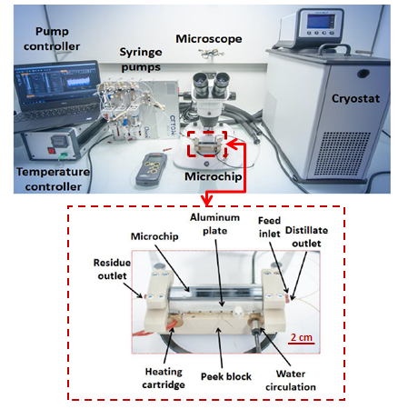
Figure 1 Experimental setup of the microdistillation process.

IV. Biography:

EL MASRI Farah is a 3rd year PhD candidate in process engineering at IFP Energies Nouvelles. She has completed her undergraduate studies in Lebanon at the Lebanese University - Faculty of Engineering specializing in Chemical and Petrochemical. During the fifth year of studies, she has done a Research Master 2 in “Catalysis and Processes" at the National Graduate School of Engineering Chemistry of Lille in France. This has been complemented by a M2 internship at IFP Energies Nouvelles over a period of 6 months. The internship mainly dealt with the treatment of catalysts. Shortly after, she began her PhD studies at IFP Energies Nouvelles in the Experimentation Intensification department. Her work involves investigating on-chip microdistillation device (design, characterization and optimization).

    - Presenting author details


Full Name: Farah EL MASRI
Email id: farah.el-masri@ifpen.fr / masri.farah@hotmail.com

Contact number: +33 6 61 95 98 36

Linked In account: Farah El Masri
Session name/ number: Lab-On-A-Chip Technology

Category: (Oral presentation/ Poster presentation) Oral presentation

