Abstract

Title: Biological applications of microfluidics in cell motility and plant root growth dynamics

Jack Merrin¹,
¹Microfluidics Staff Scientist, Institute of Science and Technology Austria, Klosterneuburg, Austria

Keywords: Microfluidics, BioMEMS, Cell Motility, Arabidopsis thaliana, Dendritic Cells

- Abstract Body (up to 250-300 words)

Microfluidics is increasingly becoming useful in a diverse range of biological investigations of model organisms. In this presentation, I will show two examples of how microfluidics is used to study immune cells and plant roots, which cannot be accomplished by traditional methods.

Eukaryotic cells such as leukocytes are generally understood to move forward by retrograde flow of the actin cytoskeleton, which is coupled to the membrane through adhesion molecules. A new mode of locomotion is demonstrated by pressing off environmental topography even in the absence of adhesion. This is demonstrated through the use of a series of microfluidic confining geometries and video microscopy. Genetic knockouts of dendritic cells in the known pathways for surface adhesion can still move in microchannels if the walls are less than the dimensions of cells and if they differ enough from being parallel.

The plant hormone auxin is involved in a variety of developmental and physiological processes, such as plant root growth inhibition. In Arabidopsis thaliana, with the use of microfluidics, microscopy, and genetic engineering, it is revealed that the root growth rate can respond rapidly and reversibly to local auxin concentration. Since it acts faster than transcription, this suggests a new alternative pathway challenging the traditional understanding of auxin.

- Image:

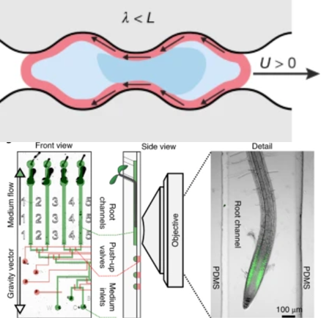

III. Biography:

Jack Merrin has completed his PhD in physics in 2006 from Princeton University. He did postdoctoral studies at Joseph Fourier University, Rockefeller University, and Memorial Sloan Kettering Cancer Center. Since 2013 Jack has been a microfluidics staff scientist at IST Austria specializing in biological applications of microfluidics.

IV. Presenting author details



Full Name: Jack Merrin
Email id: jack.merrin@ist.ac.at

Contact number: +43 (0) 664 883 49 244

Linked In account: Jack Merrin
Session name/ number:

Category: Oral Presentation

