Title: Porous bioaffinity membranes for the isolation of circulating tumor cells

Nathan Bentley¹, Marc Zinggeler², Thomas Brandstetter¹, Jürgen Rühe ¹
¹Department of Microsystems Engineering, University of Freiburg, Freiburg, Germany
²CSEM Center Muttenz, Tramstrasse 99, CH 4132 Muttenz

Keywords: Circulating Tumor Cells (CTC), Bioaffinity surfaces, Surface Modification, Hydrogels

- Abstract Body

In cancer diagnosis, a liquid biopsy to determine the presence of circulating tumor cells (CTCs) in a patient’s blood can allow for early detection of cancer. This can be made possible through the isolation and counting of CTCs, which may number in the single digits for a 7 ml sample of blood. This small number of cells requires a highly accurate method of isolation, as well as the ability to remove contamination from other cells in blood such as white and red blood cells. One method to achieve this is through a bioaffinity membrane, which combines dead-end filtration and selective capture surface comprised of immobilized antibodies which interact with proteins on the surface of the CTCs – see figure 1. A copolymer of poly (dimethyl acrylamide) (PDMAA) and methacryloyloxy benzophenone (MABP), a crosslinking group, is coated onto membrane with pore sizes of 8 µm. UV-light is then used to activate the benzophenone groups to simultaneously crosslink and attach the copolymer to the surface through the CH-insertion crosslinking (CHic) reaction.^{1,2} This has been demonstrated both on track-etched polycarbonate membranes, as well as nickel membranes with defined pore locations with the inclusion of a priming step. Following attachment of the hydrogel, streptavidin molecules are attached to the surface using the same CHic-reaction. Using the biotin-streptavidin interaction, antibodies specific to the CTCs of interest may then be immobilized on the surface. This allows for a highly specific surface, tailored to the CTCs of interest, and a high sensitivity, as a result of the immobilization of the CTCs through their interaction with the antibodies. Through filtration of a patient blood sample and a subsequent backwashing step (figure 2) with a minimal addition of complexity to the procedure, a recovery of up to 80% of CTCs (MCF-7) can be achieved with a large reduction in contamination from white blood cells compared to simple dead-end filtration – see figure 3.³

- Images:

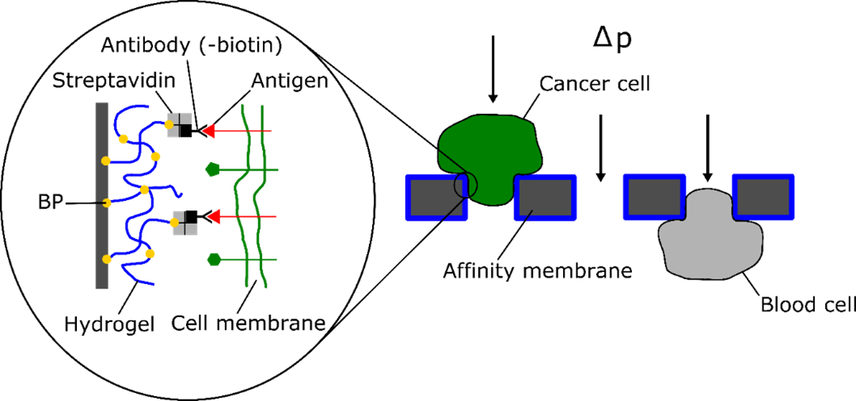

Figure 1: Schematic depiction of the dead-end affinity filtration system. A porous membrane is coated with a hydrogel precursor which is simultaneously crosslinked and attached with UV light, followed by attachment of streptavidin using the same process. An antibody specific to the cell of interest is then immobilized using the biotin-streptavidin interaction.⁴
⁴

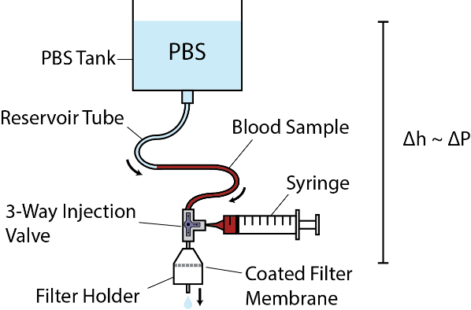
Figure 2: Schematic of hydrostatic filtration setup for CTC isolation.

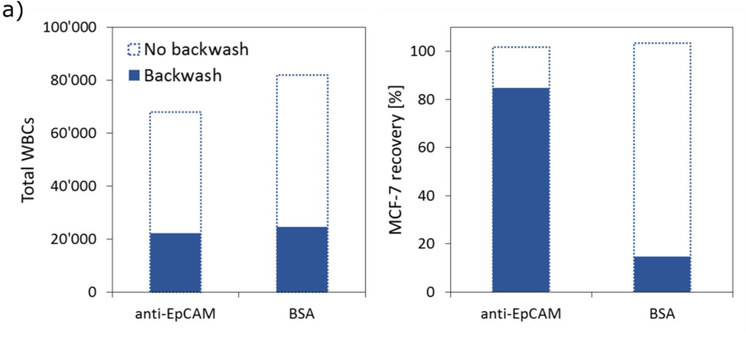
Figure 3: Comparison of the total WBCs (left) and the recovery of MCF-7 (right) measured after filtration through filters treated with BSA or coated with hydrogel and functionalized with anti-EpCAM with and without backwashing at 6 mbar for 30s.³

References:

1. Prucker, O.; Brandstetter, T.; Rühe, J. Surface-Attached Hydrogel Coatings via C,H-Insertion Crosslinking for Biomedical and Bioanalytical Applications (Review). Biointerphases 2018, 13 (1), 010801.
2. Rendl, M.; Bönisch, A.; Mader, A.; Schuh, K.; Prucker, O.; Brandstetter, T.; Rühe, J. Simple One-Step Process for Immobilization of Biomolecules on Polymer Substrates Based on Surface-Attached Polymer Networks. Langmuir 2011, 27 (10), 6116–6123.
3. Zinggeler, M. Porous Affinity Matrices for the Analysis of Low-Abundance Biomarkers, PhD Thesis, University of Freiburg, 2018.
4. Zinggeler, M.; Brandstetter, T.; Rühe, J. Towards High Performance Detection of Circulating Tumor Cells in Whole Blood. In Procedia Engineering; Elsevier Ltd, 2015; Vol. 120, pp 380–383.

IV. Biography:

Nathan Bentley is a PhD candidate in the Department of Microsystems Engineering at the University of Freiburg, Freiburg, Germany. He obtained a bachelor of science in mechanical engineering at the University of Wisconsin-Madison. He then completed a masters in polymer science and sustainable materials through a binational cooperation between the University of Freiburg and the University of Strasburg.

    - Presenting author details


Full Name: Nathan Kenneth Bentley
Email id: nathan.bentley@imtek.uni-freiburg.de

Contact number: +49(0)761/203-7169

Linked In account:
Session name/ number: Lab-On-A-Chip Technology

Category: Poster presentation

