Abstract

Title: Linear cryogel arrays in small capillaries as a microfluidic platform for multiplex assays

Patrick Fosso¹, Thomas Brandstetter¹, Jürgen Ruehe¹,
¹Laboratory for Chemistry and Physics of Interfaces, Department of Microsystems Engineering, University of Freiburg, Germany

Keywords: Cryogel monoliths, C,H-insertion crosslinking, immunoassay, analyte enrichment

- Abstract Body

The platform consists of an optically transparent capillary, in which porous cryogel monoliths were generated. For their generation, depending on the application, one or more polymer solutions containing a photo reactive polymer and capture molecules of interest are injected into the capillary and subsequently transformed into functionalized cryogel arrays through in situ UV polymerization after freezing (Fig. 1).^{1,2,3} The so prepared cryogel arrays in capillaries provide through their 3-D configuration compared to 2-D platform (e.g., lateral flow test) a huge load capacity for capture molecules which is a great attribute for assay sensitivity enhancement. The presented platform is easy to manufacture, allows multiplexing, simple optical detection and could be used as a disposable product for high-throughput applications.
Using active fluid transport, the utility of the platform was demonstrated for different applications.

- Application: Simultaneous fluorescence detection of antibodies
After immobilizing recombinant Borrelia proteins including (OspC, VIsE1), we demonstrated via a dual fluorescence immunoassay that the platform allows the simultaneous detection of IgG and IgM antibodies in sera from Borrelia-infected patients within 1 hour (Fig. 2). A study conducted with the platform and commercial lateral flow immunoassays showed that both platforms were comparable in sensitivity, whereas the cryogel arrays platform was less sensitive for IgG antibody (- 6.9 %) but equally sensitive for IgM antibody detection.

- Application: Strong enrichment of an analyte
Beside the multiplexing advantage, such a platform could also be used for affinity extraction applications (Fig. 3). As test example, using cryogel monoliths containing boronic acid groups, dopamine was successfully preconcentrated from bovine serum albumin or urine solutions and enrichment factors up to 620 in less than 3 hours were achieved. After such a strong enrichment, elution volumes can be analyzed with simple quantification detectors (e.g., photometer, amperemeter).

- Images:

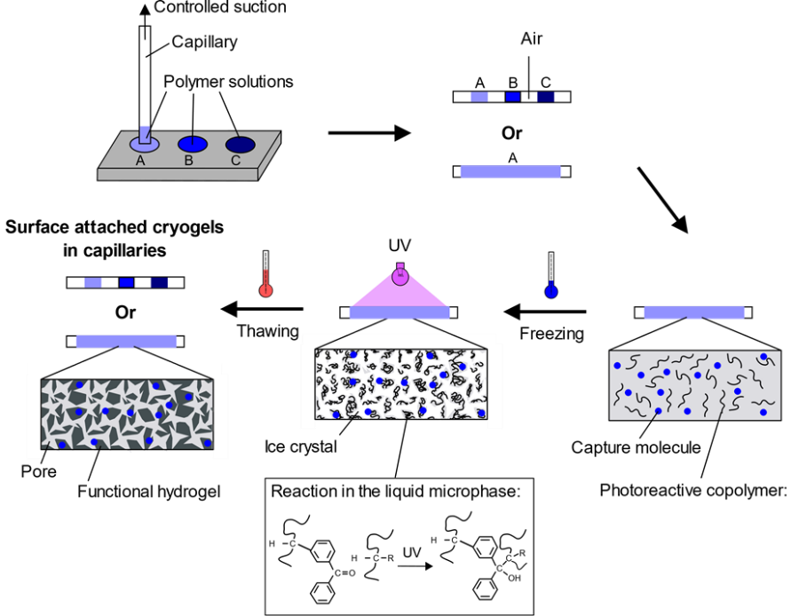
Figure 1. Preparation of surface attached cryogel monoliths in capillaries. A solution or several solutions are sucked into the capillary. In the case of different solutions, an air compartment is generated to avoid mixing. Thereafter, the solution within the capillaries is frozen at subzero temperatures to obtain a phase separation between ice crystals and the liquid microphase which mostly consists of the polymer. Upon UV light, C,H-insertion crosslinking reactions occur in the liquid phase. By thawing, a stable porous network and capillaries containing one or many cryogel compartments are generated.^{2,4}

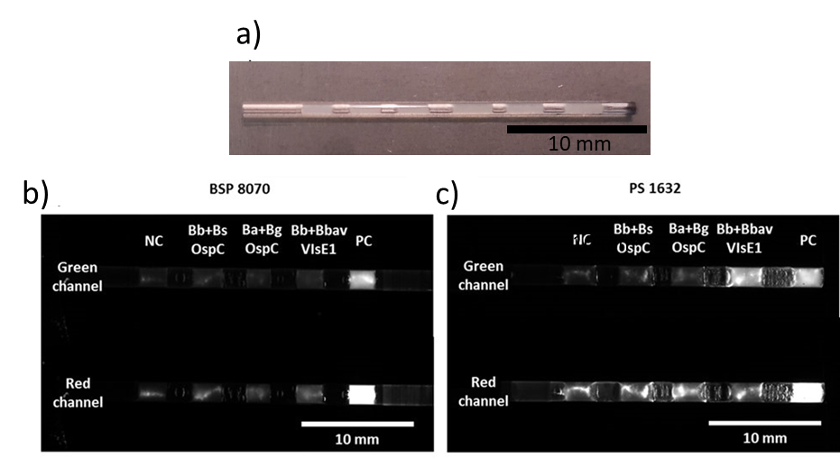
Figure 2. a) White light image of a capillary prepared with cryogel compartments, in which different biomolecules (e.g., Borrelia antigens) were immobilized. b) and c) Fluorescence micrographs showing tipical assay results for a negative (BSP 8070) and a positive sample (PS 1670).

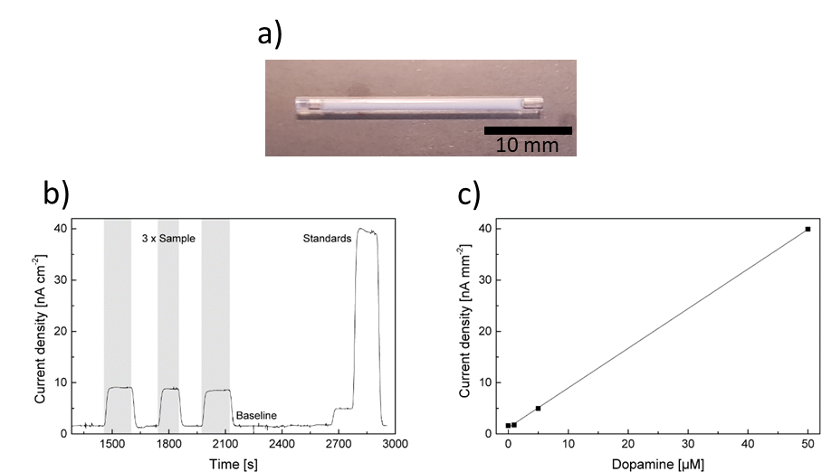
Figure 3. a) White light image of capillary completely packed with cryogel monoliths. b) Amperometric measurement of concentrated dopamine samples from synthetic urine in 0.1 M HCl. c) Dopamine calibration with standard solutions.

References:

- Rendl, M. et al. Simple One-Step Process for Immobilization of Biomolecules on Polymer Substrates Based on Surface-Attached Polymer Networks. Langmuir 27, 6116–6123 (2011).

- Zinggeler, M., Schonberg, J.-N., Fosso, P. L., Brandstetter, T. & Ruhe, J. Functional Cryogel Microstructures Prepared by Light-Induced Cross-Linking of a Photoreactive Copolymer. ACS Appl. Mater. Interfaces 9, 12165–12170 (2017).

- Prucker, O., Brandstetter, T. & Rühe, J. Surface-attached hydrogel coatings via C,H-insertion crosslinking for biomedical and bioanalytical applications (Review). Biointerphases 13, 010801 (2018).

- Zinggeler, M., Fosso, P. L., Hao, Y., Brandstetter, T. & Ruhe, J. Preparation of Linear Cryogel Arrays as a Microfluidic Platform for Immunochromatographic Assays. Anal. Chem. 89, 5697–5701 (2017).

IV. Biography:

Patrick Landry Fosso Tene studied microsystems engineering at the University of Freiburg and is currently doing his doctorate at the Chair of Chemistry and Physics for Interfaces at the same university.

    - Presenting author details


Full Name: Patrick Landry Fosso Tene
Email id: patrick.fosso@imtek.uni-freiburg.de

Contact number: 004976120367463

Linked In account:
Session name/ number: Lab-On-A-Chip Technology

Category: (Poster presentation)

