Surfactant effects on droplet formation in microfluidic systems
M. Kalli, E. Roumpea, P. Angeli*
ThAMeS Multiphase, Department of Chemical Engineering, UCL, Torrington Place, London WC1E 7JE, UK
* Corresponding author email address: p.angeli@ucl.ac.uk
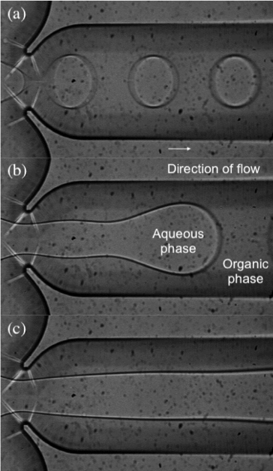

Abstract (300 word limit)
Statement of the Problem:

Formation of microfluidic droplets in an immiscible liquid enables control of the drop size and results in low polydispersity indexes. Surfactants are commonly used in liquid-liquid dispersed systems in a wide variety of applications, including emulsification, extractions and inkjet printing, and have a significant effect on droplet formation. Often equilibrium values of the interfacial tension are used to describe the droplet size. The droplet formation process however, depends on the dynamic values of the interfacial tension, which are linked to the surfactant diffusion and absorption kinetics at the interface.
Methodology & Theoretical Orientation:

The formation of aqueous droplets in an organic continuous phase was studied experimentally using a flow-focusing microchannel in the presence of different surfactants. A low viscosity silicone oil (4.6 mPa s) was used as the continuous phase and a mixture of 48% w/w water and 52% w/w glycerol was the dispersed phase. A cationic, C12TAB (50 mM) and an anionic, SDS (11 mM) surfactant were added in the aqueous phase, to compare the effects on the drop formation.
Findings:

Four regimes of drop formation were identified, namely squeezing, dripping, jetting and threading, whose transition boundaries changed when surfactants were present. The different regimes observed with SDS surfactant-laden drops are shown in Figure 1. For all solutions studied, three distinct drop formation stages were identified, expansion, necking and pinch-off. Smaller drops were observed at higher surfactant concentrations and higher surfactant activity.
Conclusion & Significance:

The dynamics of surfactant adsorption on interfaces can play a vital role in the drop formation process. Using the force balance that dominates in the dripping regime, an estimation of the dynamic interfacial tension at the characteristic time scale was quantified. The effect of the dynamic interfacial tension is more significant for surfactants with low CMC values, which suggests increased surfactant activity. Thus, their effects on the droplet formation process were discussed.

Image
Figure 1: Regimes observed in the flow-focusing microchannel (a) Dripping, (b) Jetting, (c) Threading. The surfactant-laden drop consisted of a 11 mM (CMC) solution of SDS in 52% w/w glycerol solution and the continuous organic phase is a silicone oil with 4.6 mPa·s viscosity
Recent Publications (minimum 5)
- Roumpea E, Kovalchuk N, Chinaud M, Nowak E, Simmons M, Angeli P, (2019), Experimental studies on droplet formation in a flow-focusing microchannel in the presence of surfactants, Chemical Engineering Science; 195: 507–518
- Chinaud M, Roumpea E, Angeli P, (2015) Studies of plug formation in microchannel liquid–liquid flows using advanced particle image velocimetry techniques. Experimental Thermal and Fluid Science; 69: 99-110.
- Kovalchuk N, Roumpea E, Nowak E, Chinaud M, Angeli P, Simmons M, (2018), Effect of surfactant on emulsification in microchannels, Chemical Engineering Science; 176: 139–152
- Roumpea, E., Chinaud, M. and Angeli, P. (2017). Experimental investigations of non-Newtonian/Newtonian liquid-liquid flows in microchannels. AIChE Journal, 63(8), pp.3599-3609.

 Biography (150 word limit)

Maria is a researcher in the ThAMeS multiphase systems group at UCL. Her research focuses on gaining fundamental understanding of flow phenomena in two-phase systems, combining the fields of microfluidics and surfactants. She has experience in advanced optical techniques, two-colour micro-PIV and high-speed imaging. Her current work involves performing state-of-the-art experiments to investigate droplet formation in small channels and quantify the dynamic interfacial tension at the sub-second timescale, for a range of different surfactants. Relevant industrial applications include pharmaceutical, food, printing, enhanced oil recovery and cleaning and decontamination techniques. Throughout her academic years she has won several awards, including a double prize for best poster and 3MinuteThesis presentation, as well as the recognition for the most promising PhD student graduating from UCL. Maria has a background in engineering and a passion for research relevant in particular to modern products.
Email: maria.kalli.14@ucl.ac.uk
Notes/Comments:

