Optical manipulation of nanoparticles
Yuchao Li¹, Baojun Li ¹

¹ Institute of Nanophotonics, Jinan University, Guangzhou 511443, China
With observation of small objects, a precisely manipulation is also highly desirable, especially for a three-dimensional manipulation of nanoparticles or biomolecules with a size of less than 100 nm [1]. Although optical tweezers have become powerful tools to manipulate microparticles and cells, they have limits when extended to the nanoscale because of the fundamental diffraction limit of light. The emergence of near-field methods, such as plasmonic tweezers and photonic crystal resonators, have enabled surpassing of the diffraction limit. However, these methods are usually used for two-dimensional manipulation and may lead to local heating effects that will damage the biological specimens. Therefore, we propose a near-field technique that uses a photonic nanojet to perform the three-dimensional optical manipulation of sub-100-nm objects. With the photonic nanojet generated by a dielectric microlens bound to an optical fiber probe, three-dimensional manipulations were achieved for fluorescent nanoparticles as well as for plasmid DNA molecules [2]. Backscattering and fluorescent signals from the trapped targets were detected in real time with a strong enhancement. The demonstrated approach provides a potentially powerful tool for nanostructure assembly, biosensing and single-biomolecule studies.
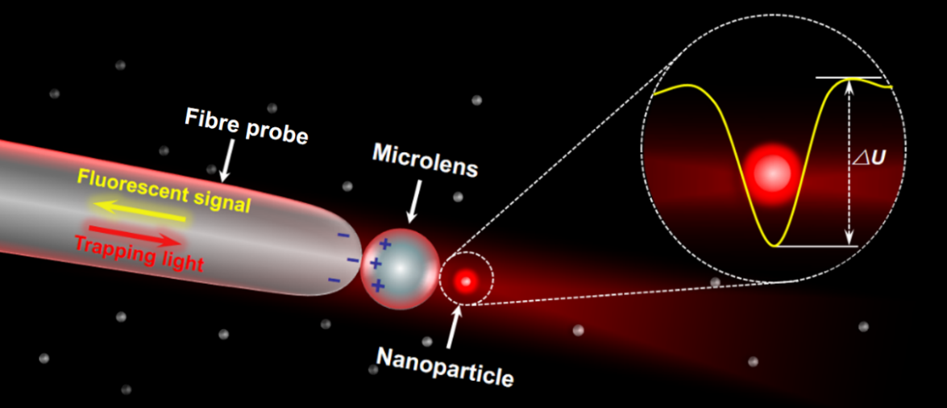
Fig. 1 Schematic illustrating the manipulation of a nanoparticle by a photonic nanojet [2].

References:
[1] Y. Li, H. Xin, X. Liu, Y. Zhang, H. Lei, B. Li. ACS Nano 10, 5800–5808 (2016).
[2] Y. Li, H. Xin, H. Lei, L. Liu, Y. Li, Y. Zhang, B. Li. Light Sci. Appl. 5, e16176 (2016).

