Title: Microplastic Detection Using Impedance Measurements in a Microfluidic Channel
Vienna Mott^{1,2}
1Draper, Cambridge, MA
2Department of Mechanical Engineering, Tufts University, Medford, MA
Abstract:
Microplastics, polymer particles ranging in size from 1 um to 1 mm in diameter, are known to abundantly litter the oceans, but quantities and pollution trends have yet to be understood. In order to effectively quantify these data, an in-situ counting mechanism must be realized. This research studies microplastic discrimination using impedance spectroscopy. A microfluidic chip was developed using a low-cost fabrication method that used a simple soft lithography process. The chip allowed for the continuous injection of microplastic particles and the characterization of their induced impedance change. An increase in capacitance was observed when the microchannel was filled with water versus silicone oil versus air, validating finite element electrostatic simulations. A 7.5 fF increase in capacitance between water and air was observed, and silicone fell between these values, both theoretically and experimentally. From simulations, we determined that one microplastic particle (48 um radius in a 50 um radius channel) would result in 0.06 fF of capacitance change in air and 0.15 fF of capacitance change in water. This is not measureable with the current geometry and instrumentation. Recommendations are made for changes to device design to increase sensitivity, and estimates are made for the required resolution to achieve single particle detection. Notably, this was the first study to explore microfluidic impedance detection of microplastic particles in the ocean.
Biography:
Vienna Mott completed her graduate degree in December of 2019 on the topic of impedance spectroscopy for the detection and identification of microplastics. With degrees in biomedical and mechanical engineering, Vienna specializes in microfluidic device design and fabrication. The concept that informed this research was named one of Time Magazines’ Top 100 Inventions of 2019.
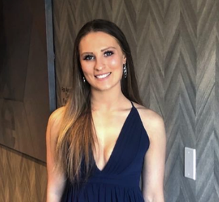

Presenting author details:
Full Name: Vienna Laura Mott
Contact number: 716-238-0554
Email Id: vmott@draper.com
Category: Submitted as YRF, open to oral or poster presentation as well.

