Abstract
Title: Simulation and 3D printing manufacturing of microfluidics for continuous particle separation with applications in monitoring air pollution
Sadabadi H1,2,3, Sanati Nezhad A3
1College of Engineering and Technology, American University of the Middle East, Kuwait
2Wireless Fluidics Inc, Edmonton, AB, Canada, Canada
3Department of Mechanical Engineering, University of Calgary, Calgary, Alberta T2N 2N1, Canada

Abstract Body:
An inertia microfluidic chip is designed to separate small particles suspended in a liquid. ANSYS fluent was further used to simulate the separation efficiently. Assuming the 3D printing resolution, the minimum printable feature size was assumed to be 850um. For results validation, the chip was made by a 3D printer and the separation was tested in the chip. Two particle sizes (50um and 5um) were used for testing. The particles were mixing first with ethanol and then diluted in water in order to create a suspension. A syringe pump then used to inject the flow into the chip. The results show good separation of particles with the selected design and in accordance with simulation results.
This results showing proof of principles of using day-today 3D printing tools for fabrication of microfluidics which can eliminates the needs for advanced manufacturing steps like photo-lithography for microfabrication of chips for particle separation. One of the main application of this technology is to enable separation of big dusts and air prolusions (which are in the same size category) for air quality monitoring in the GCC countries which is a big challenge. The next phase of this work is to integrate this chip with a sensing method (RF sensing) for continuous monitoring/detection.
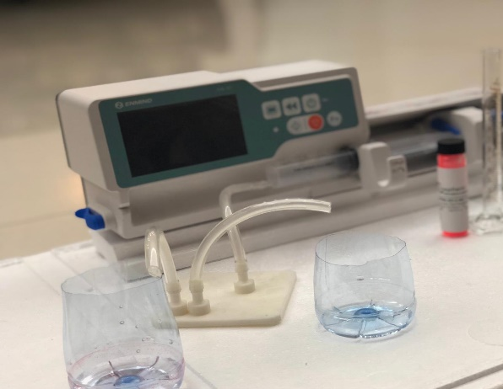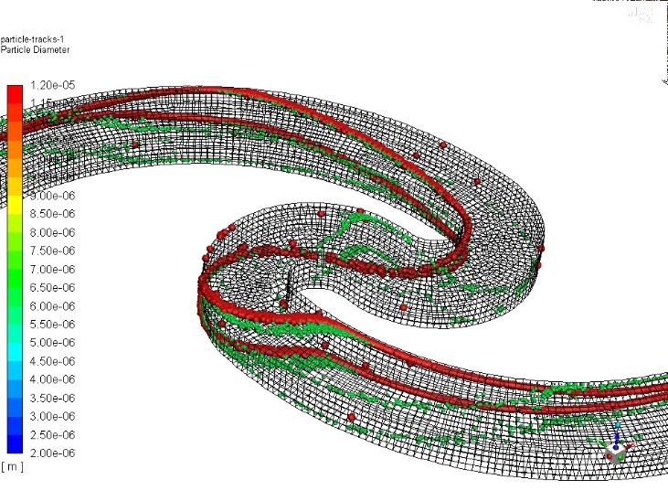

Reference
- Zhou, Y., Ma, Z. & Ai, Y. Sheathless inertial cell focusing and sorting with serial reverse wavy channel structures. Microsyst Nanoeng 4, 5 (2018).
- Nivedita, N. & Papautsky, I. Continuous separation of blood cells in spiral microfluidic devices. Biomicrofluidics 7, 54101 (2013).
- Huang, L. R., Cox, E. C., Austin, R. H. & Sturm, J. C. Continuous particle separation through deterministic lateral displacement. Science 304, 987–990 (2004).
Biography:
Hamid Sadabadi is an entrepreneur and researcher in the field of Microfluidics, Lab-on-a-chip and sensors/biosensors. He has completed his PhD in microfluidic from Concordia University in Montreal. He is recipient of 8 prestigious awards/scholarships inducing Quebec Doctoral Merit Scholarship and University of Calgary Eyes High Postdoctoral Fellowship where he did his postdoc researches. He is the currently CTO of Wireless Fluidics, a sensing technology development start-up. He is also currently invited to be an assistant professor and researcher at American University of Middle East. He has published more than 12 US patents, book chapters, and more than 16 papers in reputed journals.


Presenting author details:
Full Name: Hamid Sadabadi
Contact number: +1-780-716-6461
Email Id: hamid.sadabadi@ucalgary.ca, hamid.sadabadi@aum.edu.kw
Category: Oral presentation

