Abstract Template
Title: Retinal vascular network based Biomimetic Microchannel for LOC applications
Sudha R Karbari1, Uttara Kumari m1,
1Department Electronics and Communication, RV College of Engineering, Bangalore, India.
Abstract :
Micro channels are identified as an important components that transfer liquids within a minute area for microfluidic applications. The design and simulation of micro channel with a specific volume of fluid using COMSOL Multiphysics. Pressure controlling is an efficient and most accurate way to introduce a certain velocity to component of equipment. In this study, we described the simulation analysis for micro fluidic channels with three inlets and one outlet and went on to optimize it to two inlets and one outlet with appropriate velocity profiles and pressure profiles. The grooves in the micro channel are mimicked from vascular network of the retina which is a dynamically interconnected structure composed of three planar vascular layers with bends and grooves at its tip ends. Different fluids enter the inlets and are supposed to get mixed as much as possible before leaving the outlet. The geometry needs to be modified to increase the mixing of the two fluids within 0.05 sec. There are nine variables that are allowed to change during the geometry optimization. A passive approach to induce mixing of the biological samples is facilitated by increasing the distances. The fluids travel longer distances for mixing because of inertial and diffusive forces for which the fluids have to travel long before mixing takes place. The channel length is increased by introducing a groove along the center of each channel so as to increase the length for the mixing to happen with the same area as before. Then it is still optimized form three input micro channel to a two input micro channel with appropriate results.
Biography:
Sudha R Karbari has received Masters in the year 2013 with MEMS as specialization honours from Visvesvaraya Technological University. She received B.E degree in Electronics and Communication Engineering. Her research interests include Polymer Science, MEMS and RF MEMS. She has a work experience of 1.4 years for an IT firm and teaching experience of 5.5 years in different institutions. Currently She is working as an Assistant professor in R V College of Engineering, Electronics and Communication Department, Bangalore, Karnataka, India. Mrs Sudha R Karbari is an active member of IEEE and has publications in International Conferences and Journals.
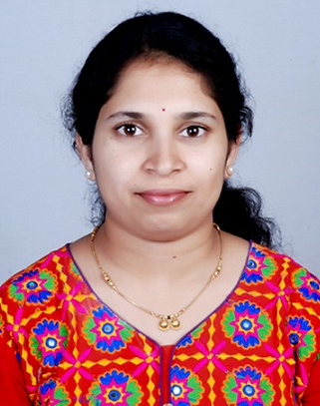
Dr. Uttara Kumari M has 25 years of experience with signal processing and Nanoelectronics as area of specialization. She is working as professor in R V College of Engineering, Electronics and Communication Dept, Bangalore, Karnataka, India. She is receipient of various awards and honors including Best Innovator Award. She is an active member of IEEE organizing conferences and workshops at institutional level. She has publications in international and National Conferences.
Presenting author details:
Full Name: Sudha R Karbari
Contact number:9611297893
Email Id: sudhark@rvce.edu.in
Category: (Oral presentation)
Full Name: Dr. Uttara Kumari M
Contact number:9611297893
Email Id: uttarakumarim@rvce.edu.in
Category: (Oral presentation)

