Abstract
Title: Design of DLD mechanism based microfluidic channel for separating the circulating tumor cells
SRIGITHA S NATH, PRAVEEN KUMAR S
Department of Electronics and Communication Engineering, Saveetha Engineering College, Chennai, Tamilnadu, India
Abstract Body:
Nowadays, due to cancer, the fatal rate of human beings has increased. Cancer is the growth of host cell without control and the host cell growth will produce several diseases to human organs. As a result the person succumbs to it. In United States, the fatal rate attributed to cancer is one for every four deaths. It can be reduced only if it is precisely prognosed. During the previous decades, many researchers and health care professionals have been garnering attention to make precise and low cost device to prognose the count of CTCs from individual patient. As a result, it helps to identify or understand the metastatic process level and development of cancer. In this paper, the microchannel is designed to separate the rarely available circulating tumour cells (CTC) to prognose the level of cancer. Prognosing the level of Circulating Tumour Cells (CTC) in a patient blood will reduce the cancer related fatal rate of human beings. Size of CTC cells is in the range of 15-30 µm. Deterministic lateral displacement mechanism is used to separate the CTCs from the applied blood sample. 42µm sized triangular posts were used to separate the CTCs. Further the separation efficiency is analyzed using critical diameter and particle tracing.
Biography:
Dr. S Praveen Kumar has completed his PhD at the age of 33 years from Anna University. He is the head of Centre for Micro Nano Design and fabrication (CMNDF) research centre, Saveetha Engineering College, Chennai, Tamilnadu, India. He has published more than 20 papers in reputed journals and presented his work in more than 15 international conferences. He is guiding 5 PhD students and he has been serving as an reviewer in various international journals. His specialization includes MEMS, Microfluidics, Biofilter, Electrochemical methods, etc.
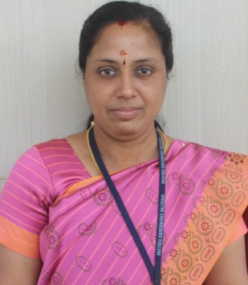
Presenting author details:
Full Name: Dr. Srigitha S Nath
Contact number: +91 9840367678
Email Id: srigithapramodh@yahoo.co.in
Category: Oral presentation / Invited Speaker

