Abstract
Title: Computation analysis on different meander shaped microfluidic channel for separating various biomolecules
PRAVEEN KUMAR S
Department of Electronics and Communication Engineering, Saveetha Engineering College, Chennai, Tamilnadu, India
Abstract Body:
In this modern era, people are facing many health issues due to various reasons and that can be detected by analyzing the blood. Blood has different components like RBC, WBC, platelets and plasma. When the human is facing health issue, they can observe change in the quantity of any of these constituents. Hence, analyzing the blood molecules will pave way to diagnose the disease well in advance. Conventionally, or even today, people used to approach the test centres to examine their health condition which leads to following uncomfortness such as taking large volume of blood, travelling to the test centre, waiting for longer time for getting result, high cost, etc. This opens the way for newer approach for testing the blood constituents in the home itself. This work investigated the meander shaped microfluidic channel for separating various biomolecules based on its size. Different geometries of meander microchannel with symmetric and asymmetric shapes are analyzed computationally in COMSOL multiphysics software. Properties of the blood such as density (1025 Kg/m³) and dynamic viscosity (3.5 x 10⁻⁴ Pa.s) were provided as input to the software, examined its flow and uniformity for various input flow rates, optimized and found out that the microchannel having 250 µm is showing uniform flow rate over the entire microchannel length for the input flow rate of 0.2 ml/min with controlled fluid flow at the bends where the trapping holes can be formed. Also, particle tracing computation is performed from which the microchannel’s trapping efficiency is computed to be 90 %. The optimized design can be used for filtering various sized biomolecules.
Biography:
Dr. S Praveen Kumar has completed his PhD at the age of 33 years from Anna University. He is the head of Centre for Micro Nano Design and fabrication (CMNDF) research centre, Saveetha Engineering College, Chennai, Tamilnadu, India. He has published more than 20 papers in reputed journals and presented his work in more than 15 international conferences. He is guiding 5 PhD students and he has been serving as an reviewer in various international journals. His specialization includes MEMS, Microfluidics, Biofilter, Electrochemical methods, etc.
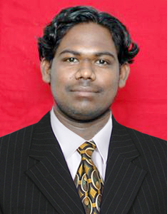
Presenting author details:
Full Name: Dr. S Praveen Kumar
Contact number: +91 9894921193
Email Id: praveenkumarsunil@gmail.com
Category: Oral presentation

